Contents

Syslog 1

SSH & Telnet 5

FTP/TFTP 11

Network Address Translation (NAT) 20

Static NAT 20

Dynamic NAT / PAT 24

Quality of Service (QoS) 30

Intro to QoS 30

QoS (Part 2) 36

Security Fundamentals 46

Port Security 54

DHCP Snooping 63

Dynamic ARP Inspection 70

Network Architectures 79

LAN Architectures 79

WAN Architectures 85

# Syslog

Things covered

* Syslog overview
* Syslog message format
* Syslog facility and severity levels
* Config

**Overview**

* Syslog is an industry standard for message logging
* On network devices, Syslog can be used to log events such as changes in interface status (up -> down), changes in OSPF neighbour status, system restarts etc
* The message can be displayed in the CLI, saved in the device's RAM, or sent to an external Syslog server
* Logs are essential when troubleshooting issues, examining the cause of incidents etc
* Syslog and SNMP are both used for monitoring and troubleshooting of devices
  + They are complementary, but their functionalities are different

**Format**

**seq: time stamp: %facility-severity-MNEMONIC: description**

* Seq
  + A sequence number indicating the order/sequence of messages
* Time stamp
  + A time stamp indicating the time the message was generated
  + Seq and time stamp may/ may not be displayed based on device's config
* Facility
  + A value that indicate which process on the device generated the message
* Severity
  + A number that indicates the severity of logged event
* MNEMONIC
  + A short code for the message, indicating what happened
* Description
  + Detailed information about the event being reported

**Severity Levels**

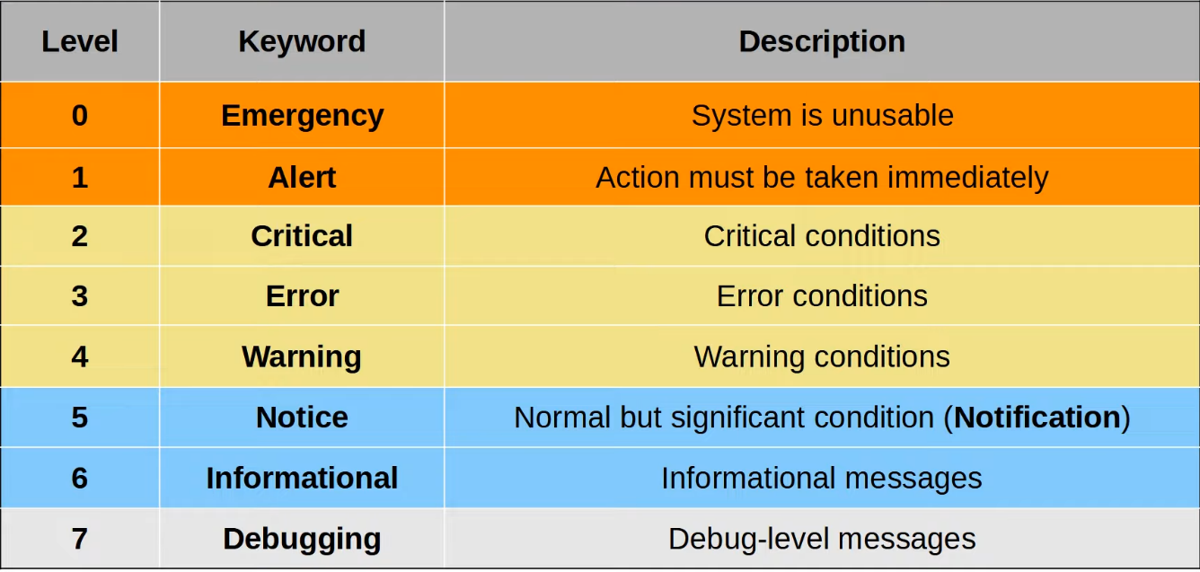

* Level 5
  + In official RFC document is Notice
  + In Cisco CLI is Notification
* Each vendor may interpret each level differently
* Every Awesome Cisco Engineer Will Need Ice Cream Daily

**Syslog Message Examples**

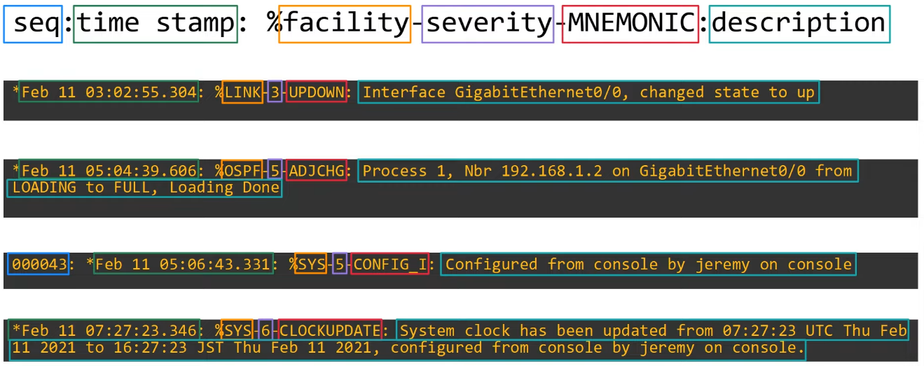

**Syslog Logging Locations**

* Console Line
  + Syslog messages will be displayed in the CLI when connected to the device via the console port
  + By default, all messaged (level 0 - 7) will be displayed
* VTY Lines
  + Syslog messages will be displayed in the CLI when connected to the device via Telnet/SSH
  + Disabled by default
* Buffer
  + Syslog messages will be saved to RAM
  + By default, all messages (level 0 - 7) are displayed
  + You can view the message with "show logging"
* External server
  + Can configure the device to send Syslog messages to external server
  + Syslog servers will listen for messages on UDP port 514

**Config**

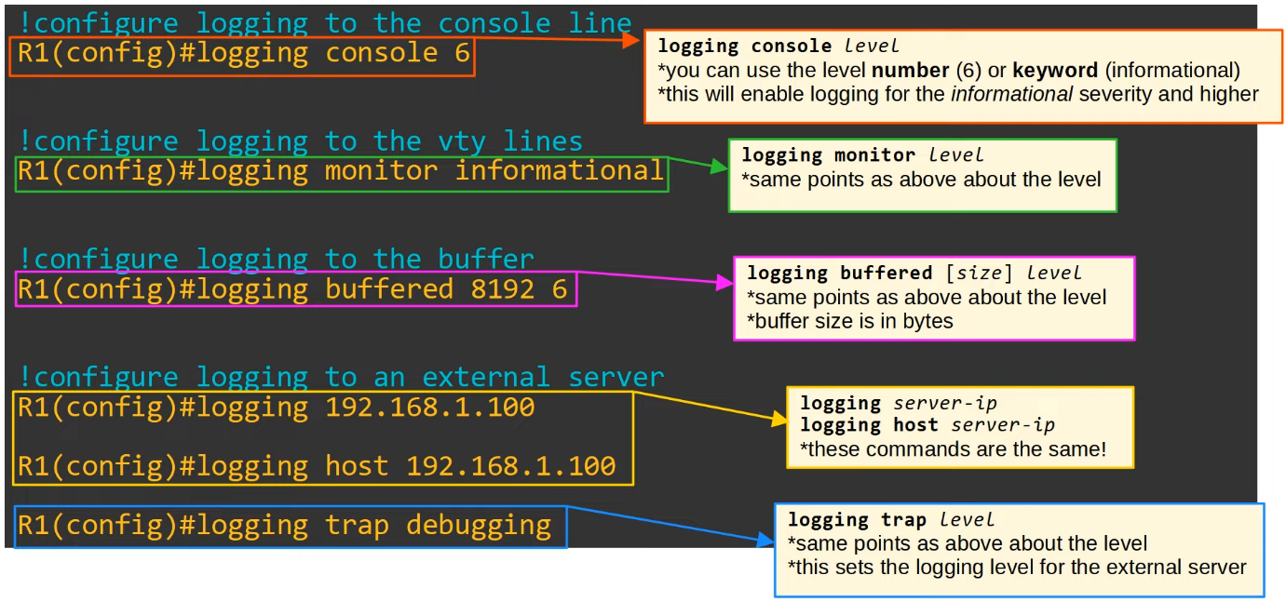

**"terminal monitor"**

* Even if "logging monitor level" is enabled, by default Syslog messages will not be displayed when connected via Telnet or SSH
* For the messages to be displayed, must use command
  + R1# **terminal monitor**
* This command must be used EVERY TIME you connect to the device via Telnet or SSH

**"logging synchronous"**

* By default, logging messages will be displayed in the CLI while you are in the middle of typing a command
* To prevent this, should use the "logging synchronous" on the appropriate line
  + R1(config)# **line console** 0
  + R1(config-line)# **logging synchronous**
* This will cause a new line to be printed if your typing is interrupted by a message

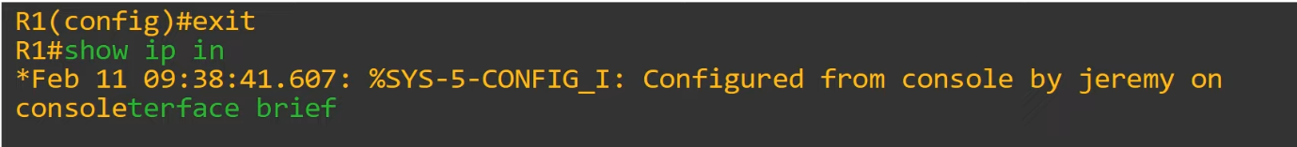

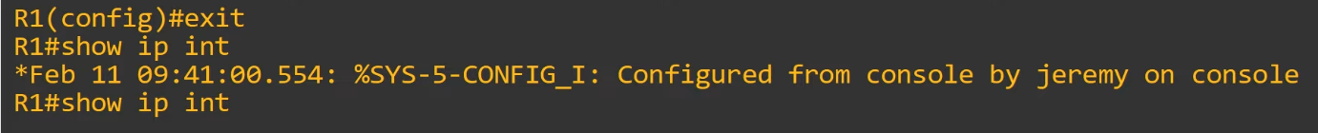

**"service timestamp" / "service sequence-numbers"**

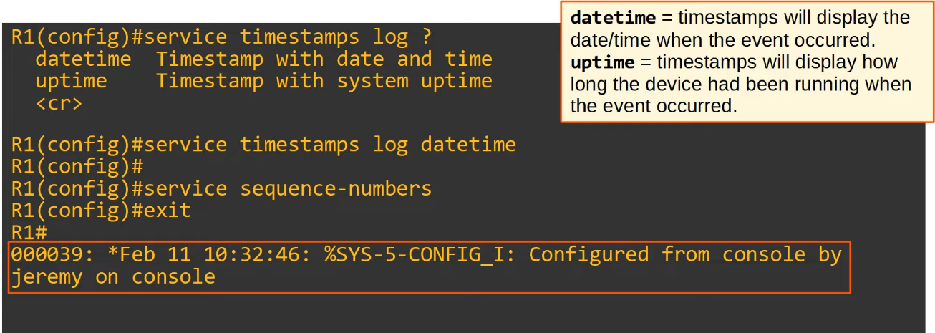

**Summary**

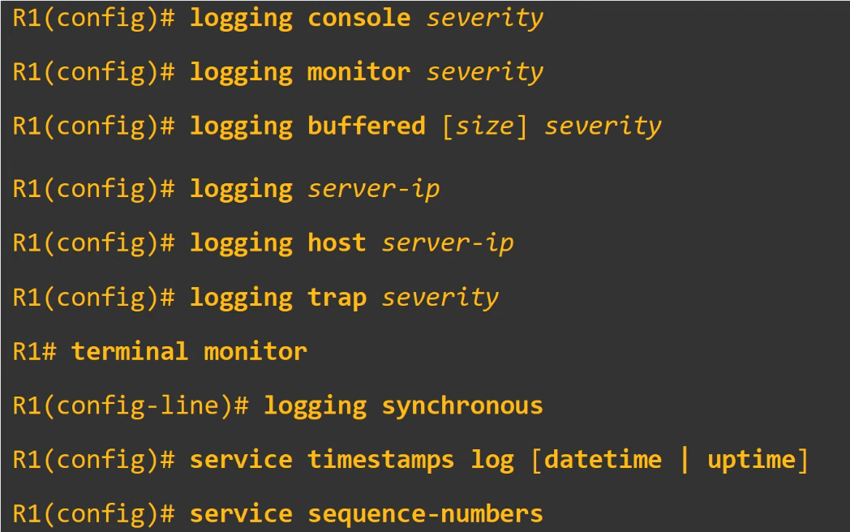

**Syslog vs SNMP**

* Syslog and SNMP are both used for monitoring and troubleshooting of devices
  + They are complementary, but their functions are different
* Syslog is used for message logging
  + Events that occurred within the system are categorized based on facility/severity and logged
  + Used for system management, analysis, and troubleshooting
  + Messages are sent from the device to the server
    - Servers can't actively pull info from the device (like SNMP Get) or modify variables (SNMP Set)
* SNMP is used to retrieve and organize information about the SNMP managed devices
  + IP addresses, current interface, temperature, CPU usage, etc
  + SNMP servers can use Get to query the clients and Set to modify variables on the clients

# SSH & Telnet

Things covered

* Console port security
* Layer 2 switch management IP
* Telnet
* SSH (Secure Shell)

Console Port Security

Login

* By default, no password needed to access the CLI of a Cisco IOS device via the console port
* Can configure a password on the console line
  + A user will have to enter a password to access the CLI via the console port

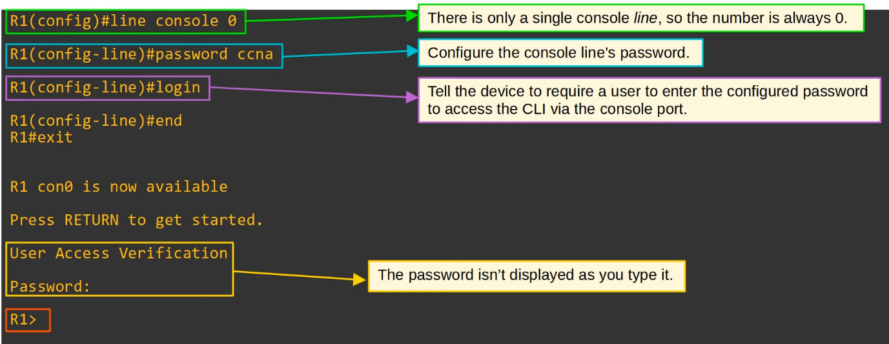

* Single console line: only 1 person can connect to the console at a time

Login Local

* Alternatively, you can configure the console line to require users to login using one of the configured usernames on the device

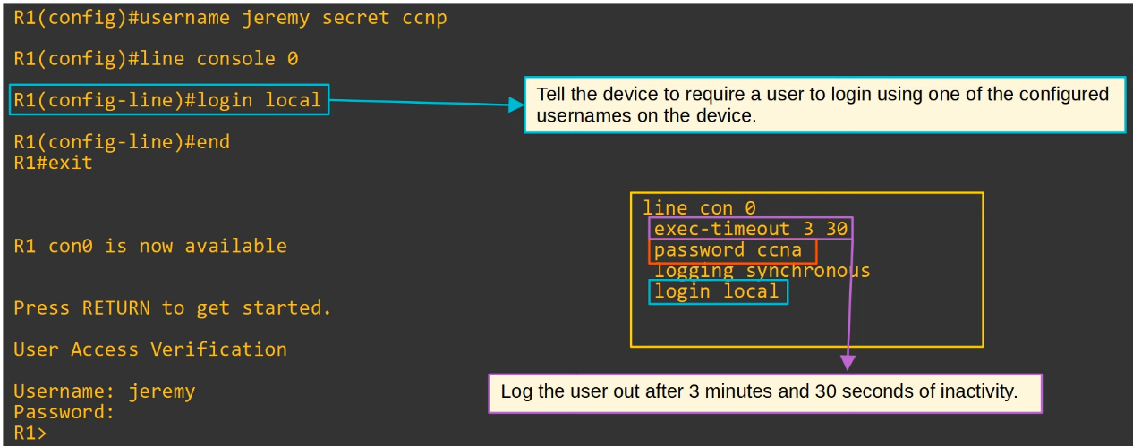

* In the running-config, there is "password ccna", but it won't be used since "login local" activated
  + It will use the password configured for the login local

Layer 2 Switch - Management IP

* Layer 2 switches don't perform packet routing and don't build a routing table
  + They are not IP routing aware
* However, can assign an IP address to an SVI to allow remote connections to the CLI of the switch
  + E.g. using Telnet or SSH

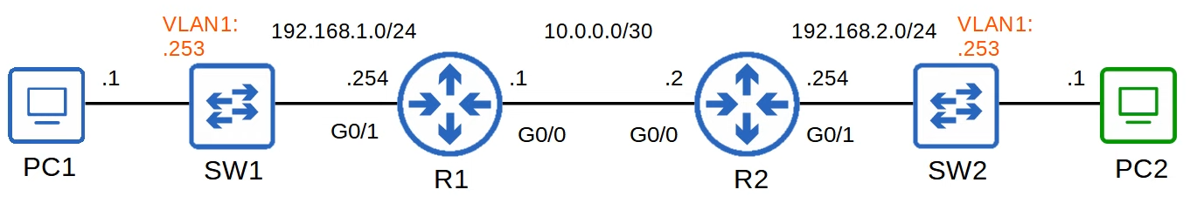

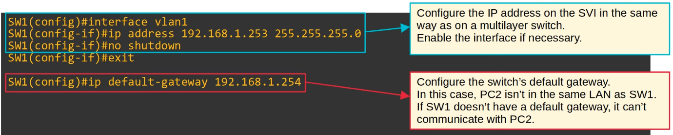

Telnet (Teletype Network)

* Protocol used to remotely access the CLI of a remote host
* Developed in 1969
* Has been largely replaced by SSH, which is more secure
* Sends data in plain text, no encryption

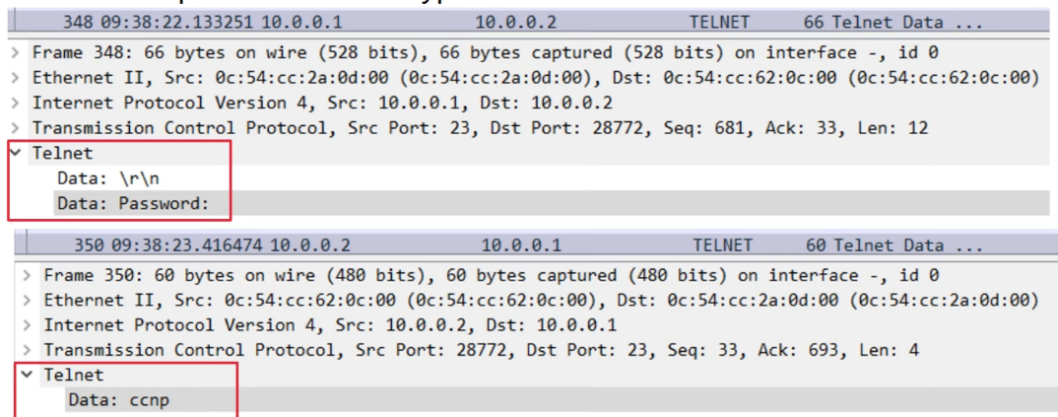

* Telnet server (the device being connected to) listens for Telnet traffic on TCP port 23

Telnet config



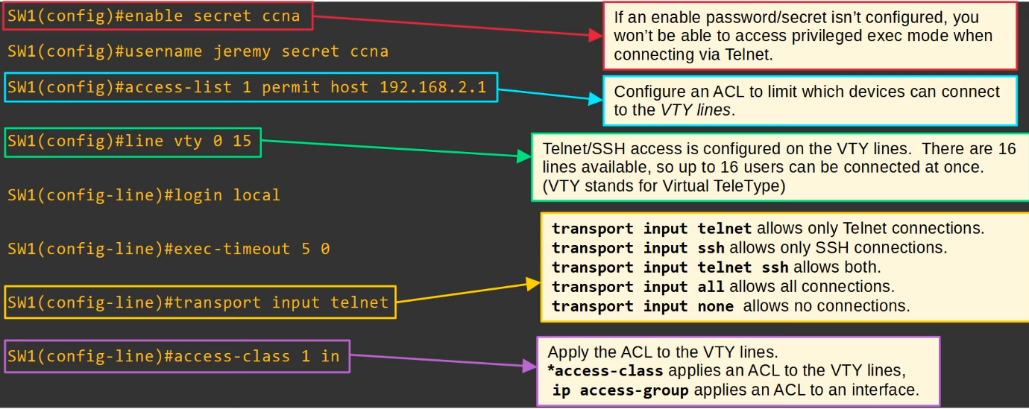

* "line vty 0 15"
  + Means all 16 lines can be used
* SW1(config-line)# access-class 1 in
  + The ACL is only applied for the VTY line
  + Other network devices can still be connected to the switch and won't be blocked as that have to modified on the interface ACL

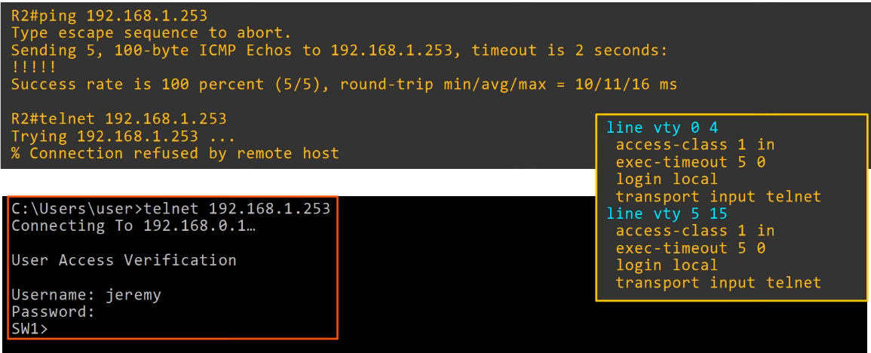

* Older versions only had 5 VTY lines, so that is why they are separated in the running-config

SSH (Secure Shell)

* Developed in 1995 to replace less secure protocols like Telnet
* Shell
  + A computer program which exposes an operating system's services to a human or other program
* SSHv2, a major revision of SSHv1, released in 2006
* If a device supports both versions, said to run 'version 1.99'
* Provides security features such as data encryption and authentication

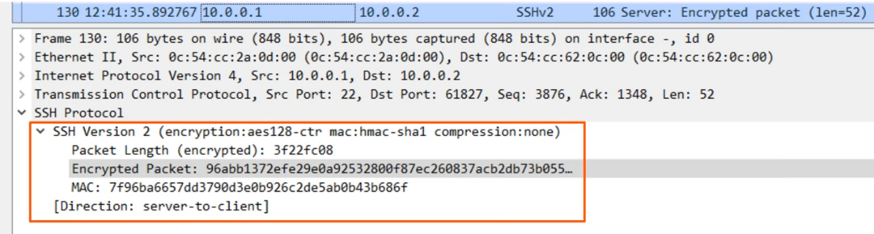

* The SSH server (the device being connected to) listens for SSH traffic on port 22

SSH Config

Check SSH Support

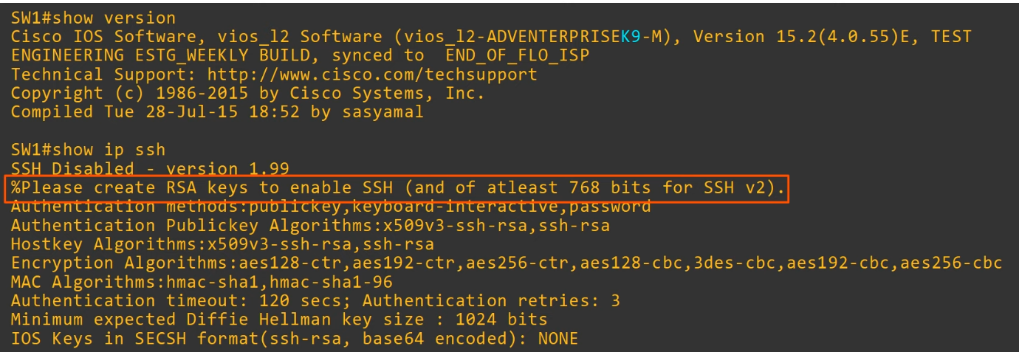

* IOS images that support SSH will have 'K9' in their name
* Cisco exports NPE (No Payload Encryption) IOS images to countries that have restrictions on encryption technologies
* NPE IOS images do not support cryptographies features such as SSH

RSA Keys

* To enable and use SSH, you must generate an RSA public and private key pair
* The keys are used for data encryption/decryption, authentication, etc

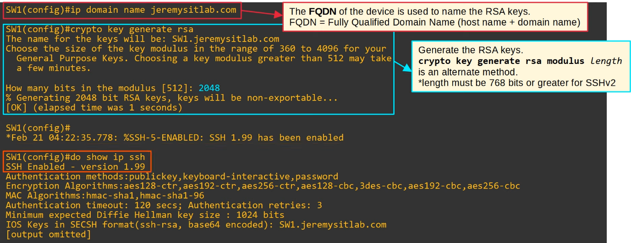

VTY Lines



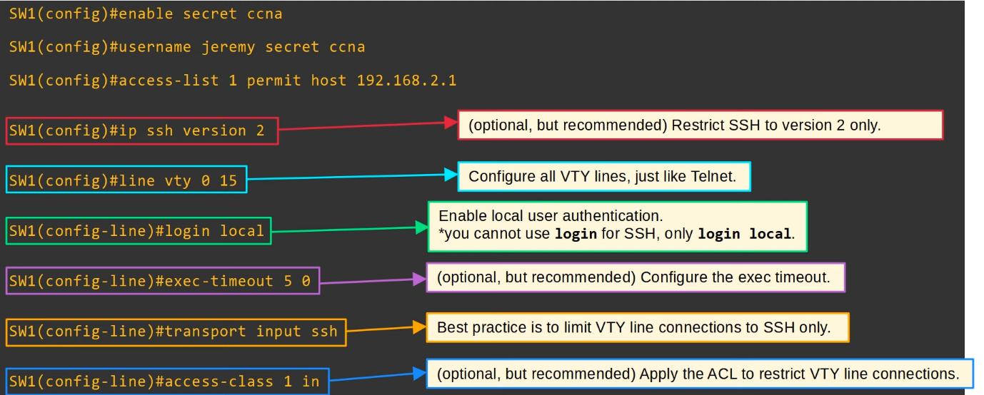

SSH Config Steps

1. Configure host name
2. Configure a DNS domain name
3. Generate RSA key pair
4. Configure enable PW, username/PW
5. Enable SSHv2 (only)
6. Configure VTY lines

* To connect from PC
  + "**ssh -l** *username ip-address*" OR
  + "**ssh** *username***@***ip-address*"

Summary

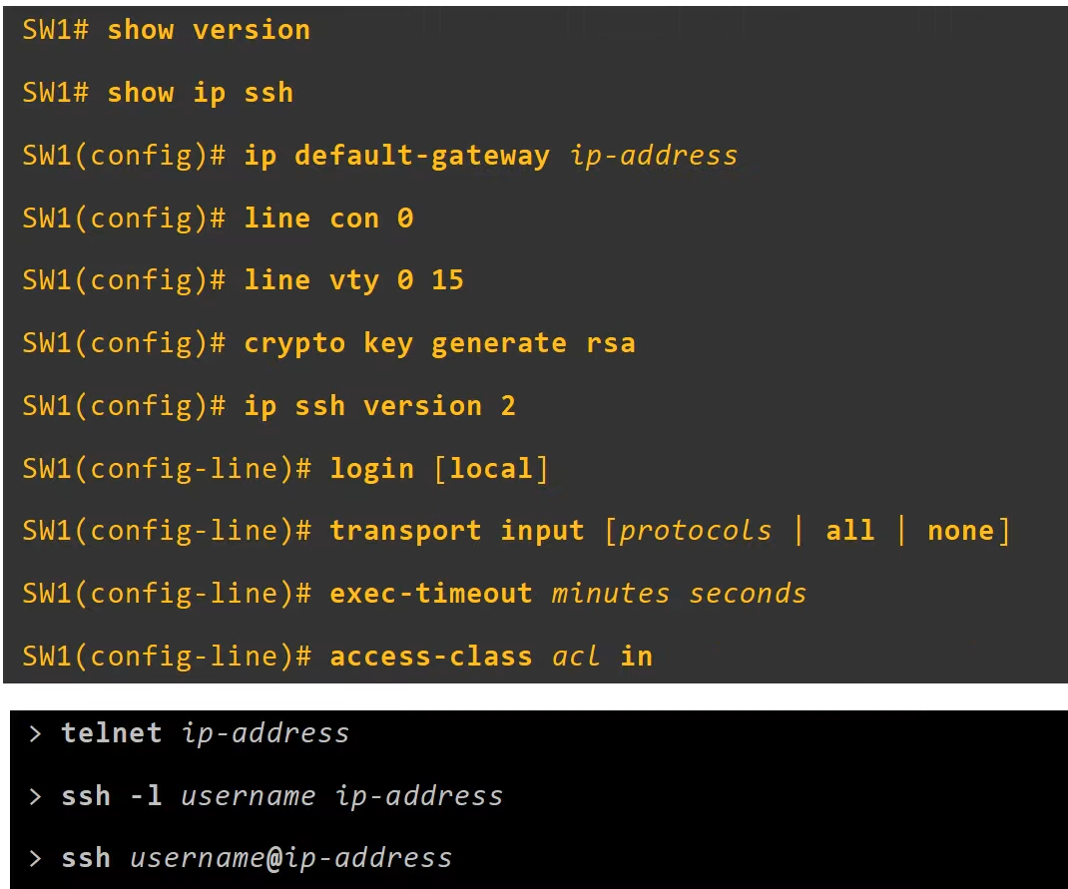

# FTP/TFTP

Things covered

* Purpose of FTP/TFTP
* FTP/TFTP functions and differences
* IOS file system
* Using FTP/TFTP in IOS

FTP & TFTP

* File Transfer Protocol (FTP)
* Trivial FTP (TFTP)
* Industry standard protocols used to transfer files over the network
* They both use a client-server model
  + Clients can use FTP/TFTP to copy files to/from a server
* As a network engineer, the most common use for FTP/TFTP is in the process of upgrading the OS of a network device
* Can use FTP/TFTP to download newer version of IOS from a server, and then reboot the device with a the new IOS image

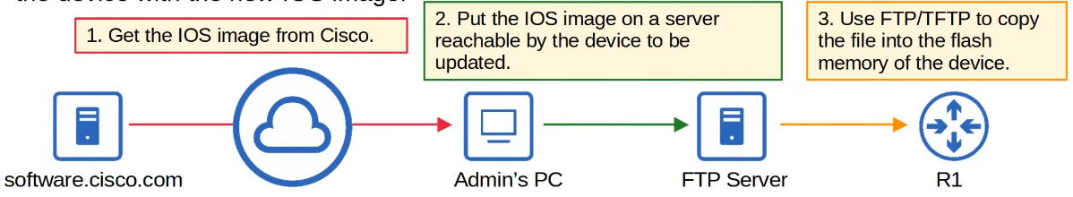

TFTP

* First standardized in 1981
* Named 'trivial' because it is simple and has only basic features compared to FTP
  + Only allows a client to copy a file to or from a server
* Was released after FTP, but not a replacement for FTP
  + It is another tool to use when lightweight simplicity is more important than functionality
* No authentication (username/PW), so servers will respond to all TFTP requests
* No encryption, so all data is sent in plain text
* Best used in a controlled environment to transfer small files quickly
* TFTP servers listen on UDP port 69
* UDP is connectionless and doesn't provide reliability with retransmissions
* However, TFTP has similar built-in features within the protocol itself

TFTP Reliability

* Every TFTP data message is acknowledged
  + If client is transferring a file to server, the server will send ACK messages
  + If server is transferring a file to client, the client will send ACK messages
* Timers are used, and if an expected message isn't received in time, the waiting device will re-send its previous message

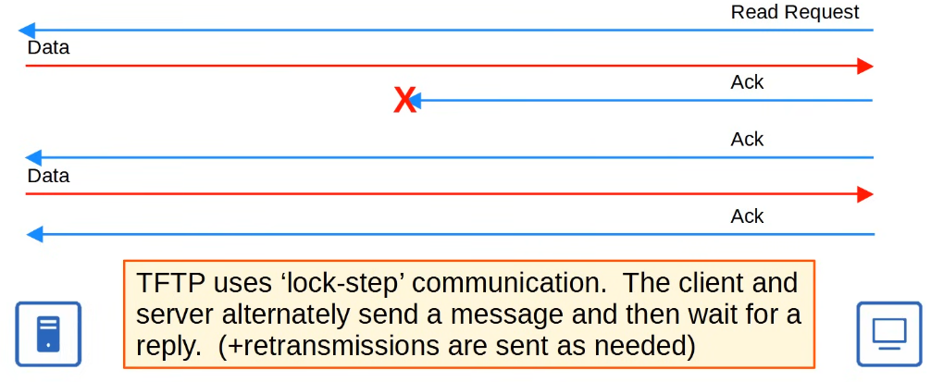

* Will never send more than 1 message in a row except in retransmission

TFTP 'Connections'

* TFTP file transfers have 3 phases
  1. Connection
     + TFTP client sends a request to the server, and the server responds back, initializing the connection
  2. Data transfer
     + The client and server exchange TFTP messages
     + One sends data and the other sends acknowledgements
  3. Connection Termination
     + After the last data message has been sent, a final acknowledgement is sent to terminate the connection

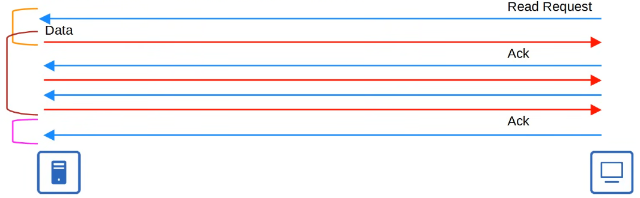

TFTP TID (not in CCNA)

* When the client sends the first message to the server, the destination port is UDP 69 and the source port is a random ephemeral port
* This random port is called a 'Transfer Identifier' (TID) and it identifies the data transfer
* The server then also selects a random TID to use as the source port when it replies, not 69
* When the client sends the next message, the destination port will be the server's TID, not 69

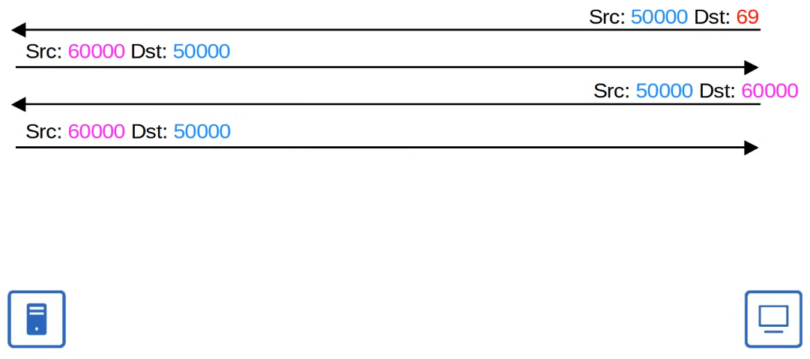

FTP

* First standardized in 1971
* Uses TCP ports 20 and 21
* Usernames and passwords are used for authentication, however, no encryption
* For greater security, FTPS (FTP over SSL/TLS) can be used
  + Upgrade to FTP
* SSH File Transfer Protocol (SFTP) can also be used for greater security
  + New protocol
* FTP is more complex than TFTP and allows not only file transfers, but clients can also navigate file directories, add and remove directories, list files, etc
* The client sends FTP commands to the server to perform these functions

FTP Control Connections

* FTP uses 2 types of connections
  + An **FTP control connection** (TCP 21) is established and used to send FTP commands and replies
  + When files or data are to be transferred, separate **FTP data connections** (TCP 20) are established and terminated as needed

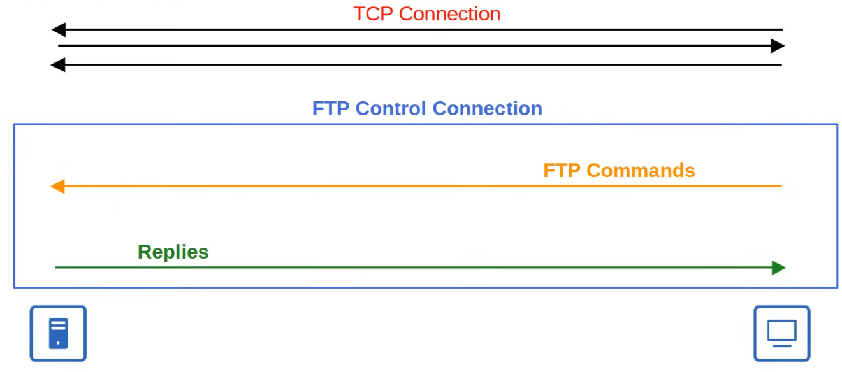

Active Mode FTP Data Connections

* The default method of establishing FTP data connections is active mode, in which the server initiates the TCP connection

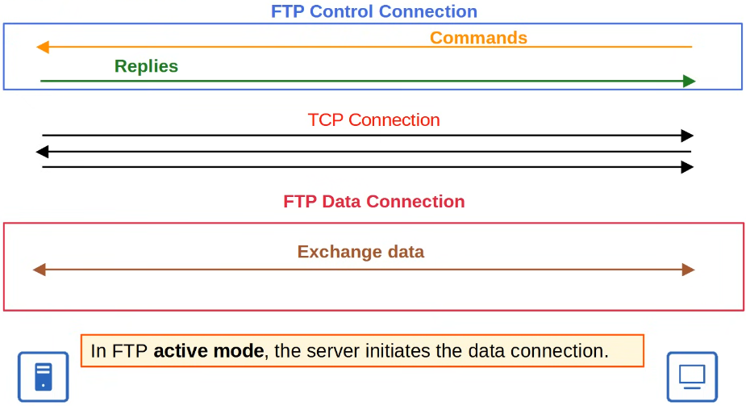

* The Control Connection is not terminated and active throughout, so there are 2 active connections

Passive Mode FTP Data Connections

* In FTP passive mode, the client initiates the data connection
* Often necessary when the client is behind a firewall, which could block the incoming connection from the server
* Firewalls usually don't allow 'outside' devices to initiate connections

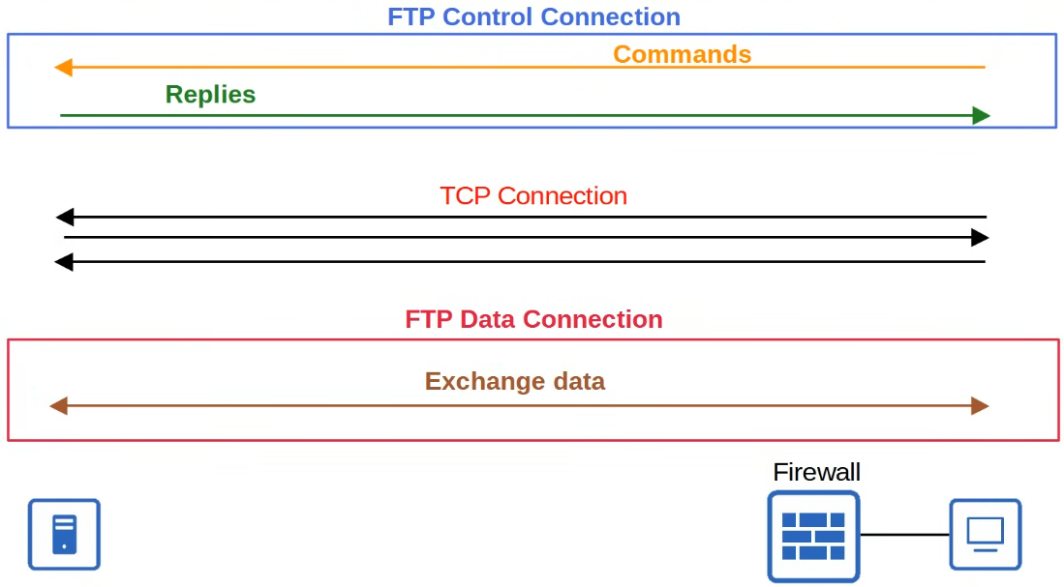

FTP vs TFTP

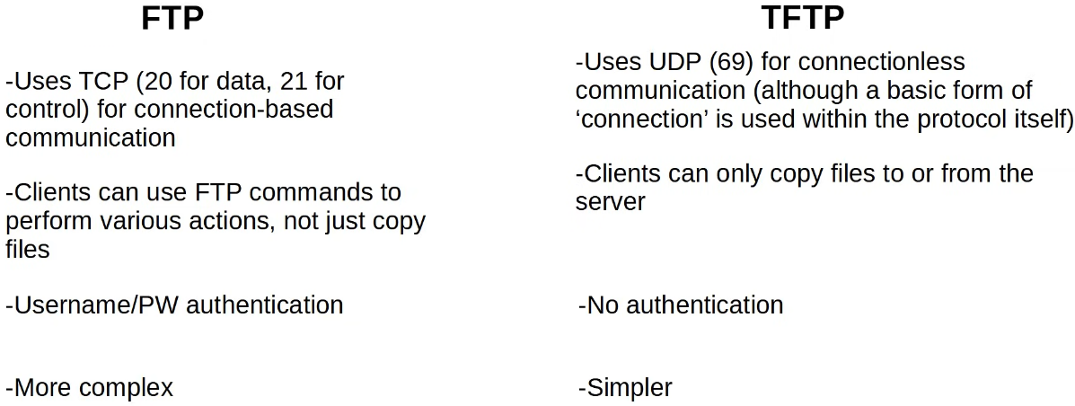

IOS File Systems

* A file system is a way of controlling how data is stored and retrieved
* Can view the file system of a Cisco IOS device with "show file systems"

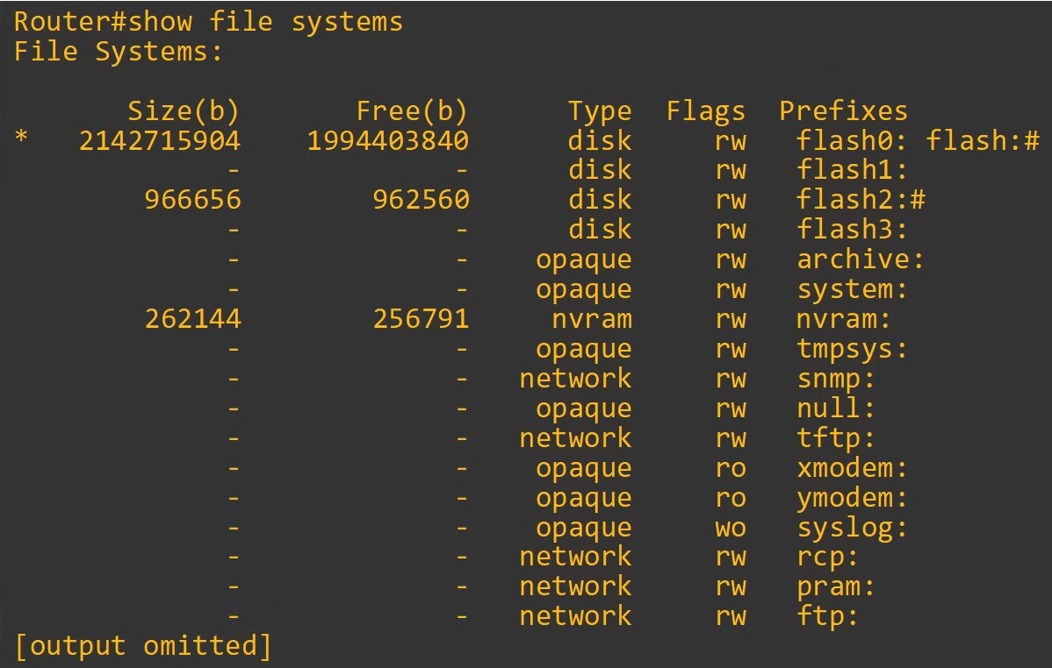



Upgrading Cisco IOS

* Can view the current version of IOS with "**show version**"

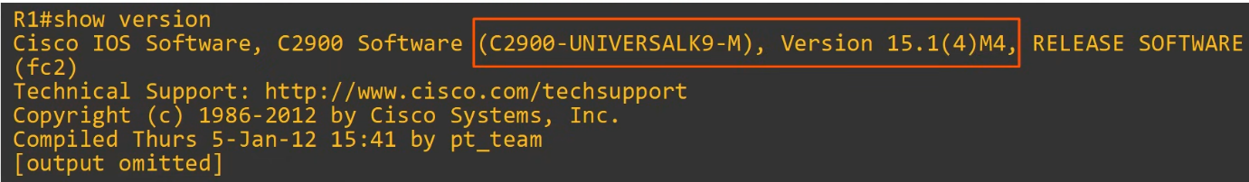

* Can view the contents of flash with "**show flash**"

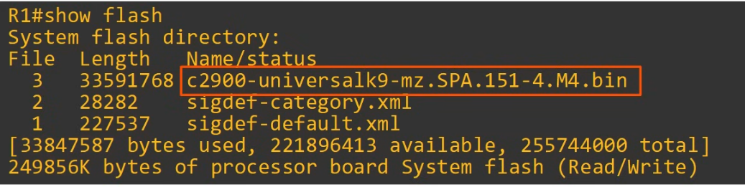

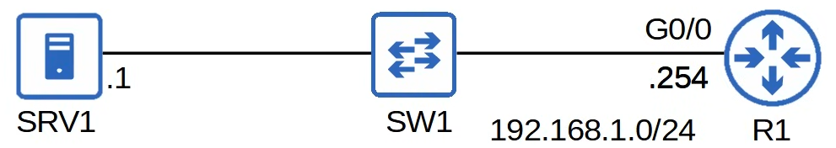

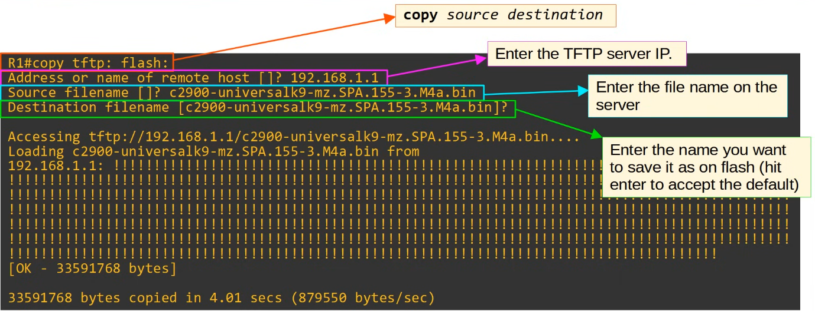

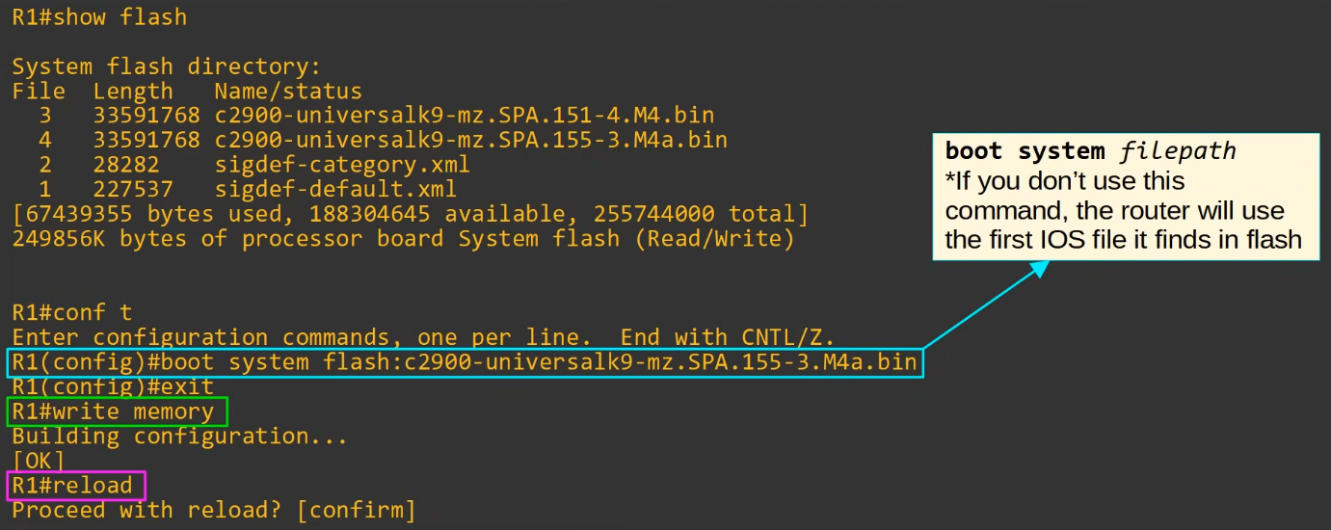

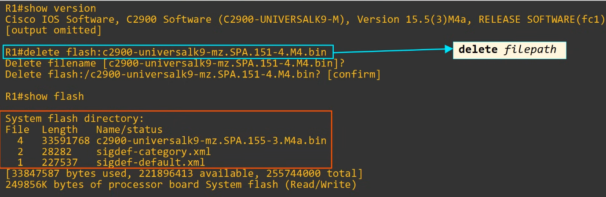

Copying Files (FTP)



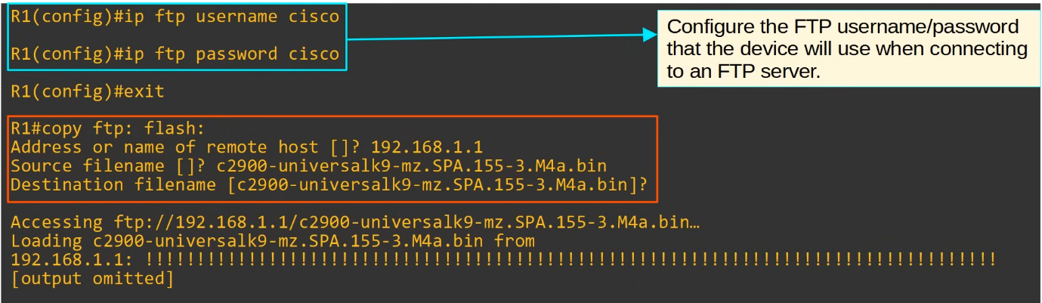

Summary

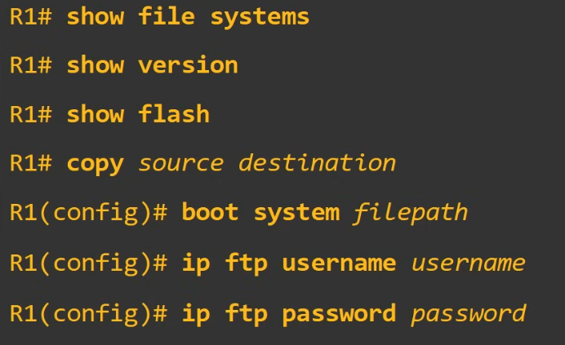

# Network Address Translation (NAT)

## Static NAT

Things covered

* Private IPv4 addresses
* Intro to NAT
* Static NAT
* Static Nat config

**Private IPv4 Addresses**

* IPv4 doesn't provide enough addresses for all devices that need an IP address in the modern world
* Long term solution is to switch to IPv6
* There are 3 main short term solutions
  + CIDR
  + Private IPv4 addresses
  + NAT
* RFC 1918 specifies the following IPv4 address range as private:
  + 10.0.0.0/8 (10.0.0.0 - 10.255.255.255) -> Class A
  + 172.16.0.0/12 (172.16.0.0 - 172.31.255.255) -> Class B
  + 192.168.0.0/16 (192.168.0.0 - 192.168.255.255) -> Class C
* You are free to use these addresses in your networks
  + They don't have to be globally unique
  + However, they cannot be used over the Internet

**NAT (Network Address Translation)**

* Used to modify the source and/or destination IP addresses of packets
* There are various reasons to use NAT, but the most common reason is to allow hosts with private IP addresses to communicate with other hosts over the Internet
* Many types of NATs, but for CCNA, need to understand source NAT and how to configure it on Cisco routers

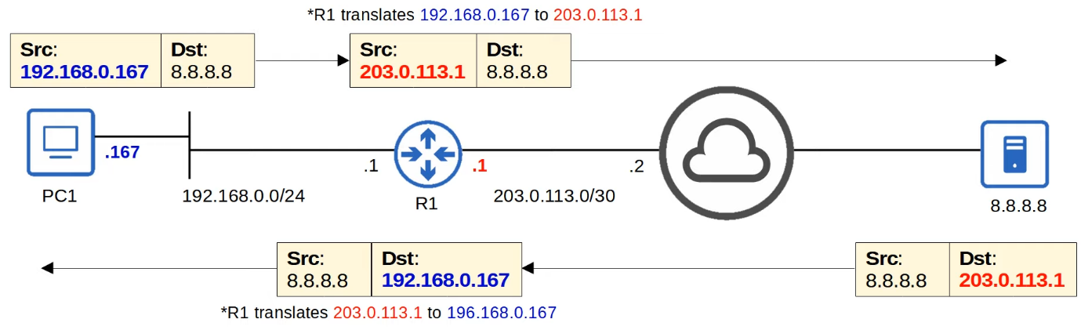

**Static NAT**

* Involves statically configuring 1-to-1 mappings of private IP addresses to public IP addresses
* An inside local IP address is mapped to an inside global IP address
  + Inside local
    - The IP address of the inside host, from the perspective of the local network
    - The IP address actually configured on the inside host, usually a private address
  + Inside global
    - The IP address of the inside host, from the perspective of the outside network
    - The IP address of the inside host after NAT, usually a public address

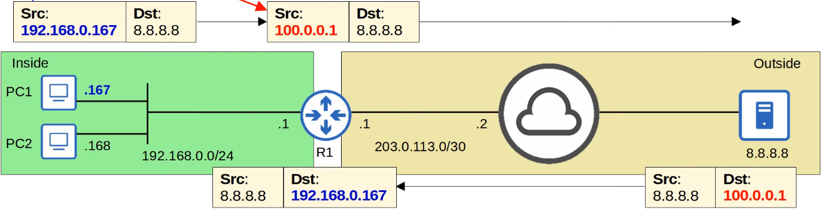

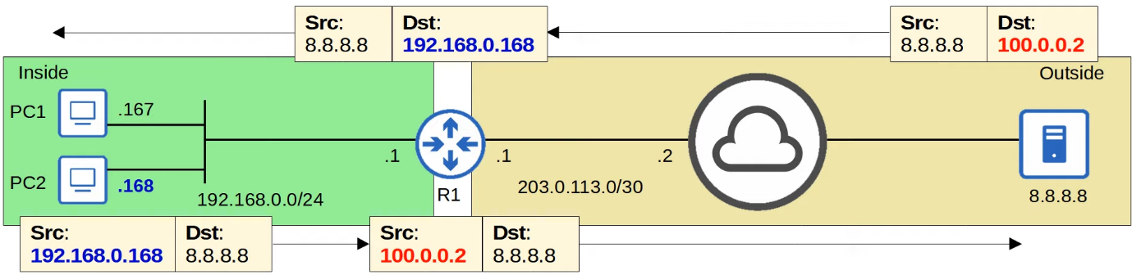

* PC1 and PC2 will have different public address
* Static NAT allows devices with private IP addresses to communicate over the Internet, however, because it requires 1-to-1 mapping, it doesn't help preserve IP addresses

**Static NAT Config**

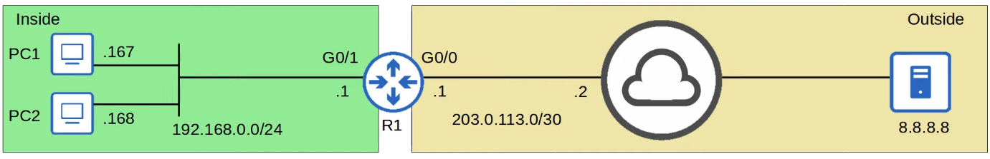

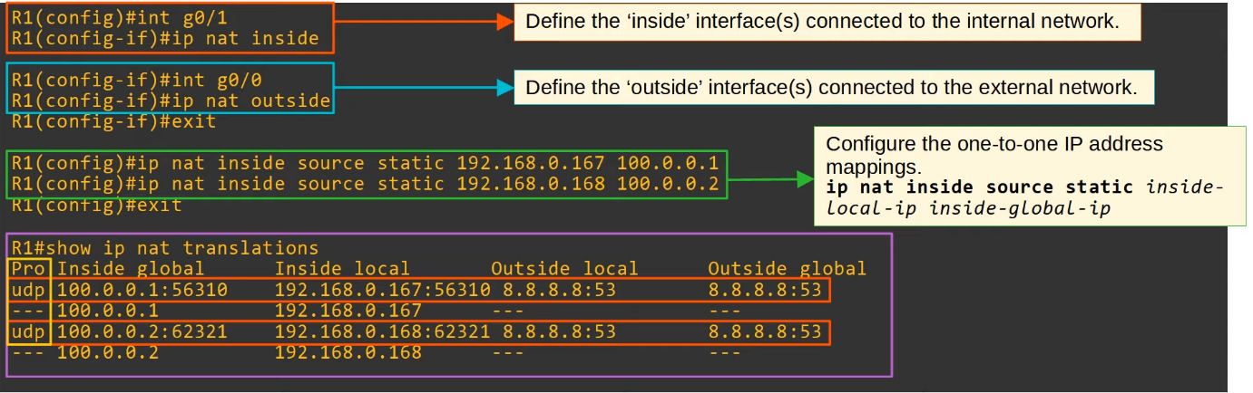

* In the "show ip nat translations"
  + There are the static entries and dynamic entries that occur when there is message sent or received
* In the IP address, the additional number is the port number
* Outside local
  + The IP address of the outside host, from the perspective of the local network
* Outside global
  + The IP address of the outside host, from the perspective of the outside network
* Unless 'destination NAT' is used, these 2 addresses will be the same
* Inside/Outside = Location of host
* Local/Global = Perspective

**"clear ip nat translation *"**

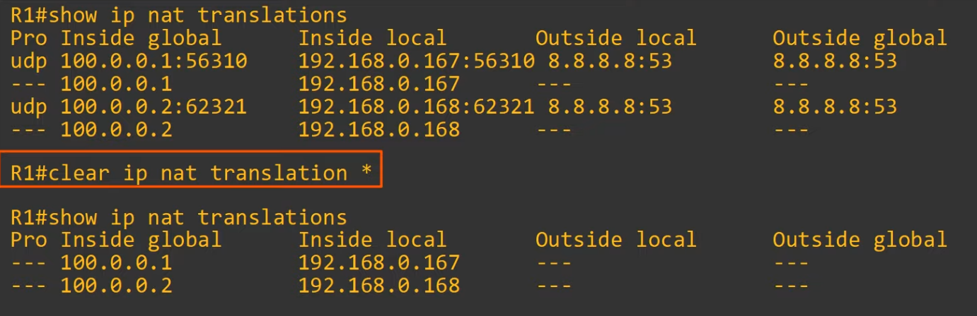

**"show ip nat statistics"**

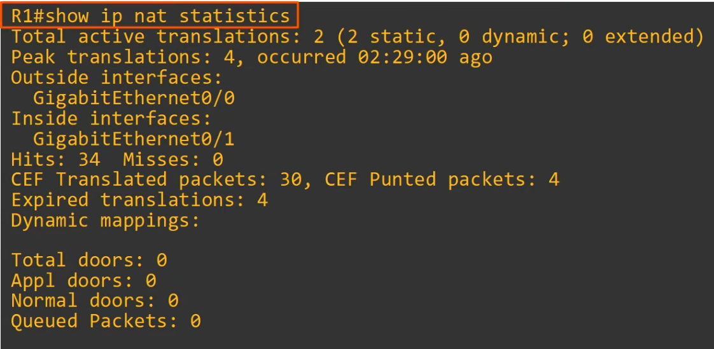

* Peak translations
  + Most number of entries in the NAT translation table

**Review**

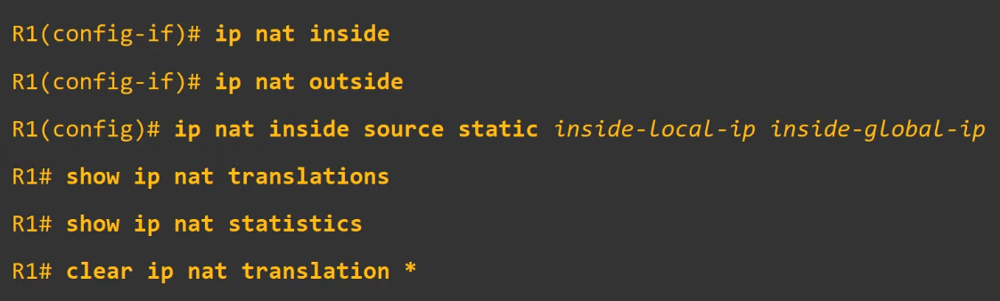

## Dynamic NAT / PAT

Things covered

* More about static NAT
* Dynamic NAT
* Dynamic PAT

**Static NAT**

* Involves statically configuring 1-to-1 mappings of private IP address to public IP addresses
* When traffic from the internal host is sent to the outside network, the router will translate the source address
* This 1-to-1 mapping also allows external hosts to access the internal host via the inside global address

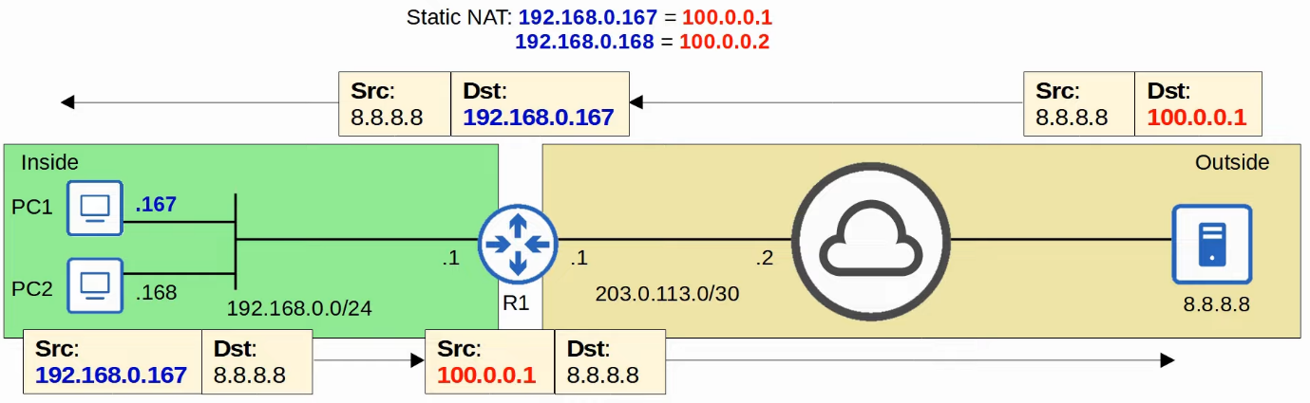

**Dynamic NAT**

* The router dynamically maps inside local addresses to inside global addresses as needed
* An ACL is used to identify which traffic should be translated
  + If the source IP is permitted by the ACL, the source IP will be translated
  + If not permitted, source IP will not be translated (traffic will NOT be dropped)
* A NAT pool is used to define the available inside global addresses

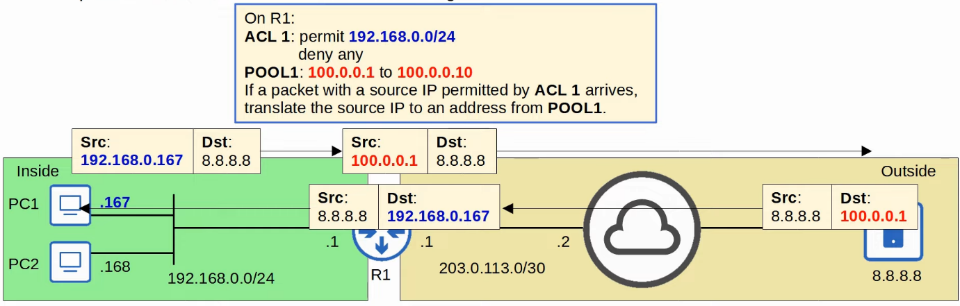

* If there are not enough inside global IP addresses available (all are being used), it is called 'NAT pool exhaustion'
  + If a packet from inside host arrives and need a NAT but there are no available addresses, the router will drop the packet
  + The host will be unable to access outside networks until one of the inside global IP addresses becomes available
  + Dynamic NAT entries will time out automatically if not used, or you can clear them manually

**NAT Pool Exhaustion**

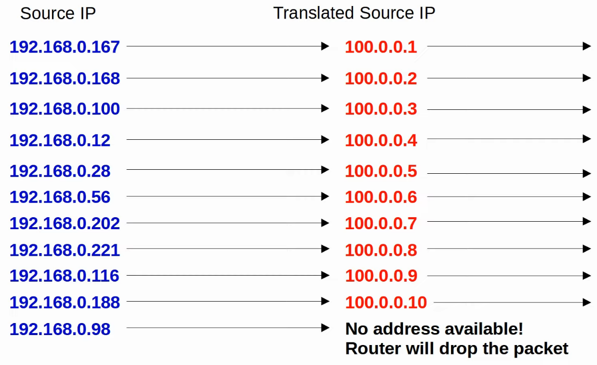

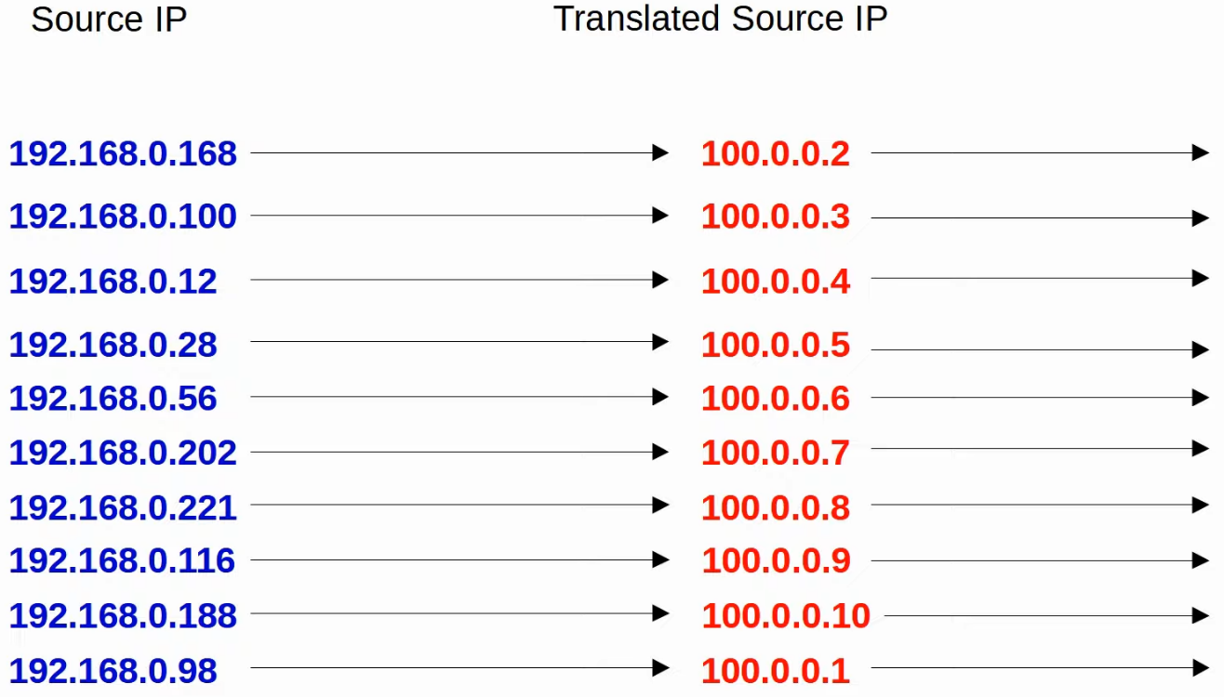

**Dynamic NAT Config**

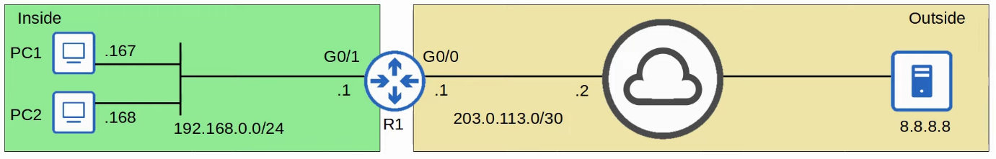

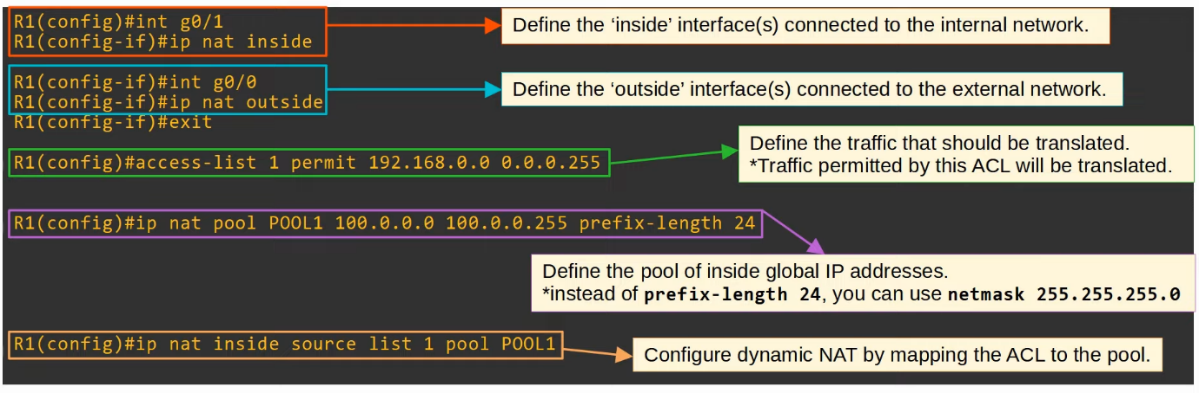

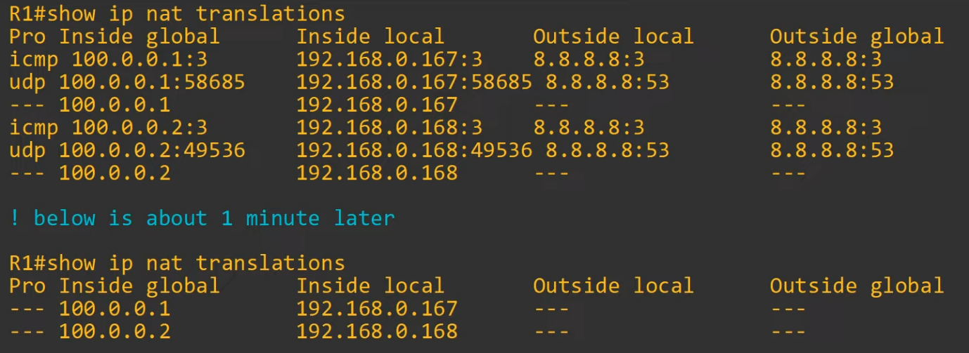

* The dynamic addresses will time out after 24 hours
  + Timers can be changes
* The dynamic addresses will also be cleared if command 'clear ip nat translation *" since they are dynamic and not static

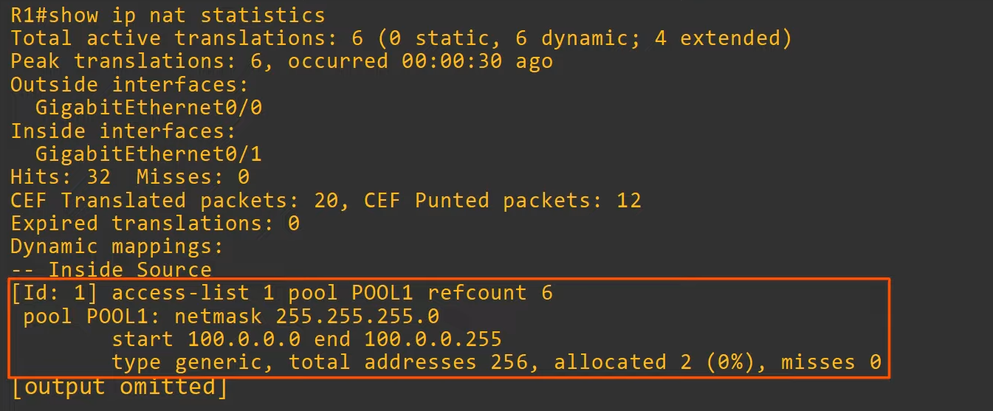

**PAT (Port Address Translation)**

* PAT, also known as NAT overload, translates both the IP address and port number (if necessary)
* By using a unique port number for each communication flow, a single public IP address can be used by many different internal hosts (port number are 16 bits = over 65,000 available port numbers)
* The router will keep track of which inside local address is using which inside global address and port
* Because many inside hosts can share a single public IP, PAT is very useful for preserving public IP addresses, and it is used in networks all over the world

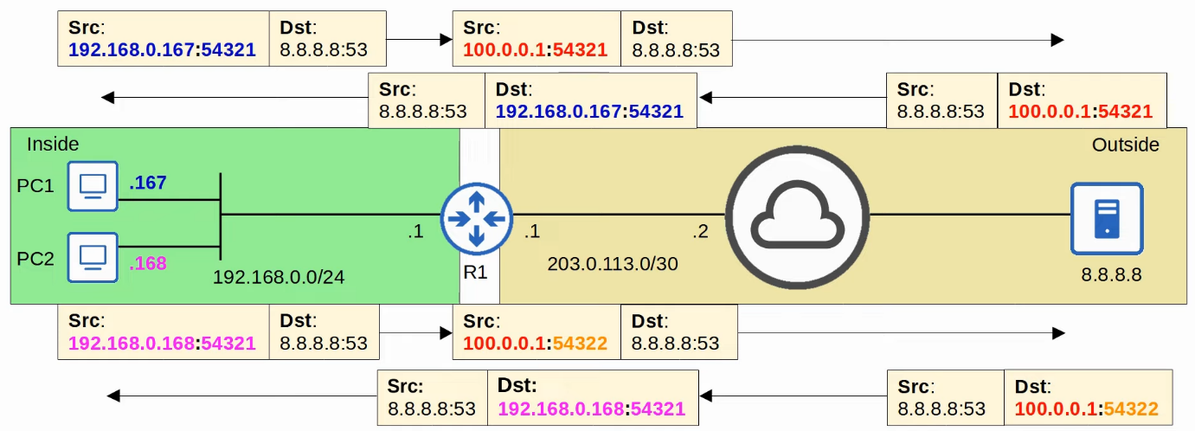

* Router will use a new port number only if the port numbers selected by the end hosts (PCs) are the same, else there is no need

**PAT Config**

**Pool**



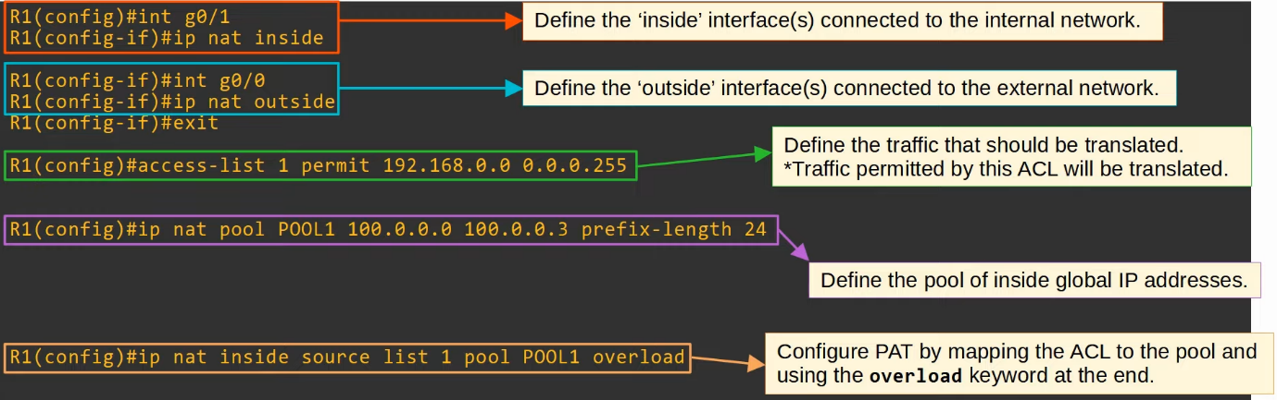

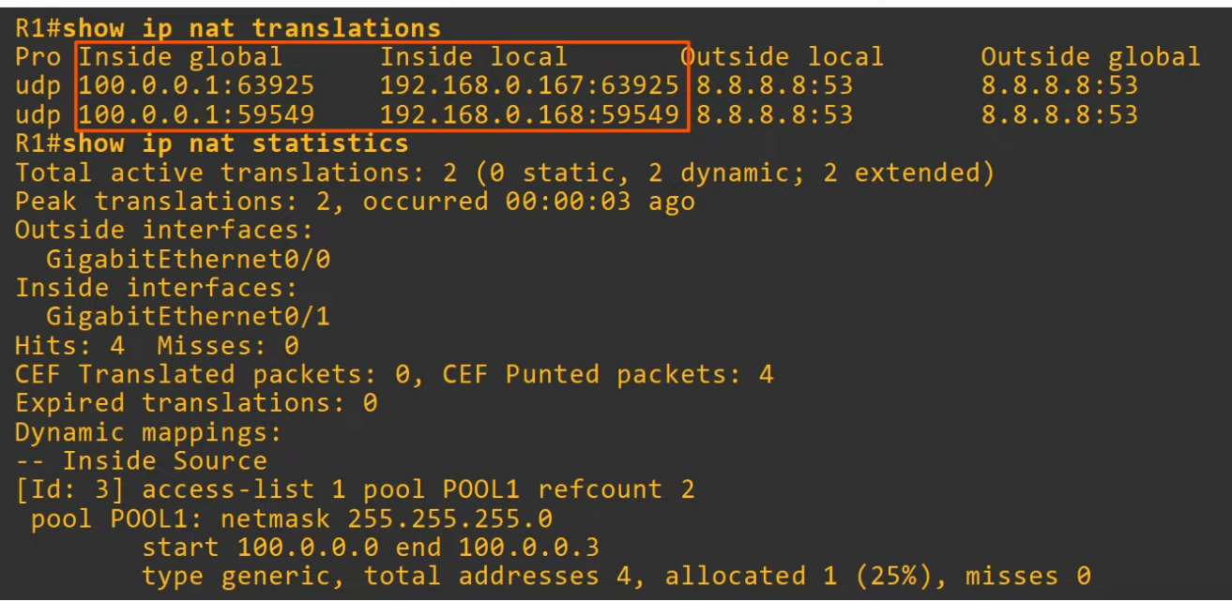

**Interface**

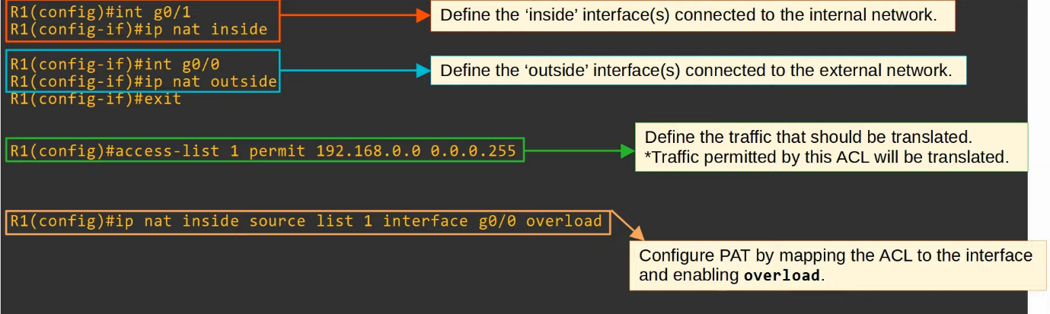

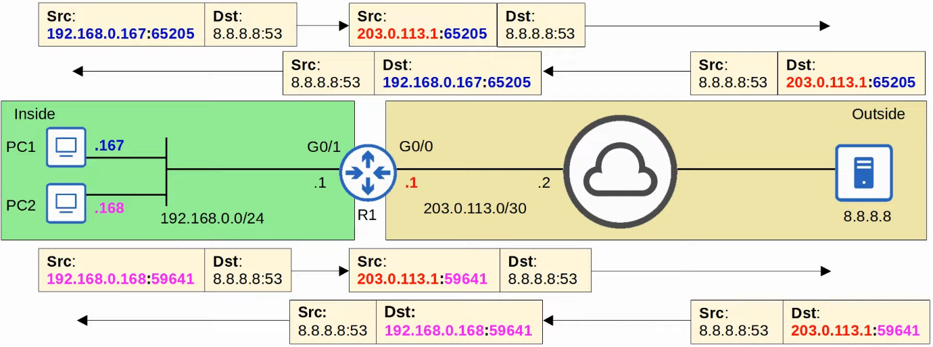

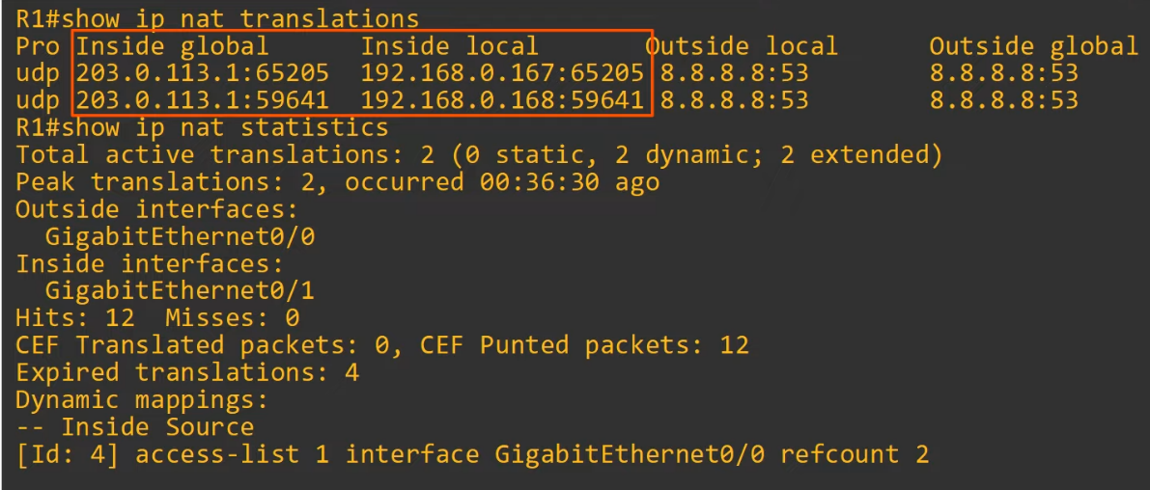

Command Review

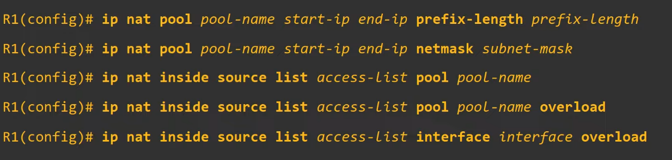

# Quality of Service (QoS)

## Intro to QoS

Things covered

* IP Phones/ Voice VLANs
* Power over Ethernet (PoE)
* Intro to Quality of Service (QoS)

**IP Phones**

* Traditional phones operate over the public switched telephone network (PSTN)
* Sometimes, this is called POTS (Plain Old Telephone Service)
* IP phones use VoIP (Voice over IP) technologies to enable phone calls over an IP network, such as Internet
* IP phones are connected to a switch just like any other end host
* IP phones have an internal 3-port switch
  + 1 is the 'uplink' to the external switch
  + 1 is the 'downlink' to the PC
  + 1 connects internally to the phone itself
* This allows the PC and IP phone to share a single switch port
  + Traffic from the PC passes through the IP phone to the switch
* It is recommended to separate 'voice' traffic (from the IP phone) and 'data' traffic (from the PC) by placing them in separate VLANs
  + This can be accomplished using a voice VLAN
  + Traffic from the PC will be untagged, but traffic from the phone will be tagged with a VLAN ID

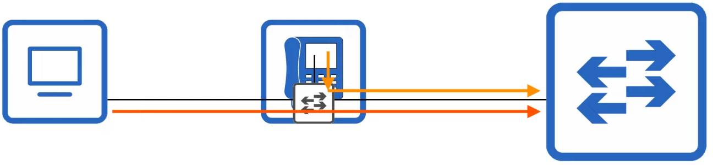

**Voice VLAN**

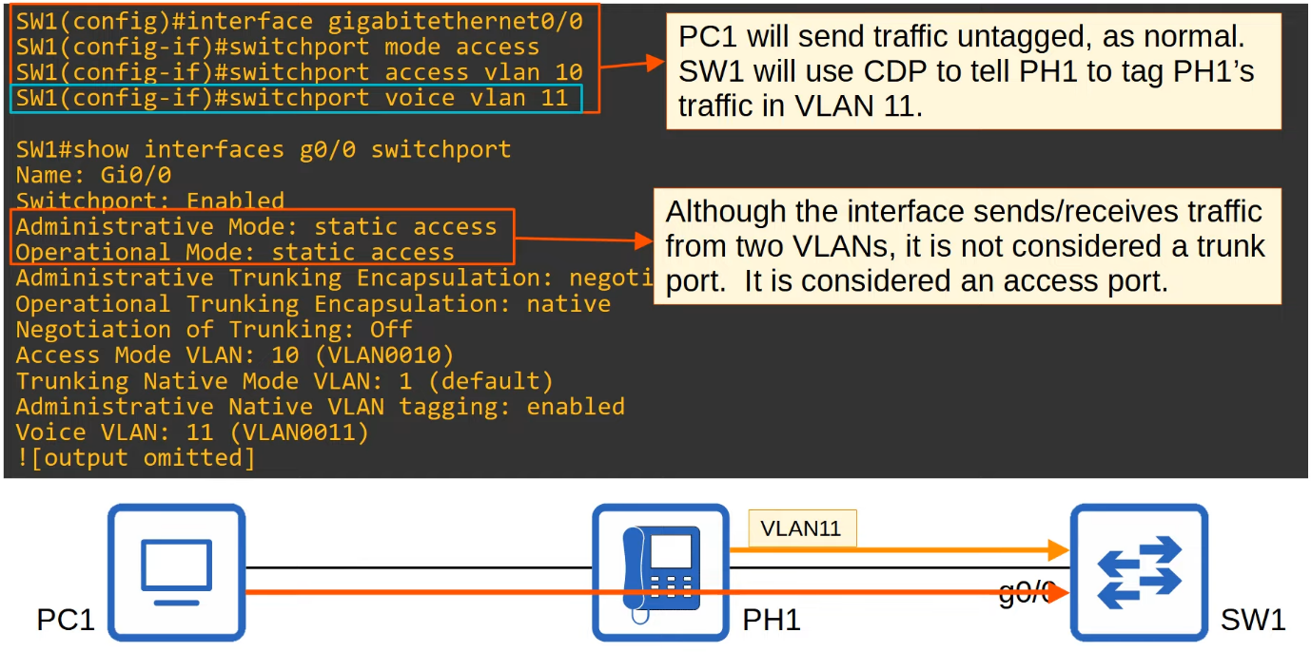

* SW1 G0/0 is still considered an access port and not a trunk port
* Access port also known as untagged ports

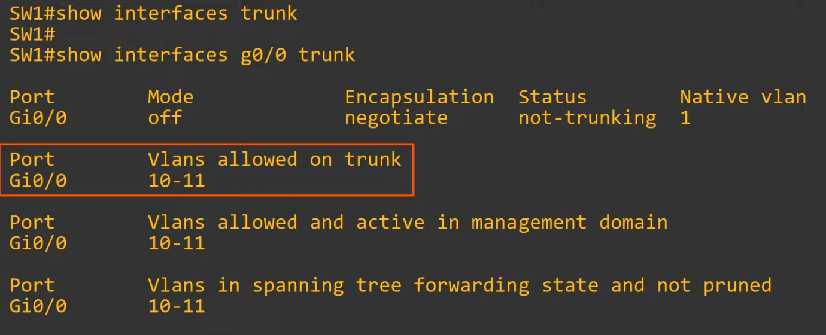

**PoE (Power over Ethernet)**

* PoE allows Power Sourcing Equipment (PSE) to provide power to Powered Devices (PD) over an Ethernet cable
* Typically, the PSE is a switch and the PDs are IP phones, IP cameras, wireless access points, etc
* The PSE receives AC power from the outlet, converts it to DC power, and supplies that DC power to the PDs
* The same cable is used to provide power and data transfer

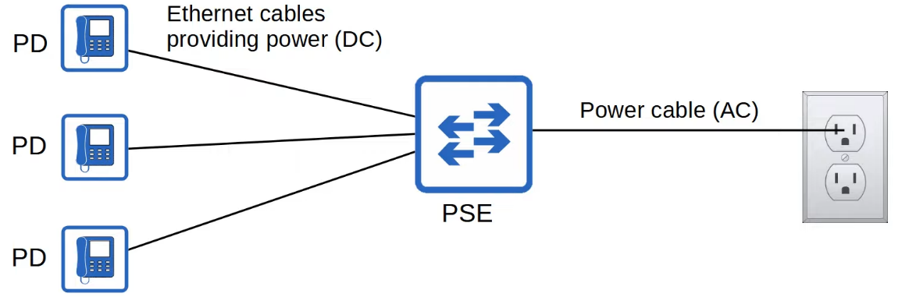

* Too much electrical current can damage electrical devices
* PoE has a process to determine if a connected device needs power, and how much power it needs
  + When a device is connected to PoE-enabled port, the PSE sends low power signals, monitors the response, and determine how much power the PD needs
  + If the device needs power, the PSE supplies the power to allow the PD to boot
  + The PSE continues to monitor the PD and supply the required amount of power (but not too much)
* Power policing can be configured to prevent a PD from taking too much power
  + "power inline police"
    - Configures power policing with default settings: disable the port and send a Syslog message if a PD draws too much power
    - Equivalent "power incline police action err-disable"
    - The interface will be put in err-disabled state and can be re-enabled with "shutdown" command followed by "no shutdown"
  + "power inline police action log"
    - Does not shutdown the interface if the PD draws too much power
    - It will restart the interface and send a Syslog message
    - Since restart, PD will lose power and also restart and they will renegotiate power settings

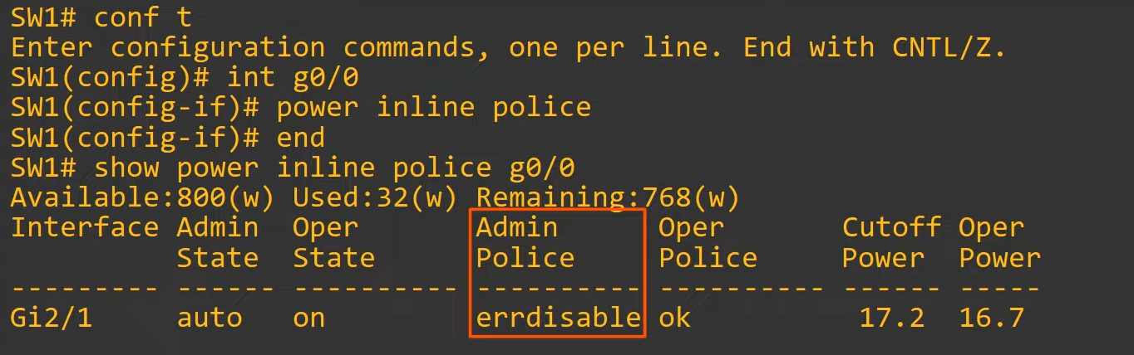

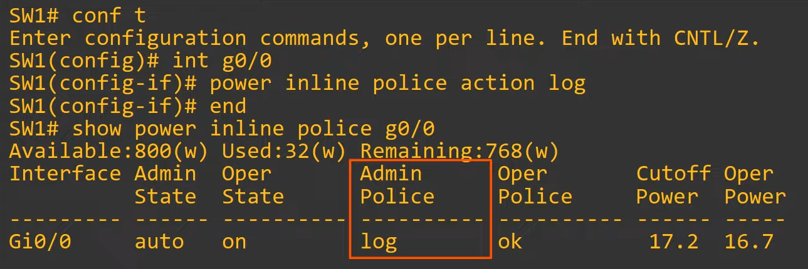

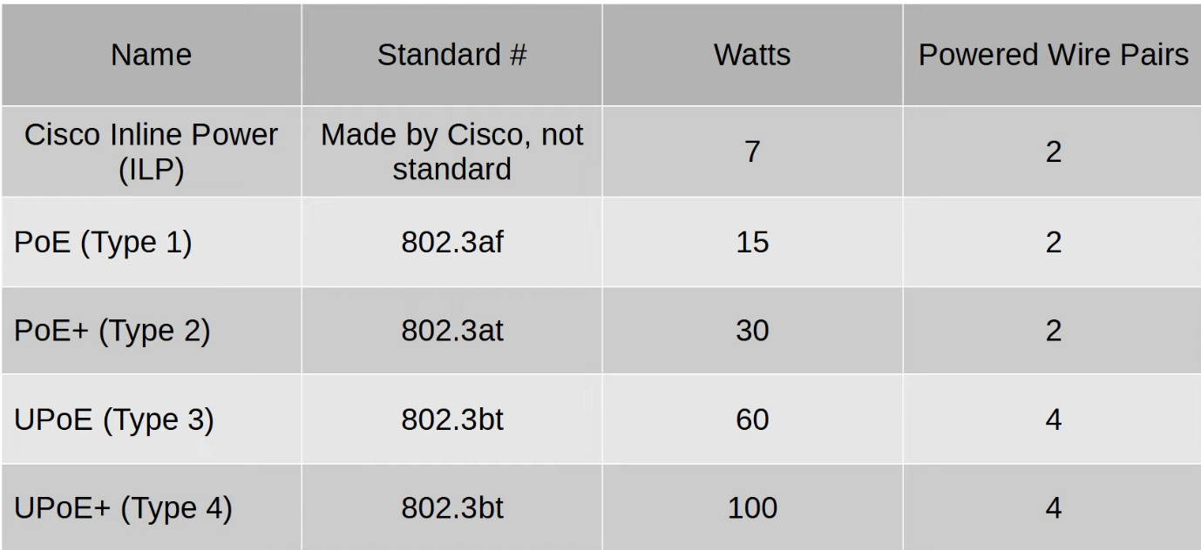

**QoS (Quality of Service)**

* Voice traffic and data traffic used to use entirely separate networks
  + Voice data used the PSTN
  + Data traffic used the IP network (enterprise WAN, Internet, etc)
* QoS wasn't necessary as the different kinds of traffic didn't compete for bandwidth

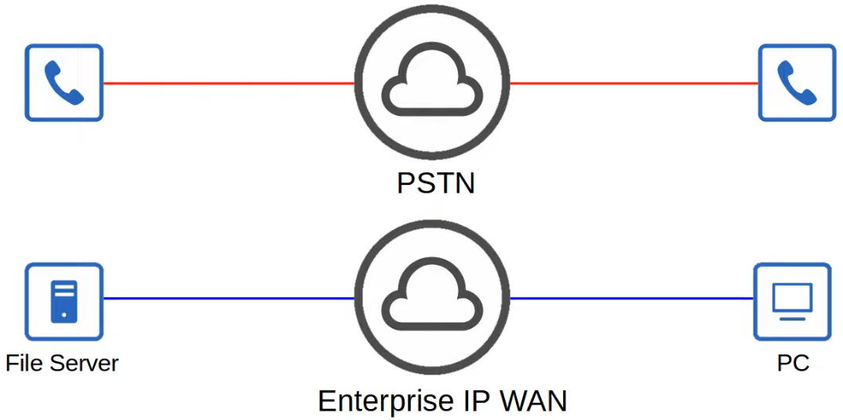

* Modern networks are typically converged networks in which IP phones, video traffic, regular data traffic, etc all share the same IP network
* This enable cost savings as well as more advanced features for voice and video traffic, for example integrations with collaboration software (Cisco WebEx, Microsoft Teams, etc)
* However, the different kinds of traffic now have to compete for bandwidth
* QoS is a set of tools used by network devices to apply different treatment to different packets

* QoS is used to manage the following characteristics of network traffic:
  1. Bandwidth
     + The overall capacity of the link, measured in bps
     + QoS tools allow you to reserve a certain amount of a link's bandwidth for specific kinds of traffic
     + For example, 20% voice traffic, 30% for specific kinds of traffic, and the remaining 50% for all other traffic
  2. Delay
     + The amount of time it takes traffic to go from source to destination: 1-way delay
     + The amount of time it takes traffic to go from source to destination and return: 2-way delay
  3. Jitter
     + The variation in 1-way delay btw packets sent by the same application
     + IP phones have a 'jitter buffer' to provide a fixed delay to audio packets
  4. Loss
     + The % of packets sent that do not reach their destination
     + Can be caused by faulty cables
     + Can also be caused when a device's packet queues get full and the device starts discarding packets
* The following standards are recommended for acceptable interactive audio (e.g. phone call) quality:
  1. 1-way delay = 150ms or less
  2. Jitter = 30ms or less
  3. Loss = 1% or less
* If the standards are not met, there could be a noticeable reduction in the quality of the phone call

**Queueing**

* If a network device receives messages faster than it can forward them out of the appropriate interface, the message are placed in a queue
* By default, queued messages will be forwarded in FIFO manner
* If queue is full, new packets are dropped
  + Called 'tail drop'

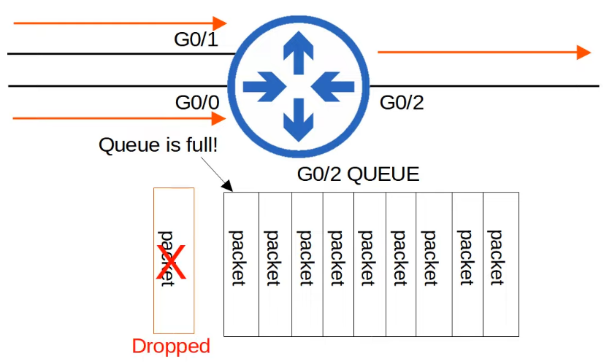

* Tail drop is harmful because it can lead to TCP global synchronization
* Review of the TCP sliding window
  + Hosts using TCP use the 'sliding window' increase/decrease the rate at which they send traffic as needed
  + When a packet is dropped, it will be re-transmitted
  + When a drop occurs, the sender will reduce the rate it sends traffic
  + It will then gradually increase the rate again
* When the queue fills up and tail drop occurs, all TCP hosts sending traffic will slow down the rate at which they send traffic
* They will all then increase the rate at which they send traffic, which rapidly leads to more congestion, dropped packets, and the process repeats again

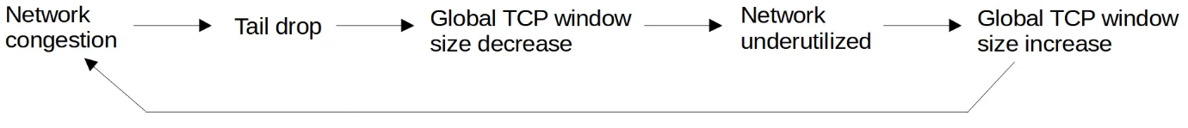

* A solution to prevent tail drop and TCP global synchronization is Random Early Detection (RED)
* When the amount of traffic in the queue reaches a certain threshold, the device will start to randomly drop packets from select TCP flows
* Those TCP flows that dropped packets will reduce the rate at which traffic is sent, but you will avoid global TCP synchronization, in which ALL TCP flows reduce and then increase the rate of transmission at the same time in waves
* In standard RED, all kinds of traffic are treated the same
* An improved version, Weighted RED (WRED), allows you to control which packets are dropped depending on the traffic class

## QoS (Part 2)

Things covered

* Classification/ Marking
* Queueing / Congestion Management
* Shaping / Policing

**Classification**

* The purpose of QoS is to give certain kinds of network traffic priority over others during congestion
* Classification organizes network traffic (packets) into traffic classes (categories)
* Classification is fundamental to QoS. To give priority to certain types of traffic, you have to identify which type of traffic to give priority to
* There are many methods of classifying traffic. For example
  + ACL
    - Traffic permitted by the ACL will be given certain treatment, other traffic will not
  + NBAR (Network Based Application Recognition)
    - Performs a deep packet inspection, looking beyond the Layer 3 and 4 information layer up to Layer 7 to identify specific kinds of traffic
  + In the layer 2 and 3 headers, there are specific fields used for this purpose
* The PCP (Priority Code Point) field of the 802.1Q tag (in the Ethernet header) can be used to identify high/low priority traffic
  + Only when there is a dot1q tag
* The DSCP (Differentiated Services Code Point) field of the IP header can also be used to identify high/low priority traffic

**PCP / CoS**

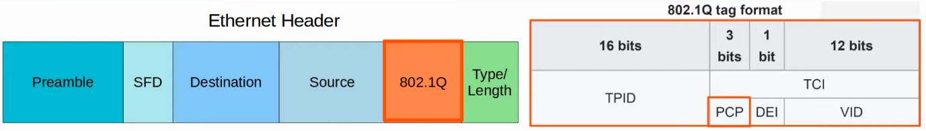

* PCP is also known as Class of Service (CoS)
* Defined by IEEE 802.1p
* 3 bits = 8 possible values

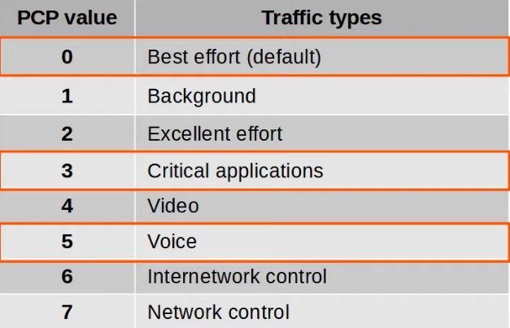

* 0: Best effort
  + 'Best effort' delivery means there is no guarantee that data is delivered or that it meets any QoS standard
  + This is regular traffic, not high-priority
* IP phones **mark** call signalling traffic (used to establish calls) as PCP 3
* They **mark** the actual voice traffic as PCP 5

* Because PCP is found in the dot1q header, it can only be used over the following connections:
  + Trunk links
  + Access links with a voice VLAN
* In the diagram below, traffic btw R1 and R2, or btw R2 and external destinations will not have a dot1q tag. So, traffic over those links PCP cannot be marked with a PCP value

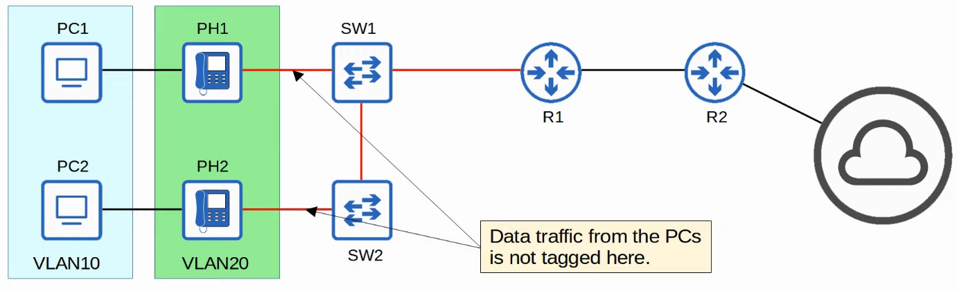

**IP Type of Service (ToS) Byte**

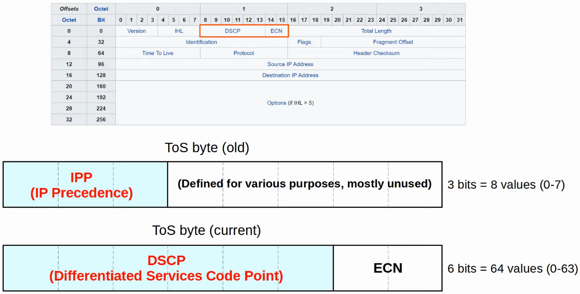

**IP Precedence**



* Standard IPP markings are similar to PCP
  + 6 and 7 are reserved for 'network control' traffic (i.e. OSPF messages btw routers)
  + 5: voice
  + 4: video
  + 3: voice signalling
  + 0: best effort
* With 6 and 7 reserved, 6 possible values remain
* Although 6 values is sufficient for many networks, the QoS requirements of some networks demand more flexibility

**DSCP**



* RFC 2474 (1998) defines the DSCP field, and other 'DiffServ' RFCs elaborate on its use
* With IPP updated to DSCP, new standard markings had to be decided upon
  + By having generally agreed upon standard markings for different kinds of traffic, QoS design & implementation is simplified, QoS works better btw ISPs and enterprises, among other benefits
* You should be aware of the following standard markings
  + Default Forwarding (DF) - best effort traffic
  + Expedited Forwarding (EF) - low loss/latency/jitter traffic (usually voice)
  + Assured Forwarding (AF) - A set of 12 standard values
  + Class Selector (CS) - A set of 8 standard values, provides backward compatibility with IPP

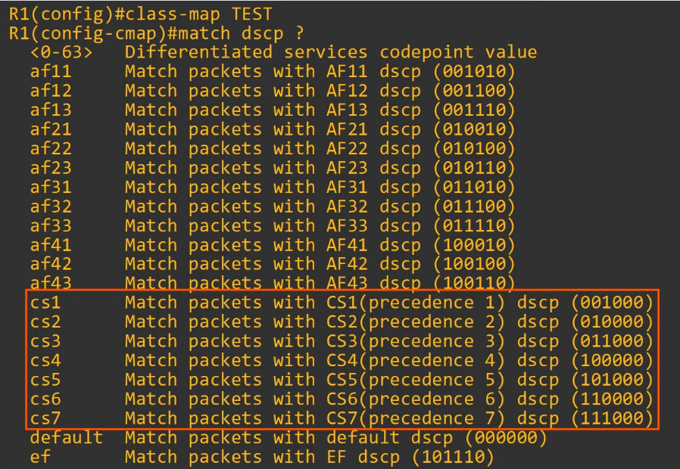

**DF (Default Forwarding)**

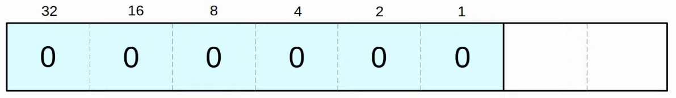

* DF is used for best-effort traffic
* The DSCP marking for DF is 0

**EF (Expedited Forwarding)**

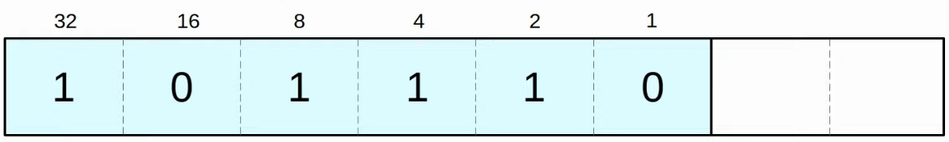

* EF is used for traffic that require low loss/latency/jitter
* The DSCP marking for EF is 46

**AF (Assured Forwarding)**

* AF defines 4 traffic classes
  + All packets in a class have the same priority
* Within each class, there are 3 levels of drop precedence
  + Higher drop precedence = more likely to drop the packet during congestion
* Max value = AF43, DSCP 38
* Formula: DSCP = 8X + 2Y

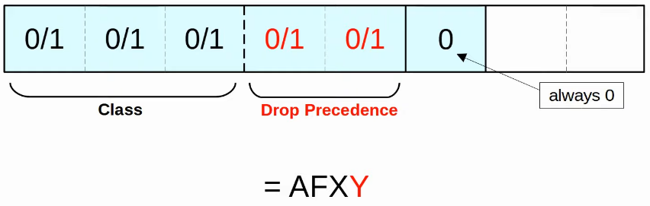

**Example**

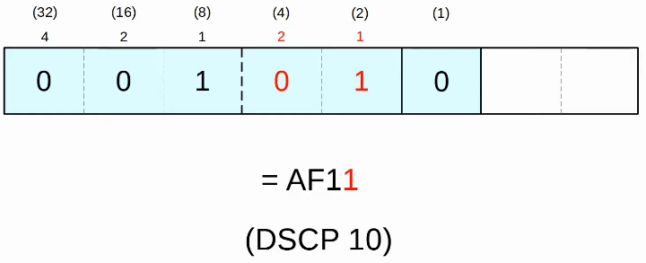

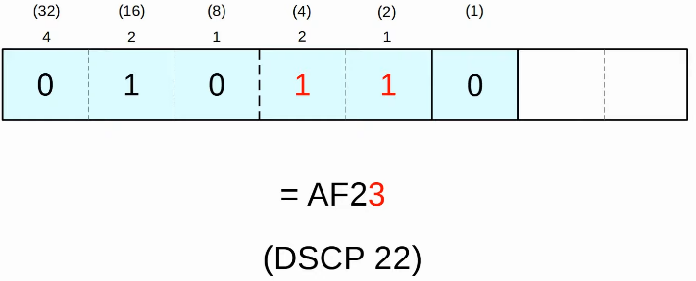

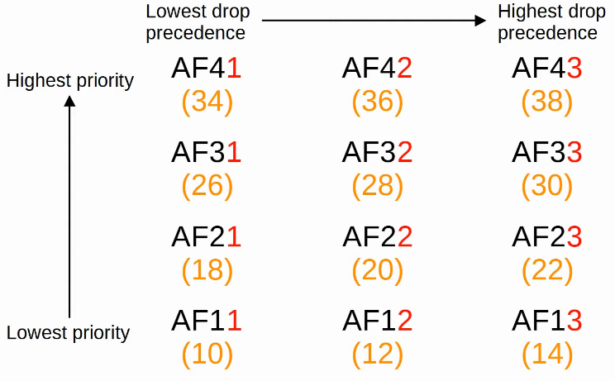

**CS (Class Selector)**

* CS defines 8 DSCP values for backward compatibility with IPP
* The 3 bits that were added for DSCP are set to 0, and the original IPP bits are used to make 8 values

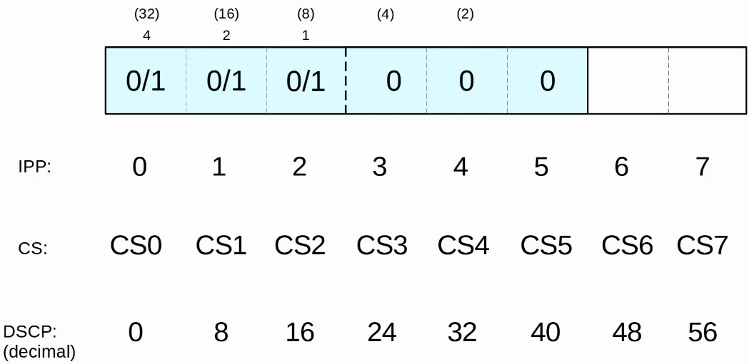

**RFC 4954**

* Was developed with the help of Cisco to bring all of these values together and standardize their use
* The RFC offers many specific recommendations, but here are a few key ones:
  + Voice traffic: EF
  + Interactive video: AF4X
  + Streaming video: AF3X
  + High priority data: AF2X
  + Best effort: DF
  + X: can be any number

**Trust Boundaries**

* The trust boundary of a network defines where devices trust/don't trust the QoS markings of received messages
* If the markings are trusted, the device will forward the message without changing the markings
* If the markings aren't trusted, the device will change the markings according to the configured policy

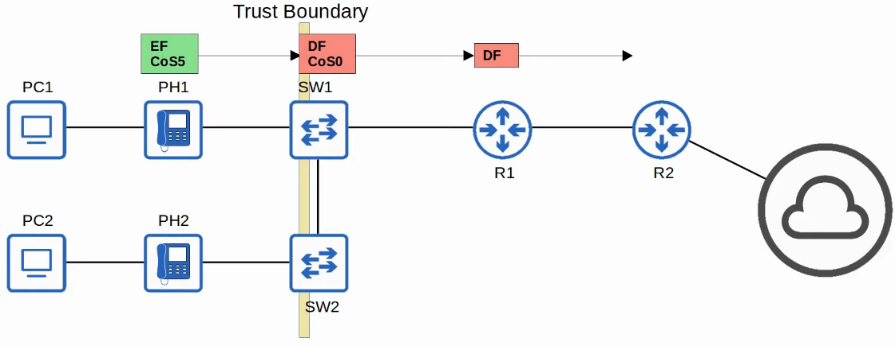

* If an IP phone is connected to the switch port, it is recommended to move the trust boundary to the IP phones
* This is done via configuration on the switch port connected to the IP phone
* If a user marks their PC's traffic with a high priority, the marking will be changed (not trusted)

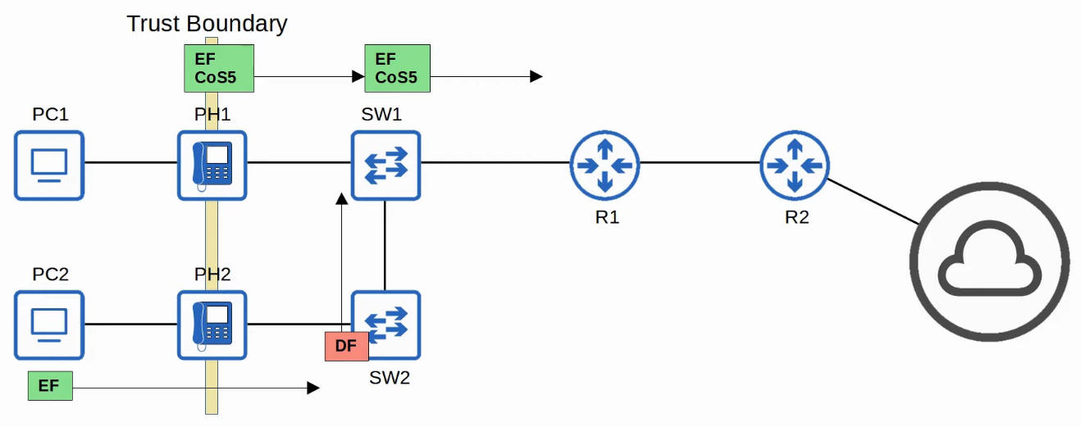

**Queueing / Congestion Management**

* When a network device receives traffic faster at a faster rate than it can forward the traffic out of the appropriate interface, packets are placed in that interface's queue as they wait to be forwarded
* When the queue becomes full, packets that don't fit in the queue are dropped (tail drop)
* RED and WRED drop packets early to avoid tail drop

* An essential part of QoS is the use of multiple queues
  + This is where classification plays a role
  + The device can match traffic based on various factors (e.g. DSCP marking in IP header) and then place it in the appropriate interface
* However, the device is only able to forward one frame out of an interface at a time, so a scheduler is used to decide which queue traffic is forwarded from next
  + Prioritization allows the scheduler to give certain queues more priority than others

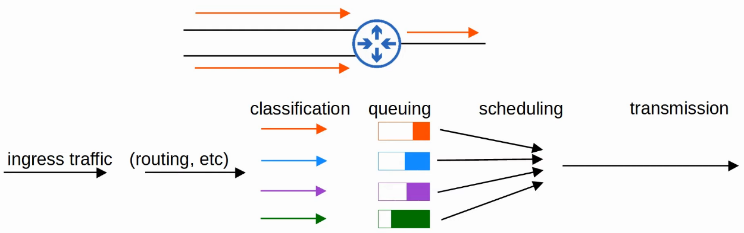

* A common scheduling method is weighted round robin
  + Round-robin = packets are taken from each queue in order, cyclically
  + Weighted = more data is taken from high priority queues each time the scheduler reaches that queue
* CBWFQ (Class-Based Weighted Fair Queueing)
  + Popular method of scheduling
  + Uses a weighted round-robin scheduler while guaranteeing each queue a certain percentage of the interface's bandwidth during congestion

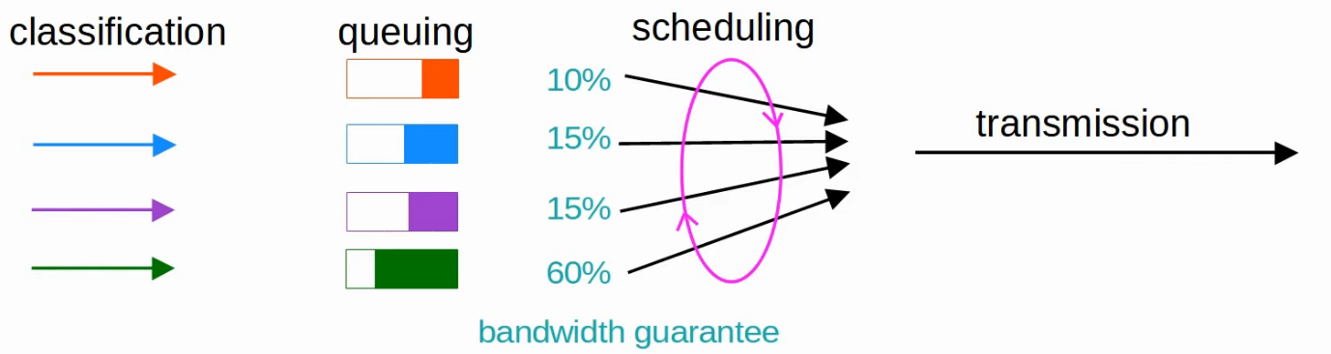

* Round robin scheduling is not ideal for voice/video traffic
  + Even if the voice/video traffic receives a guaranteed minimum amount of bandwidth, round robin can add delay and jitter because even the high priority queues have to wait their turn in the scheduler

* LLQ (Low Latency Queueing) designates 1 (or more) queues as strict priority queues
  + This means that if there is traffic in the queue, the scheduler will ALWAYS take the next packet from that queue until it is empty
* This is very effective for reducing delay and jitter of voice/video traffic
* However, it has the downside of potentially starving other queues if there is always traffic in the designated strict priority queue
  + Policing can control the amount of traffic allowed in the strict priority queue so that it can't take all of the link's bandwidth

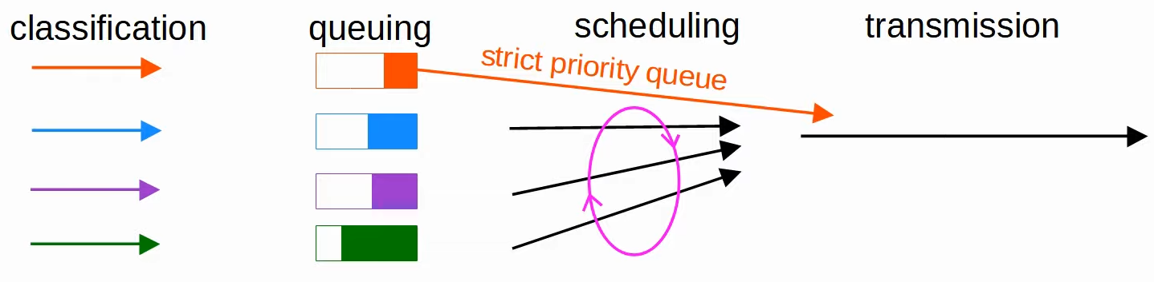

**Shaping and Policing**

* Traffic shaping and policing are both used to control the rate of traffic
* Shaping buffers traffic in a queue if the traffic rate goes over the configured rate
* Policing drops traffic if the traffic rate goes over the configured rate
  + Note: policing also has the option of re-marking the traffic instead of dropping it
  + 'Burst' traffic over the configured rate is allowed for short period of time
  + This accommodates data applications which typically are 'bursty' in nature. Instead of a constant stream of data, they send data in bursts
  + The amount of burst traffic allowed is configurable
* In both cases, classification can be used to allow for different rates for different kinds of traffic
* Why would you want to limit the rate traffic is sent/received?

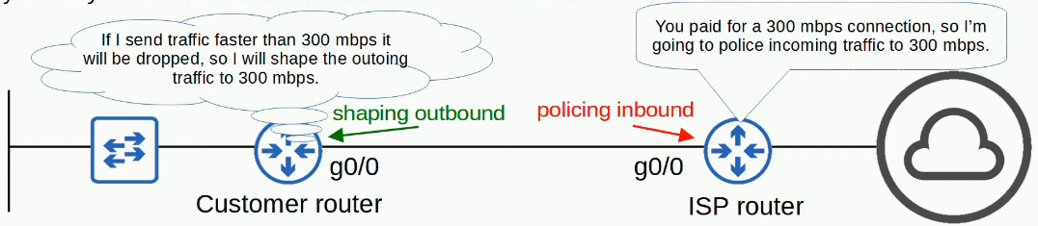

# Security Fundamentals

Things covered

* Key security concepts
* Common attacks
* Password / Multi-Factor Authentication (MFA)
* Authentication, Authorization, Accounting (AAA)
* Security Program Elements

**Why security?**

* What is the purpose/goal of security in an enterprise?
* The principles of the CIA Triad form the foundation of security
  + Confidentiality
    - Only authorized users should be able to access data
    - Some information/data is public and can be accessed by everyone
    - Some are secret and can only be accessed by certain people
  + Integrity
    - Data should not be tampered/modified by unauthorized users
    - Data should be authentic and correct
  + Availability
    - The network/systems should be operational and accessible to authorized users
* Attackers can threaten the CIA of an enterprise's systems and information

* Vulnerability
  + Any potential weakness that can compromise the CIA of a system/info
  + A potential weakness isn't a problem on its own
* Exploit
  + Something that can potentially be used to exploit the vulnerability
  + An exploit isn't a problem on its own
* A threat
  + The potential of a vulnerability to be exploited
  + E.g. A hacker exploiting a vulnerability in your system is a threat
* Mitigation Technique
  + Something that can protect against threats
  + Should be implemented everywhere a vulnerability can be exploited: Client devices, servers, switches, routers, firewalls, etc
* No system is perfectly safe

**Common Attacks**

* DoS (denial-of-service)
* Spoofing
* Reflection/amplification
* Man-in-the-middle
* Reconnaissance
* Malware
* Social Engineering
* Password-related

**DoS (Denial-of-Service)**

* Threatens the availability of a system
* A common DoS attack is TCP SYN flood
  + TCP 3-way handshake: SYN / SYN-ACK / ACK
  + Attacker send lots of SYN messages but don't acknowledge them, which causes the target run out of TCP connections
  + How it works
    - Attacker sends countless TCP SYN messages to the target
    - Target send SYN-ACK in response to each SYN message received
    - Attacker never replies with the final ACK of the 3-way handshake
    - The incomplete connection fills up the target's TCP connection table
    - Attacker continues to send SYN messages
    - The target is no longer able to make legitimate TCP connections

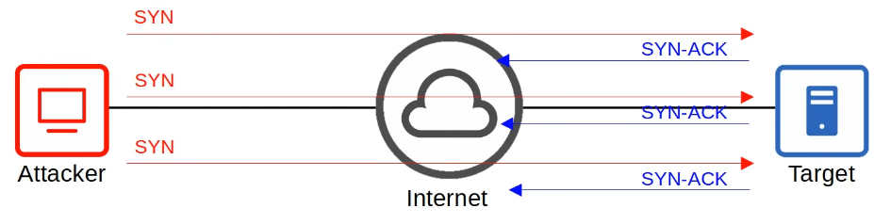

* Note: SYN-ACK not returning to Attacker directly as most likely attacker has spoofed his IP address

* More common is DDoS (Distributed DoS)
  + Attacker infects many target computers with malware and uses them all to initiate a DoS attack
  + The group of infected computers is called botnet

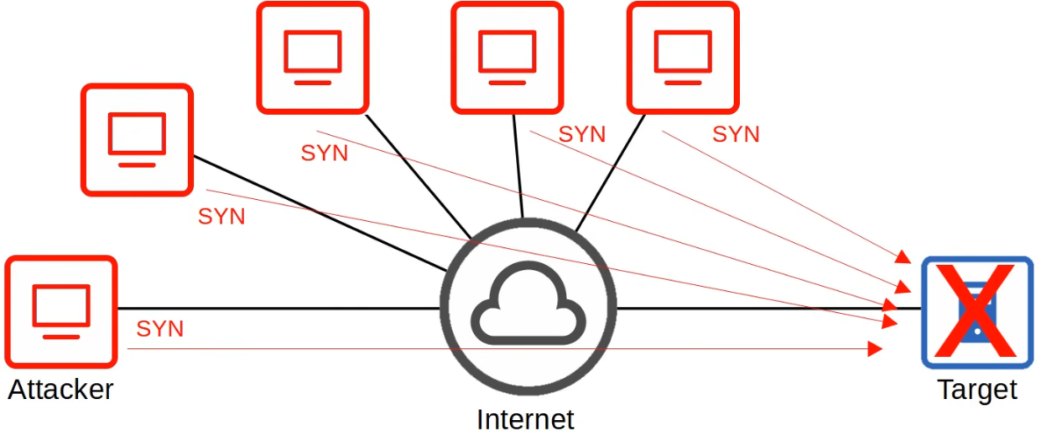

**Spoofing**

* To spoof an address is to use a fake source address (IP/MAC address)
* Numerous attacks involve spoofing, it is not a single kind of attack
* Example: DHCP exhaustion
  + An attacker uses spoofed MAC addresses to flood DHCP Discover messages
  + The target server's DHCP pool becomes full, resulting in DoS to other devices

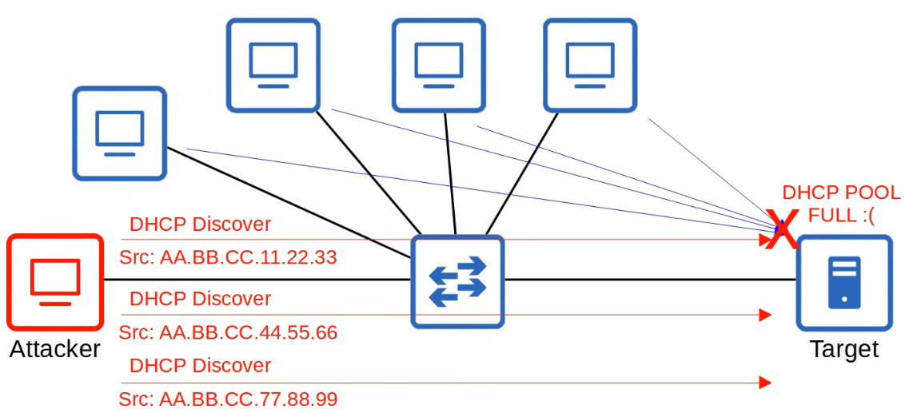

**Reflection/Amplification**

* In a reflection attack, the attacker sends traffic to a reflector, and spoofs the source address of its packets using the target's IP address
* The reflector (i.e. DNS server) sends the reply to the target's IP address
* If the amount of traffic sent to the target is large enough, can cause a DoS
* A reflection attack becomes an amplification attack when the amount of traffic sent by the attacker is small, but it triggers a large amount of traffic to be sent from the reflector to the target
  + Example: DNS/NTP amplification attack

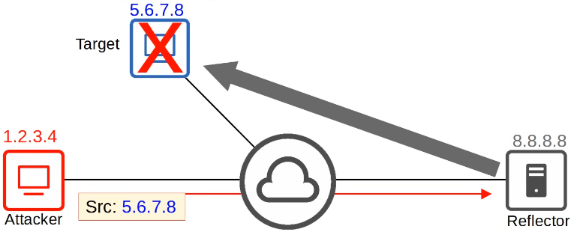

**Man-in-the-middle**

* The attacker places himself btw the source and destination to eavesdrop on communications, or to modify traffic before it reaches the destination
* Common example: ARP Spoofing/Poisoning
  + Host sends an ARP Request, asking for MAC address of another device
  + The target of the request sends an ARP Reply, informing the requester of its MAC address
  + The attacker waits and sends another ARP Reply after the legitimate replier
  + If the attacker's ARP reply arrives last, it will overwrite the legitimate ARP entry in PC1's ARP table

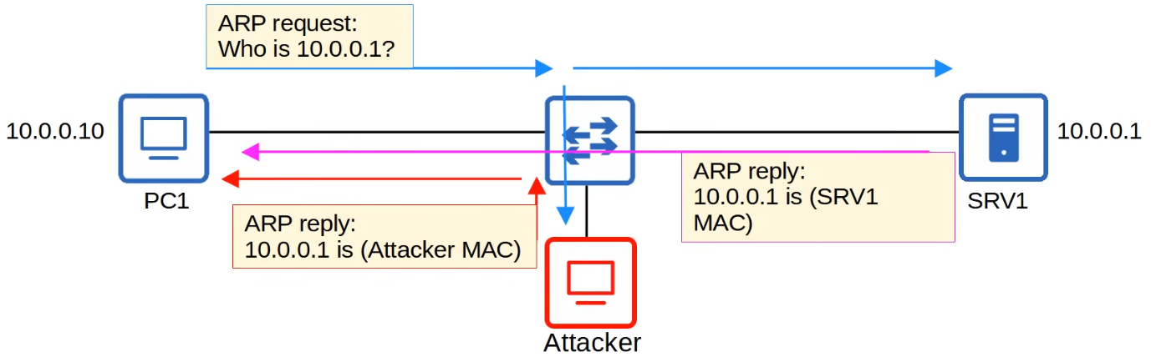

* In PC1's ARP table, the entry for 10.0.0.1 will have the attacker's MAC address
* When PC1 tries to send traffic to SRV1, it will be forwarded to the attacker instead
* The attacker can modify/inspect the message before forwarding them to SRV1
* This compromises the Confidentiality and Integrity of communications btw PC1 and SRV1

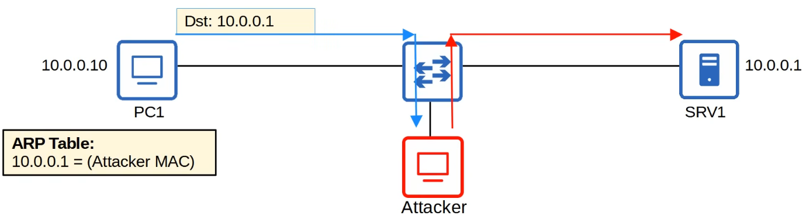

**Reconnaissance**

* Reconnaissance attacks aren't attacks themselves, but they are used to gather information about a target which can be used for a future attack
* This is often publicly available information
* E.g. "nslookup" to learn IP address of a site

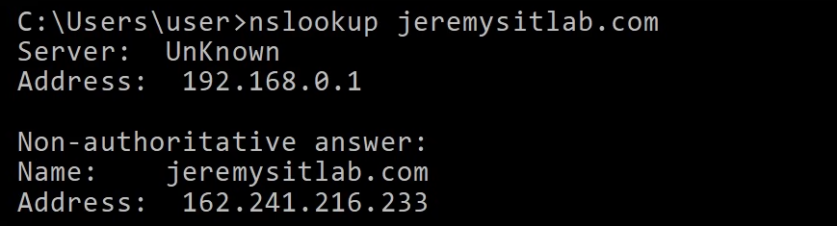

* E.g. WHOIS query to learn email addresses, phone numbers, physical address, etc

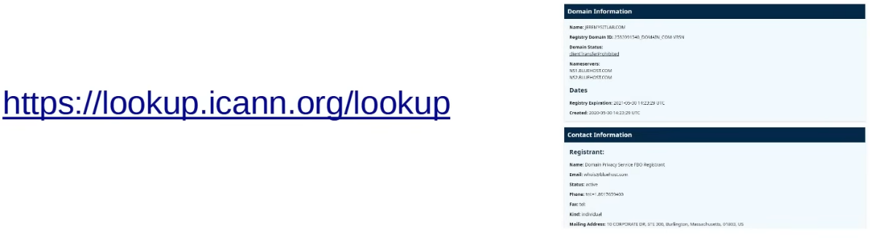

**Malware (Malicious Software)**

* Refers to a variety of harmful programs that can infect a computer
* Viruses
  + They infect other software ("host program")
  + The virus spread as the software is shared by users
  + Typically corrupt or modify files on the target computer
* Worms
  + Do not require a host program
  + They are a standalone malware and they are able to spread on their own w/o user interaction
  + The spread of worms can congest the network, but the 'payload' of a worm can cause additional harm to target devices
* Trojan Horse
  + Harmful software that is disguised as legitimate software
  + They spread through user interaction such as opening email attachments, or downloading a file from the Internet
* These malware types can exploit various vulnerabilities to threaten any of the CIA of the target device
* There are many other types of malware

**Social Engineering**

* Attacks the most vulnerable part of any system: people
* They involve psychological manipulation to make the target reveal confidential information or perform some action
* Phishing
  + Typically involves fraudulent emails that appear to come from a legitimate business and contain links to a fraudulent website that seems legitimate
  + Users are told to login to the fraudulent website, providing their login credentials to the attacker
  + Spear phishing
    - A more targeted form of phishing, i.e. aimed at employees of a certain company
  + Vishing (voice phishing)
    - Phishing performed over the phone
    - 'Hi, this is Jeremy from the IT department. Due to company policy we need to reset your password, could you tell me the password you're currently using and I'll reset it for you?'
  + Smishing (SMS phishing)
    - phishing using SMS text messages.
* Watering hole attacks
  + Compromises sites that the target victim frequently visits
  + If a malicious link is placed on a website the target trusts, they might not hesitate to click it
* Tailgating
  + Involve entering restricted, secured areas by simply walking in behind an authorized person as they enter

**Password-related**

* Most systems use a username/password combination to authenticate users
* The username is often simple/easy to guess (e.g. user's email), and the strength and secrecy of the password is relied on to provide the necessary security
* Attackers can learn a user's password via multiple methods
  + Guessing
  + Dictionary attack
    - Use a dictionary of common words/passwords
  + Brute force attack
    - Try every possible combination of characters
* Strong password should contain
  + >= 8 characters
  + Mix of upper/lower case
  + Mix of letters/numbers
  + >= 1 special character
  + Changed regularly

* DOS (denial-of-service) attacks
  + target the availability of a system so users can't access it
* Spoofing attacks
  + involve using fraudulent source IP/MAC addresses
* Reflection/amplification attacks
  + involve spoofing a source IP address to cause a reflector to send lots of traffic to the target
* Man-in-the-middle attacks
  + an attacker intercepts traffic between the source and destination to eavesdrop and/or modify the traffic
* Reconnaissance attacks
  + used to gather information on the target to perform future attacks
* Malware
  + malicious software such as viruses, worms, and trojan horses that infect a system
* Social engineering attacks
  + attacks that use psychological manipulation to target people and make them reveal info or perform an action
* Password-related attacks
  + attacks such as dictionary attacks and brute force attacks, used to guess the target's password

**Multi-factor Authentication**

* Involves more than just username/password
* Usually involves providing 2 of the following ( = 2-factor authentication)
  + Something you know
    - Username/password, PIN, etc
  + Something you have
    - Pressing a notification that appear on your phone, a badge that is scanned, etc
  + Something you are
    - Biometrics such as face scan, palm scan, fingerprint scan, etc
* Requiring multiple factors of authentication greatly increases the security
  + Even if attackers learns the target's password, they won't be able to login to the account

**Digital Certificates**

* Another form of authentication used to prove the identity of the holder of the certificate
* Used for websites to verify that the website being accessed is legitimate
* Entities that want a certificate to prove their identity send a CSR (Certificate Signing Request) to a CA (Certificate Authority), which will generate and sign the certificate

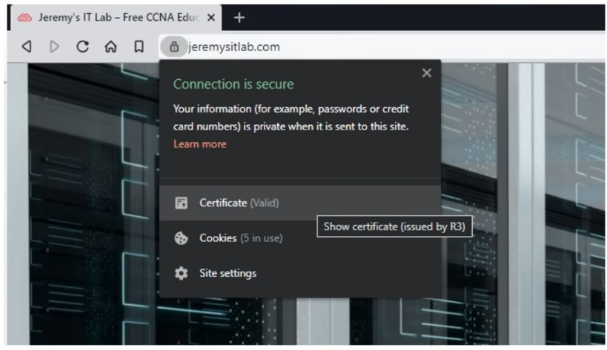

**Controlling and Monitoring users with AAA**

* AAA (triple-A): Authentication, Authorization, Accounting
* Framework for controlling and monitor users of a computer system (i.e. a network)
* Authentication
  + Process of verifying a user's identity
  + E.g. Logging in
* Authorization
  + Process of granting the user the appropriate access and permissions
  + E.g. Granting user access to certain files/services, restricting others
* Accounting
  + Process of recording the user's activities on the system
  + E.g. logging when a user makes a change to a file
* Enterprises usually use a AAA server to provide AAA services
  + ISE (Identity Services Engine) is Cisco's AAA server
* AAA servers usually support the following 2 AAA protocols
  + RADIUS
    - Open standard protocol
    - UDP port 1812 and 1813
  + TACACS+
    - Cisco proprietary protocol
    - TCP port 49

**Security Program Elements**

* User awareness programs
  + Designed to make employees aware of potential security threats and risks
  + E.g. Company send fake phishing emails, those who fall for it will be informed
* User training
  + More formal than user awareness programs
  + E.g. Dedicated training sessions on security policies, how to make strong passwords, etc
* Physical access control
  + Protects equipment and data from potential attackers by only allowing authorized users into protected areas such as network closets or data centre floors
  + Multifactor locks can protect access to restricted areas
  + E.g. Door that requires users to swipe a badge and scan their fingerprint to enter
    - Permissions of the badge can easily be changed

# Port Security

Things covered

* Intro to port security
* Why use port security
* Config

**Port security**

* A security feature of Cisco switches
* Allows you to control which source MAC address(es) are allowed to enter the switchport
* If an unauthorized source MAC address enters the port, an action will be taken
  + Default action: place the interface in 'err-disable' state

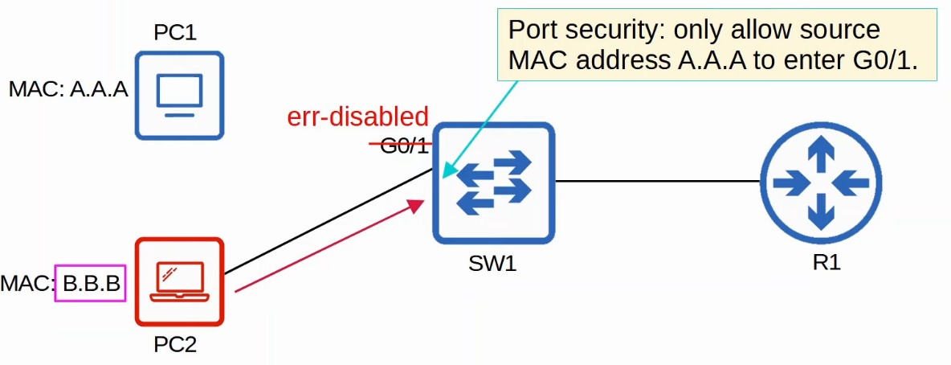

* When you enable port security on an interface with the default settings, 1 MAC address is allowed
  + Can config the allowed MAC address
  + Default: allow the first source MAC address that enters the interface
* Can change the max number of MAC address allowed
  + Can be a combination of manually configured and dynamically learned
* 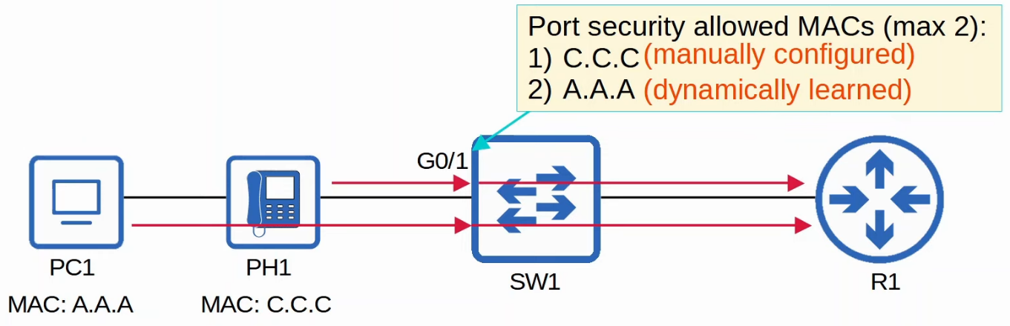

**Why port security?**

* Allow network admins to control which devices are allowed to access the network
* However, MAC address spoofing is a simple task
  + Easy to configure a device to send frames with a different source MAC address
* Ability to limit the number of MAC address is more useful than specifying MAC addresses allowed on interface
* Think of the DHCP starvation attack
  + Attacker spoofed thousands of fake MAC addresses
  + The DHCP server assigned IP addresses to these fake MAC addresses, exhausting the DHCP pool
  + Switch's MAC address table can also be full in such attacks
* Limiting the number of MAC addresses on an interface can protect against those attacks

**Enabling port security**

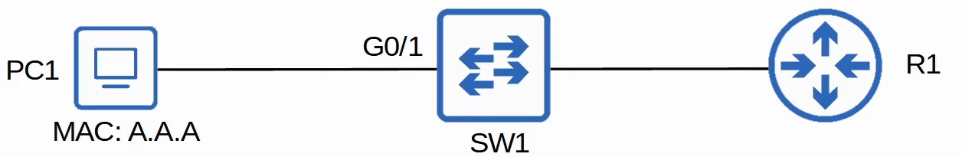

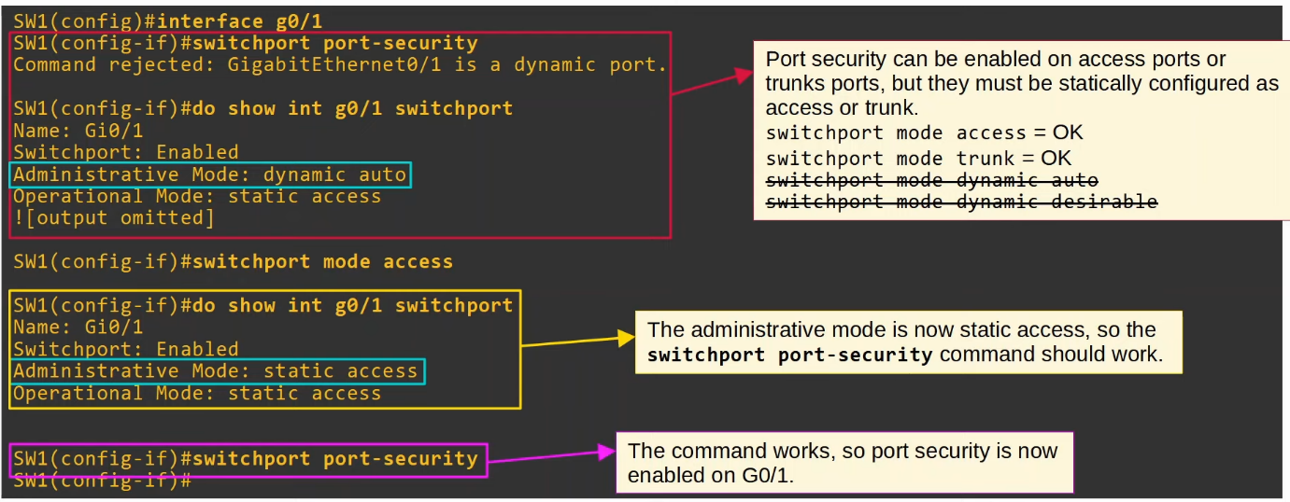

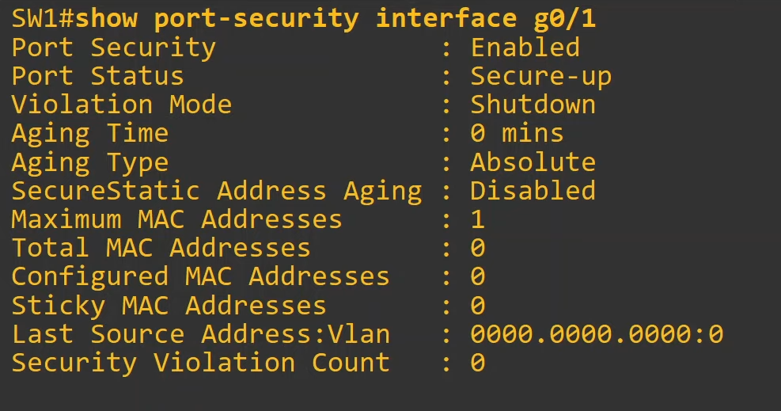

* Ping from PC1 to R1

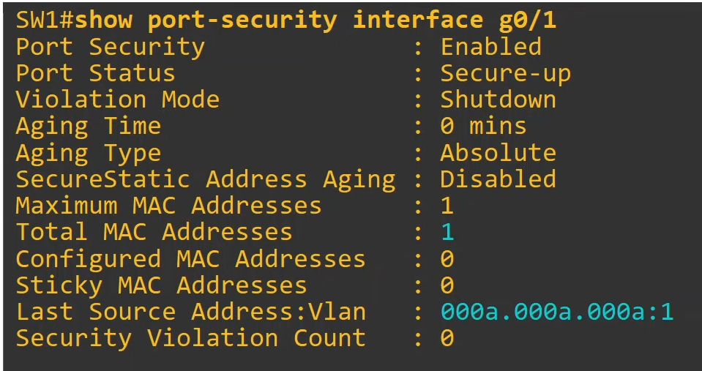

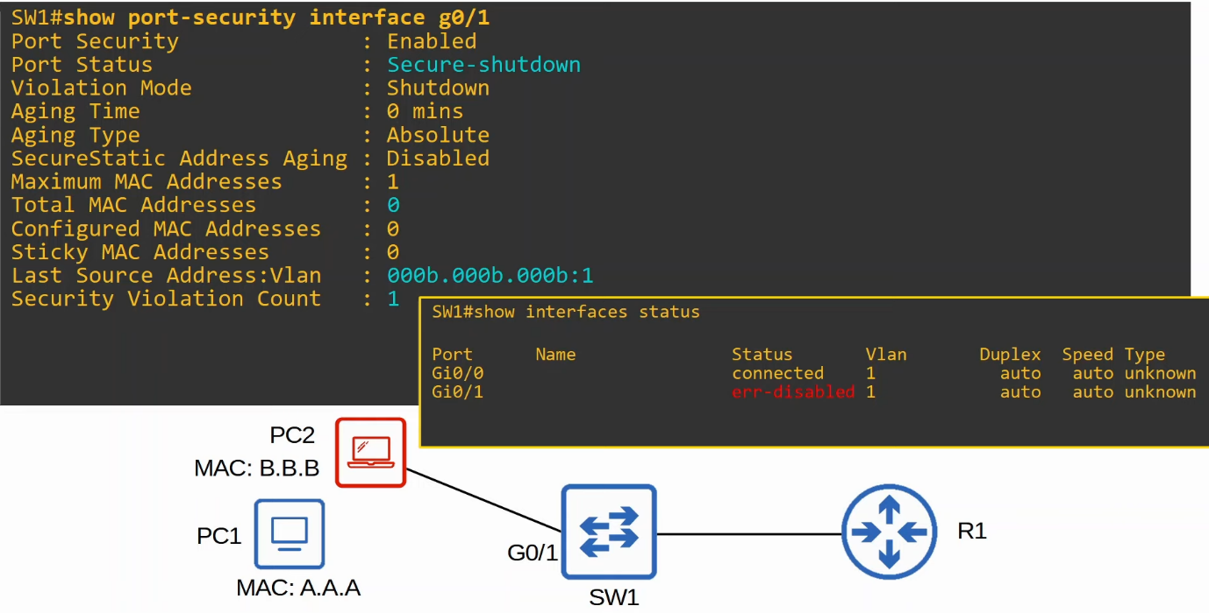

Re-enabling an interface (Manual)

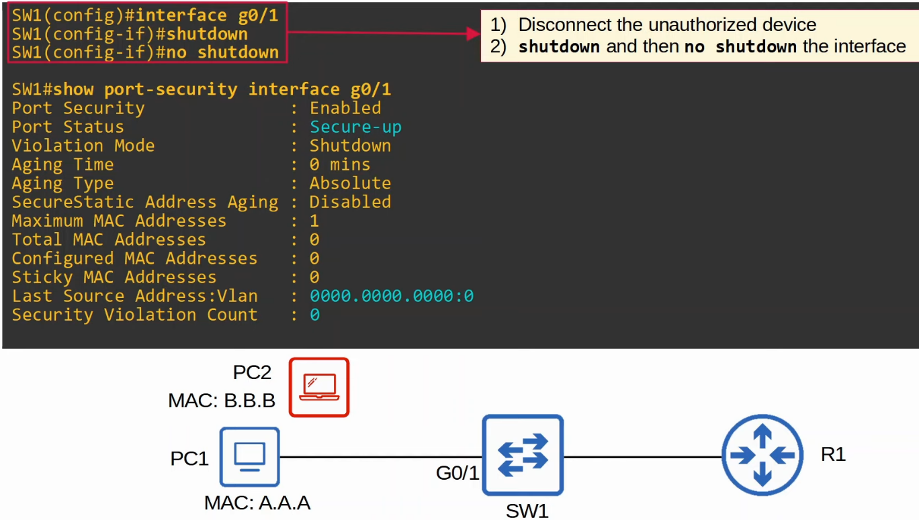

Re-enabling an interface (ErrDisable Recovery)

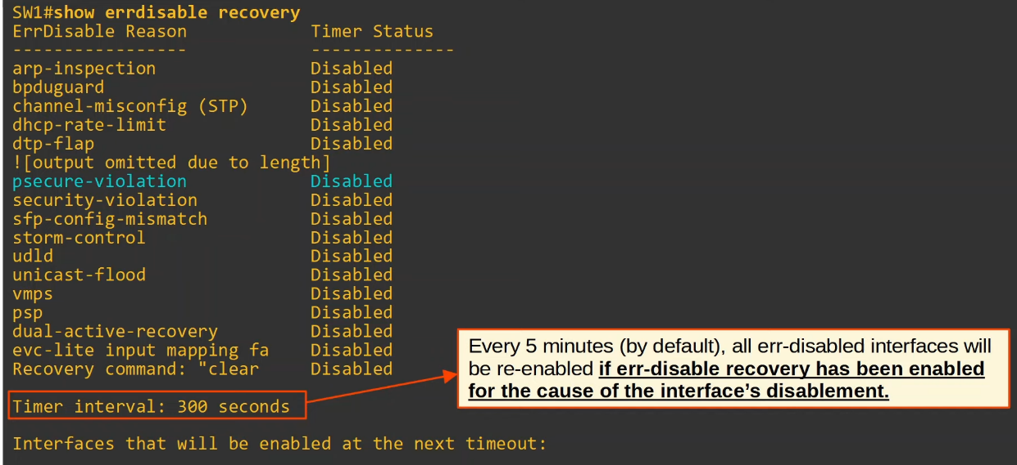

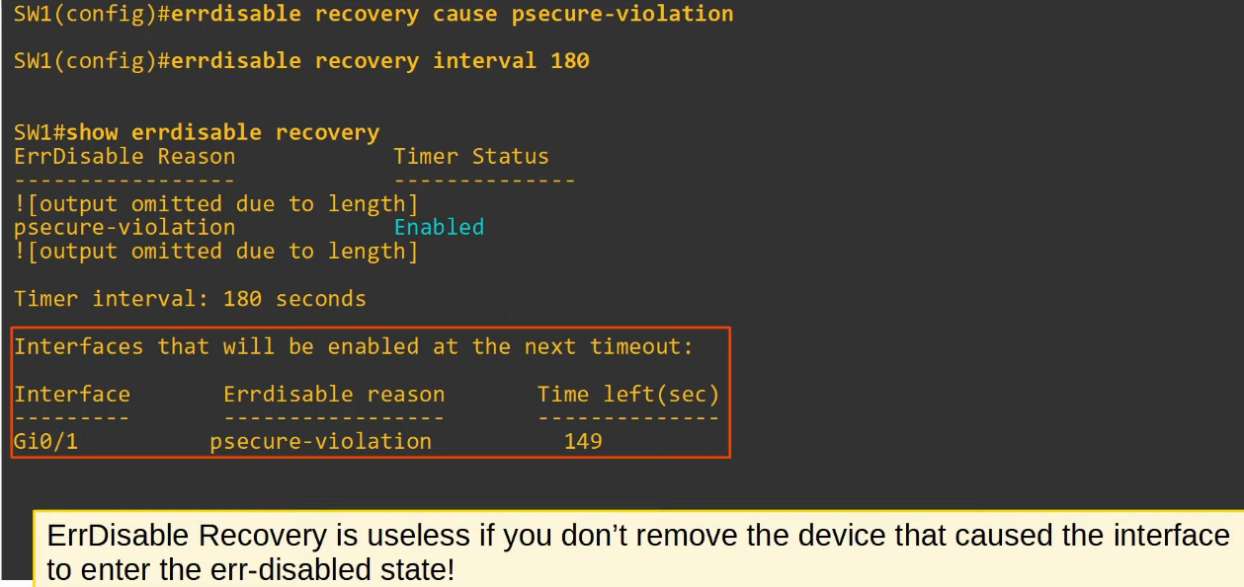

* Note: If never disconnect the unauthorized device
  + If manual, the interface will just enter err-disabled state again
  + If auto, may select the device as the first device and allow messages from that device, which is bad

**Violation Modes**

* There are 3 different violation modes that determine what the switch will do if an unauthorized frame enters an interface configured with port security
  + Shutdown
    - Effectively shuts down the port by placing it in err-disabled state
    - Generates a Syslog and/or SNMP message when the interface is disabled
    - The violation counter is set to 1 when the interface is disabled
  + Restrict
    - The switch discards traffic from unauthorized MAC address
    - Interface NOT disabled
    - Generates a Syslog and/or SNMP message each time an unauthorized MAC is detected
    - Violation counter incremented by 1 for each unauthorized frame
  + Protect
    - Switch discards traffic from unauthorized MAC address
    - Interface NOT disabled
    - Does NOT generate Syslog/SNMP message for unauthorized traffic
    - Does NOT increment counter

Restrict

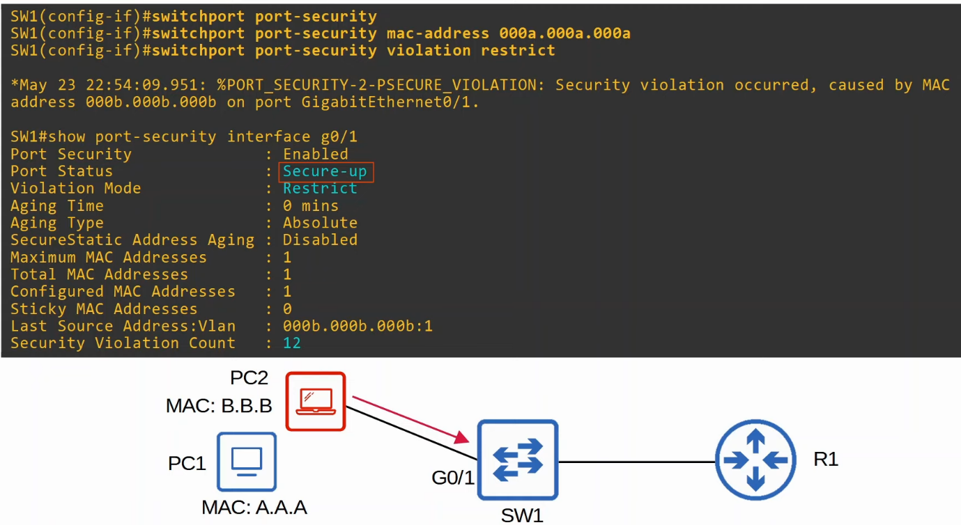

Protect

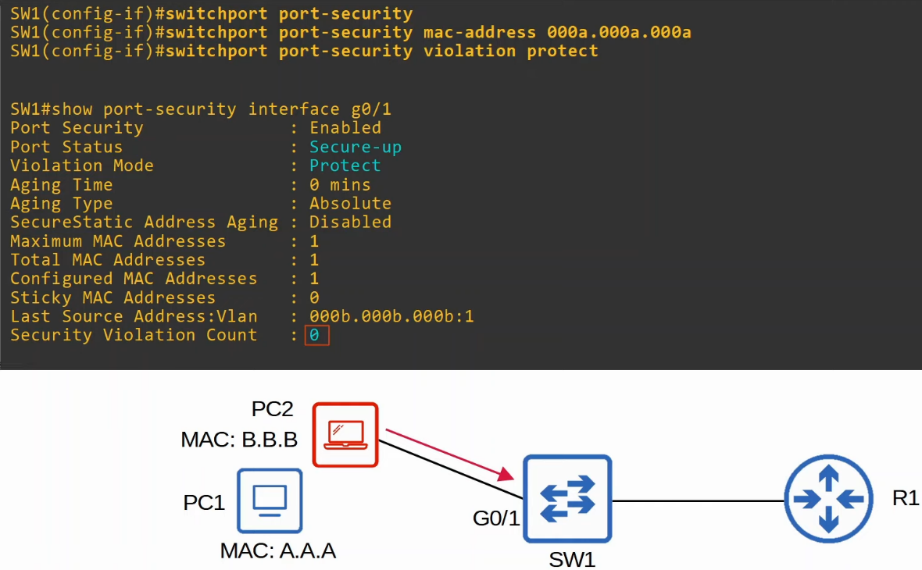

**Secure MAC address aging**

* Secure MAC address: MAC address learned dynamically / statically configured on port-security enabled port
* By default, secure MAC address will not 'age' out (Aging time : 0 mins)
  + Can be configured with "**switchport port-security aging time** *minutes*"
* Aging type
  + Absolute (default)
    - After the secure MAC address is learned, the aging timer starts and the MAC address is removed after the timer expires, even if the switch continues receiving frames from the source MAC address
  + Inactivity
    - After the secure MAC address is learned, the aging timer starts but resets every time a frame from that source MAC address is received on the interface
  + Aging type is configured with "**switchport port-security aging type {absolute | inactivity}**"
* Secure Static MAC aging is disabled by default
  + Addresses configured with "**switchport port-security mac-address** *x.x.x.x*"
  + Can be enabled with "**switchport port-security aging static**"

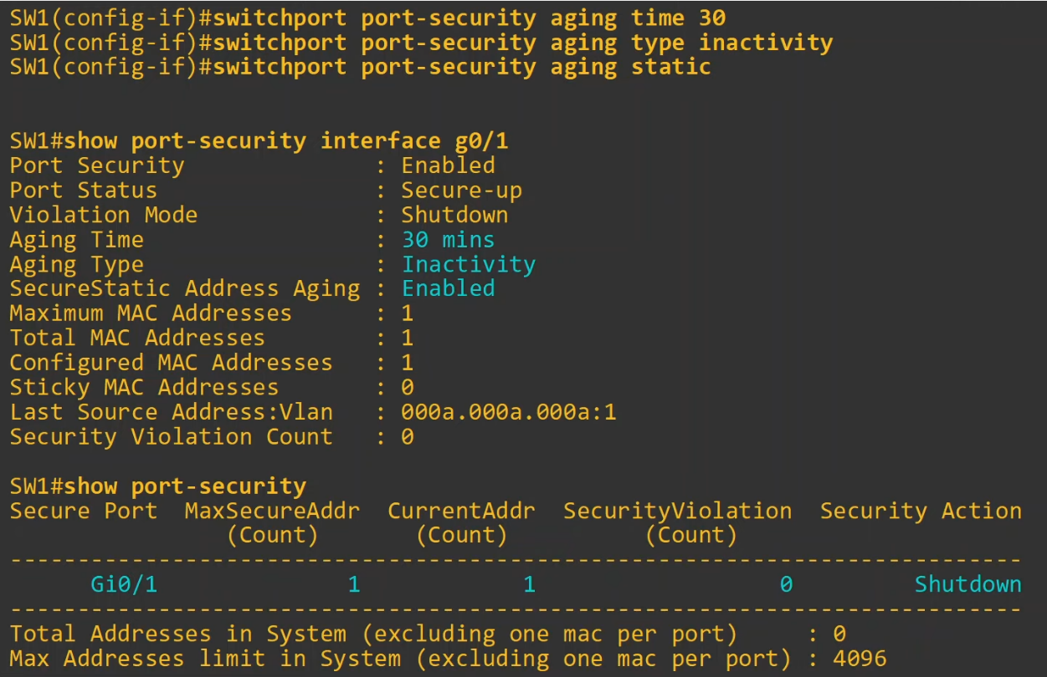

**Sticky Secure MAC addresses**

* 'Sticky' secure MAC address learning can be enabled with the following command:
  + SW1(config-if)# **switchport port-security mac-address sticky**
* When enabled, dynamically-learned secure MAC addresses will be added to the running config like this:
  + "**switchport port-security mac-address stick** *mac-address*"
* The sticky secure MAC addresses will never age out
  + You need to save the running-config to the startup-config to make them truly permanent
  + Else, they will not be kept if the switch restarts
* When you issue "**switchport port-security mac-address sticky**" command, all current dynamically learned secure MAC addresses will be converted to sticky secure MAC addresses
* If you issue "**no switchport port-security mac-address sticky**" command, all current sticky secure MAC addresses will be converted to regular dynamically-learned secure MAC addresses

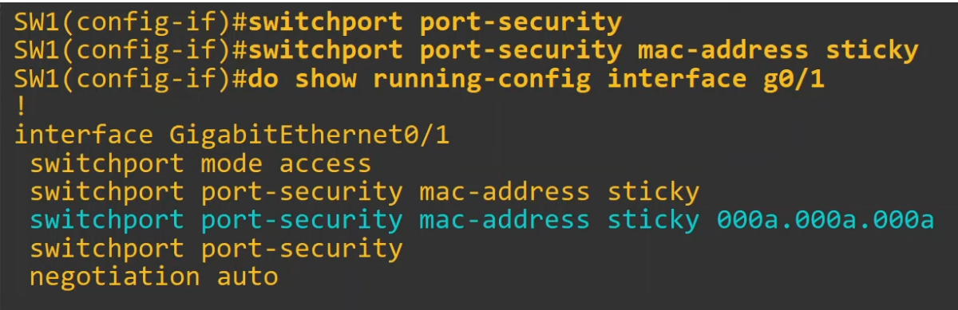

**MAC Address Table**

* Secure MAC addresses will be added to the MAC address table like any other MAC address
  + Sticky and Static secure MAC addresses will have a type of STATIC
  + Dynamically-learned secure MAC addresses will have a type of DYNAMIC
  + Can view all secure MAC addresses with "**show mac address-table secure**"

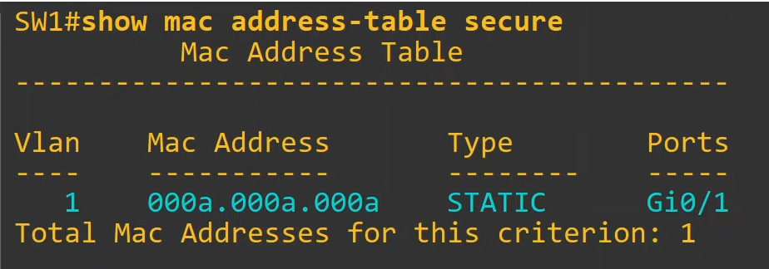

* The type is STATIC even though it is learned dynamically

Summary

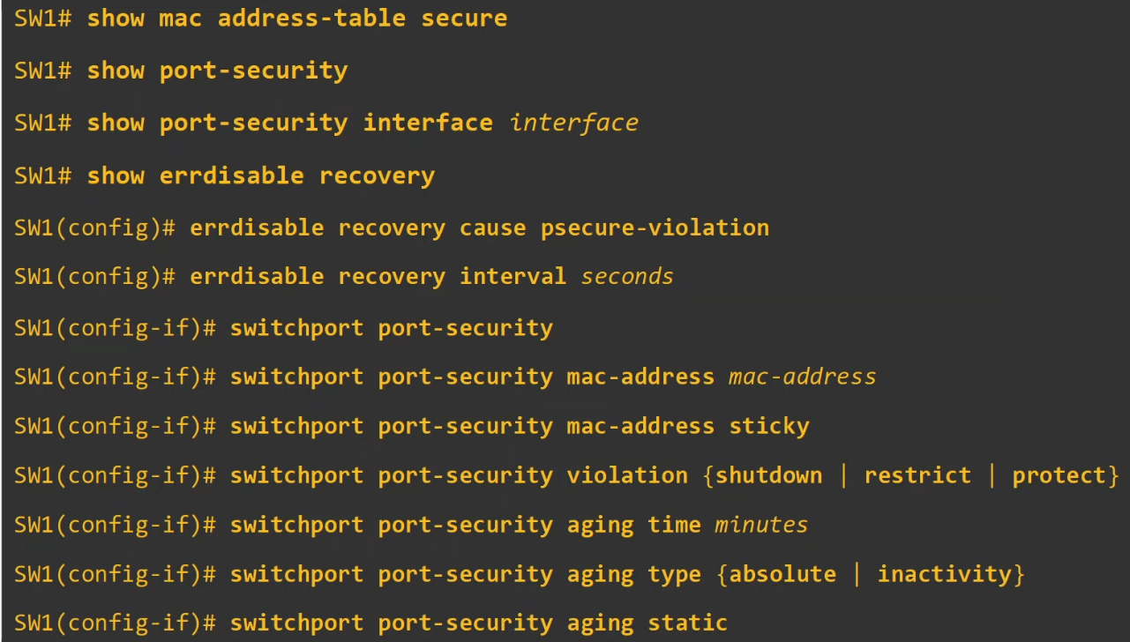

# DHCP Snooping

**Things covered**

* What is DHCP snooping
* How does it work
* What attacks does it prevent
* Config

**DHCP Snooping**

* A security feature of switches that is used to filter DHCP messages received on untrusted ports
* DHCP snooping only filters DHCP messages
  + Non-DHCP are not affected
* All ports are untrusted by default
  + Usually, uplink ports are configured as trusted ports, and downlink ports remain untrusted

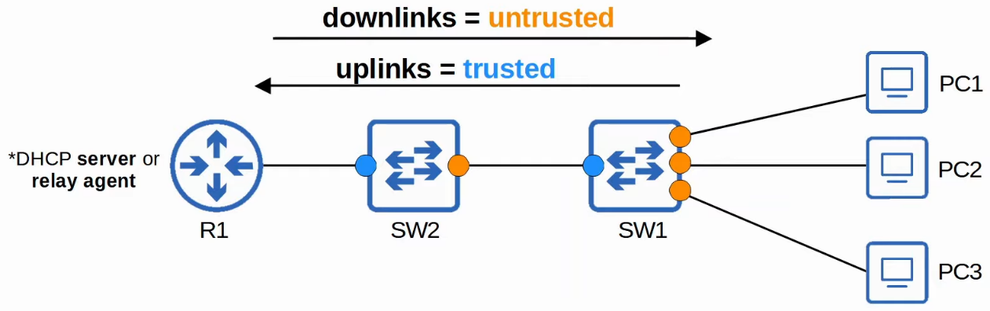

* Can trust that R1 won't do anything bad, but cannot trust PCs won't do anything bad

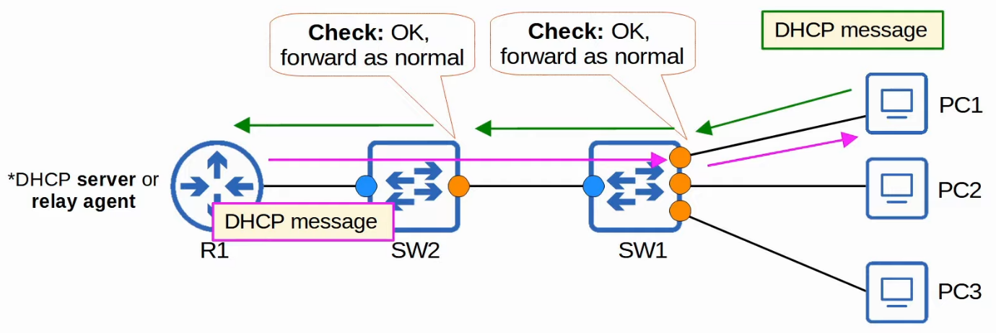

* DHCP messages are checked when arrive on untrusted ports
* Not checked if arrive on trusted ports

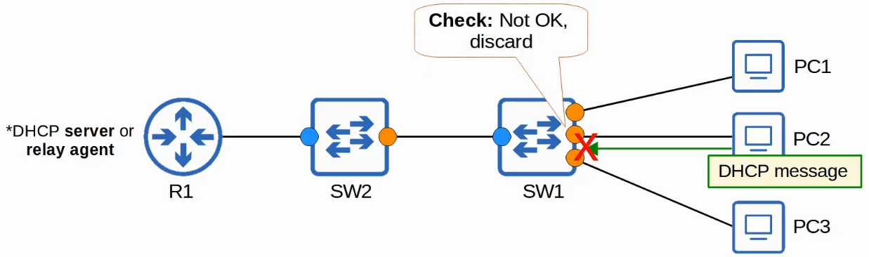

**What it protects**

**DHCP Starvation**

* An example of DHCP-based attacks is DHCP starvation attack
* An attacker uses spoofed MAC addresses to flood DHCP Discover messages
* The target server's DHCP pool becomes full, resulting in a DoS to other devices

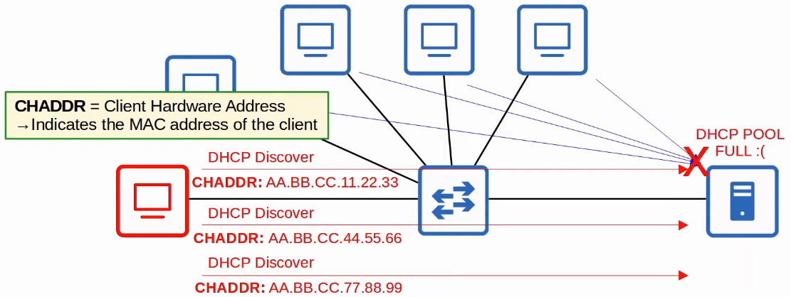

**DHCP Poisoning (Man-in-the-middle)**

* Similar to ARP poisoning, DHCP poisoning can also be used to perform Man-in-the-middle attack
* A spurious DHCP server replies to clients' DHCP Discover messages and assigns them IP addresses, but makes the clients use the spurious server's IP as the default gateway
  + *Clients usually accept the first Offer message they receive
  + If router is only a DHCP relay, then more likely PC will use the attacker's Offer message
* This will cause the client to send traffic to the attacker instead of the legitimate default gateway
* The attacker can examine/modify the traffic before forwarding it to the actual default gateway

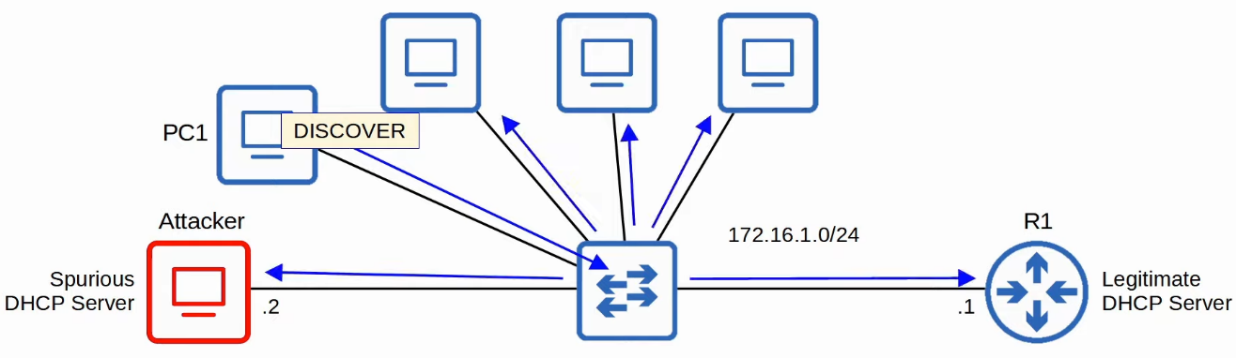

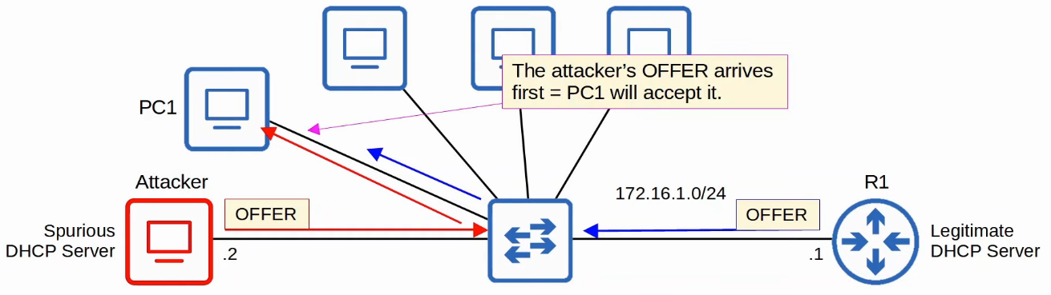

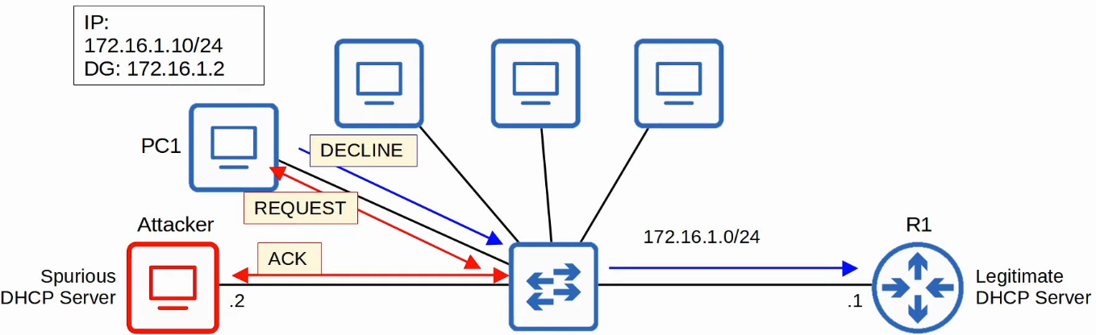

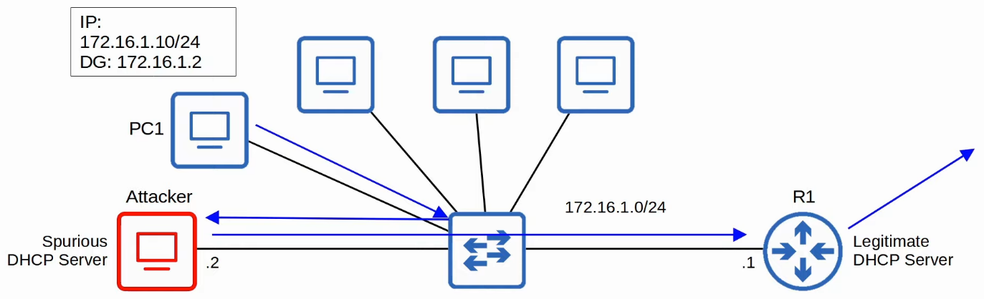

**DHCP Messages**

* When DHCP Snooping filters messages, it differentiates btw DHCP Server and DHCP Client messages
* Messages sent by DHCP Servers
  + OFFER
  + ACK
  + NAK (Opposite of ACK, used to decline a client's REQUEST)
* Messages sent by DHCP Clients
  + DISCOVER
  + REQUEST
  + RELEASE (used to tell the server that the client no longer need its IP address)
  + DECLINE (used to decline the IP address offered by a DHCP server)

**DHCP Snooping Operations**

* If a DHCP message received on trusted ports, forward it as normal w/o inspection
* IF a DHCP message received on untrusted ports, inspect it and act as follows
  + If a DHCP Server message, discard it
  + If a DHCP Client message, perform the following checks
    - DISCOVER/REQUEST messages
      * Check if the frame's source MAC address and DHCP message's CHADDR fields match
      * Match = forward, mismatch = drop
    - RELEASE/DECLINE messages
      * Check if the packet's source IP address and the receiving interface match the entry in the DHCP Snooping Binding Table
      * Match = forward, mismatch = discard
* When a client successfully leases an IP address from a server, create a new entry in the DHCP Snooping Binding Table

**Config**

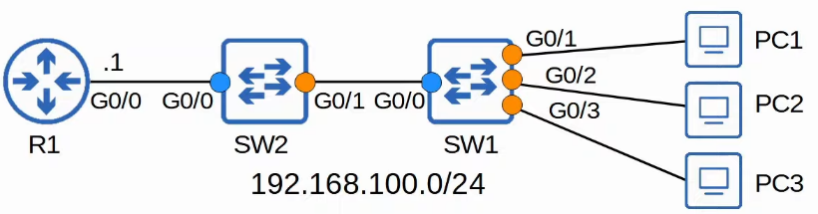

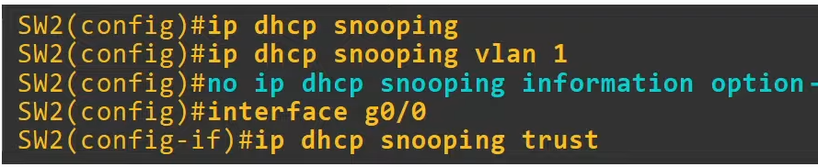

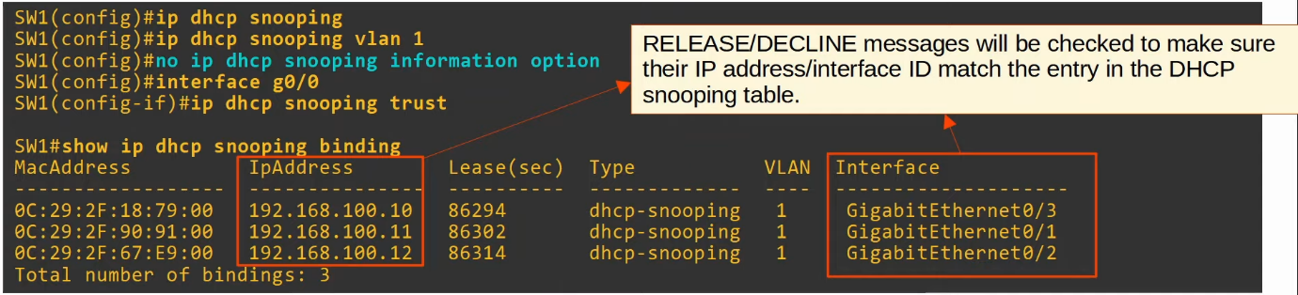

**DHCP Snooping Rate-Limiting**

* DHCP Snooping can limit the rate at which DHCP messages are allowed to enter an interface
* If the rate of DHCP messages crosses the configured limit, the interface is err-disabled
* Like with Port Security, the interface can be manually re-enabled, or automatically re-enabled with errdisable recovery
* Rate-limiting can be very useful to protect against DHCP exhaustion attacks

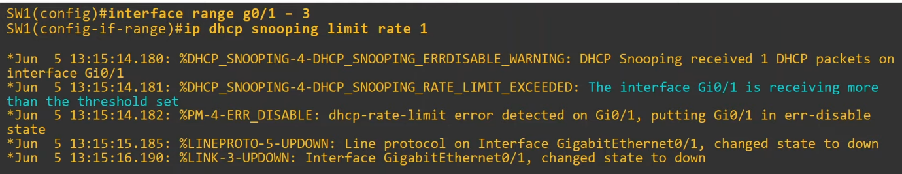

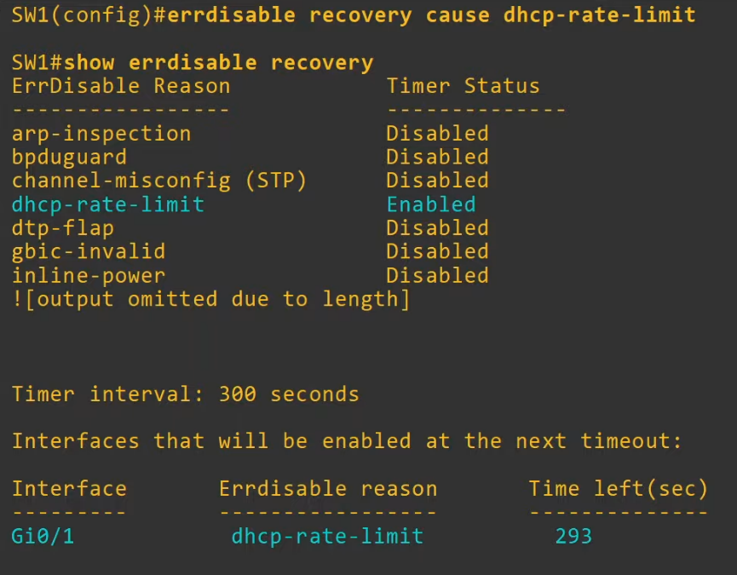

**DHCP Option 82 (Information Option)**

* Option 82, also known as the "DHCP relay agent information option" is one of the many DHCP options
* It provides additional information about which DHCP relay agent received the client's message, on which interface, in which VLAN, etc
* DHCP relay agents can add Option 82 to messages they forward to remote DHCP servers
* With DHCP Snooping enabled, by default, Cisco switches will add Option 82 to DHCP messages they receive from clients, even if the switch is not acting as a DHCP relay agent
* By default, Cisco switches will drop DHCP messages with Option 82 that are received on untrusted ports

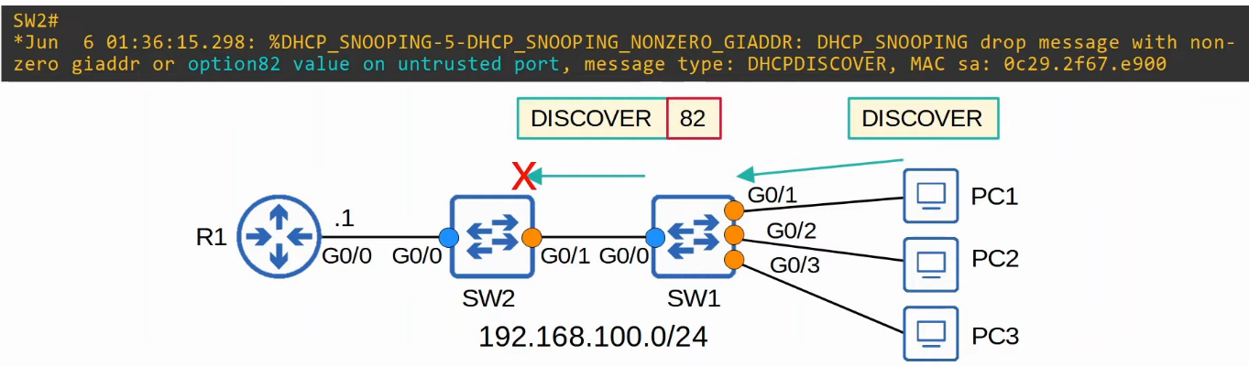

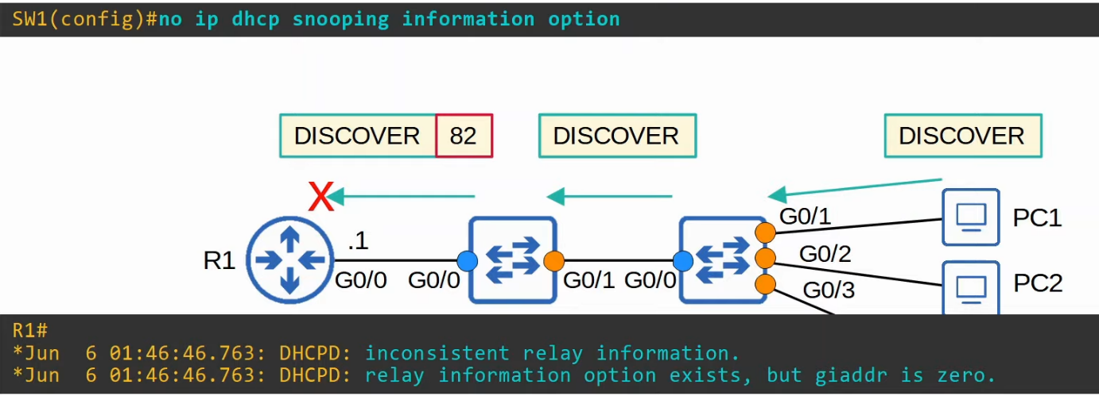

* "inconsistent relay information": received Option 82 from SW2 even though not a DHCP relay agent

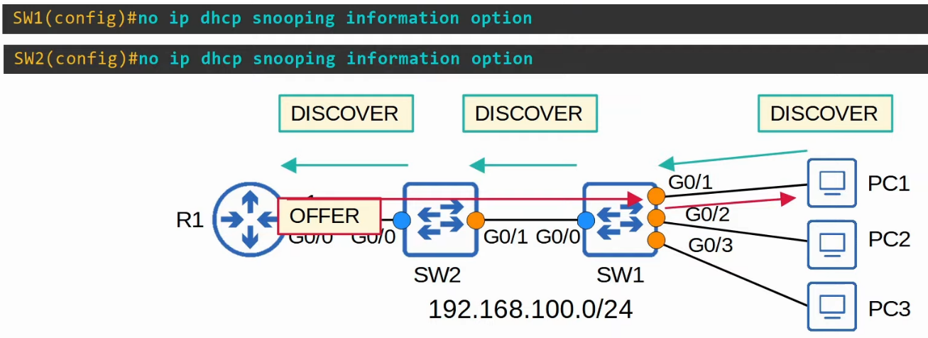

**Summary**

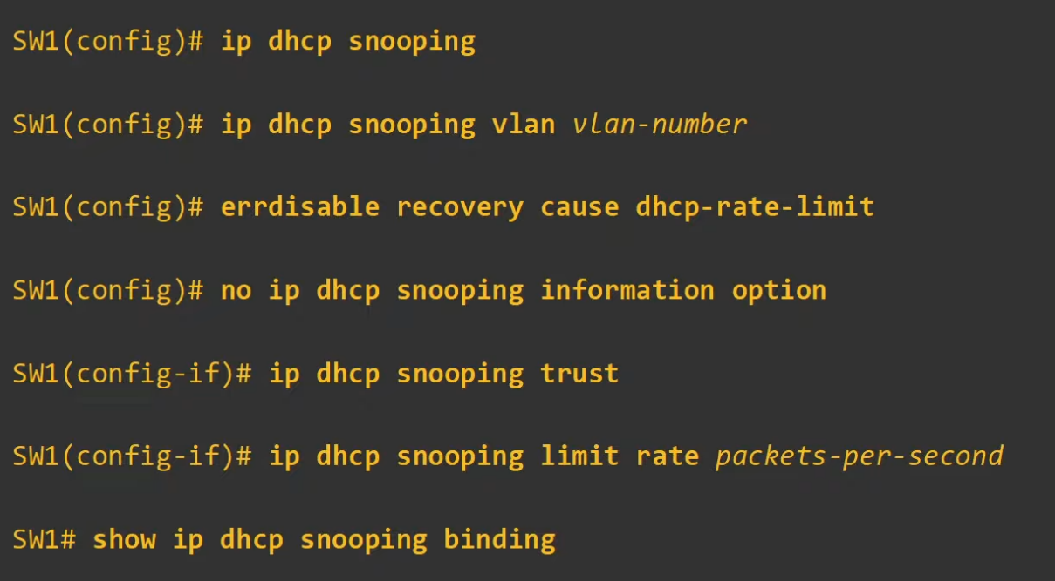

# Dynamic ARP Inspection

Things covered

* What is Dynamic ARP Inspection
* How does it work
* What attack does it prevent
* Config

ARP Review

* ARP is used to learn the MAC address of another device with a known IP address
* E.g. a PC will use ARP to learn the MAC address of its default gateway to communicate w external networks
* Typically, it is a 2 message exchange: request, reply

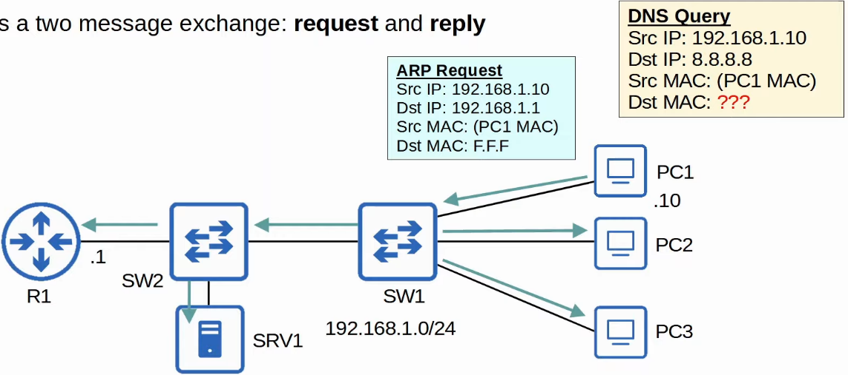

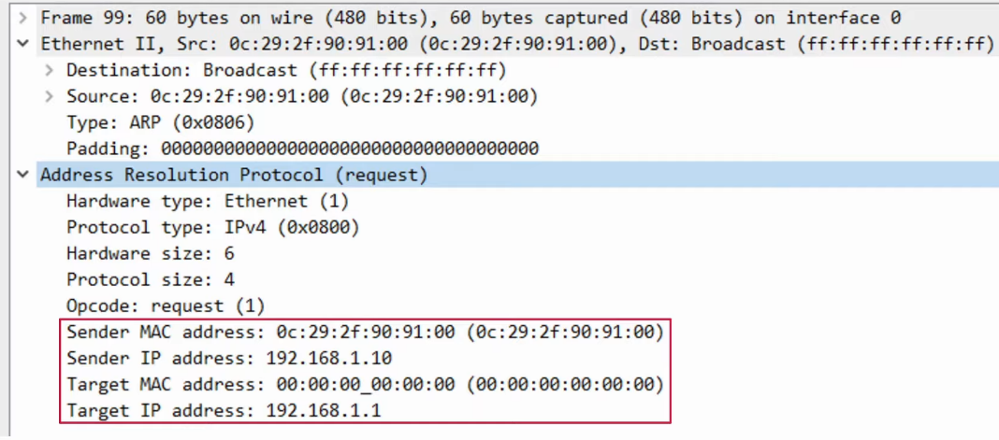

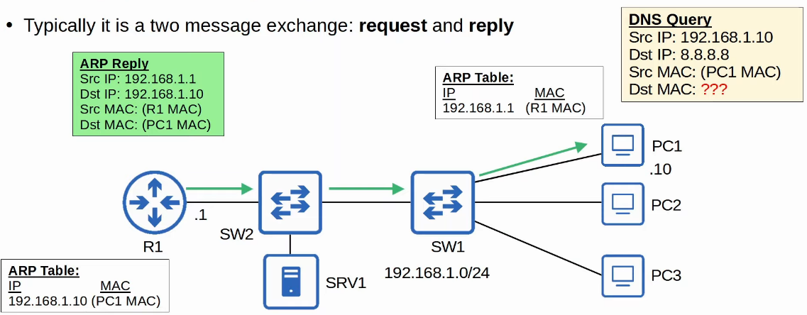

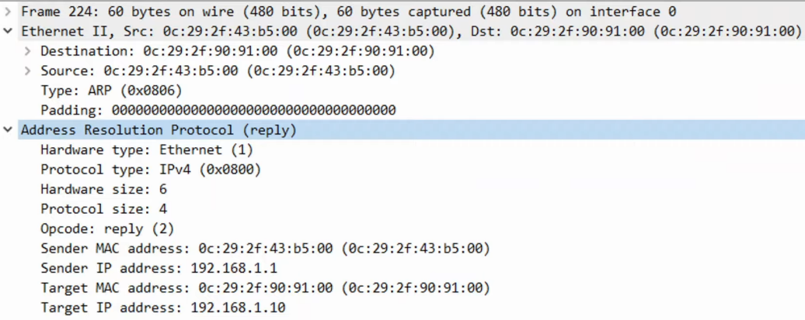

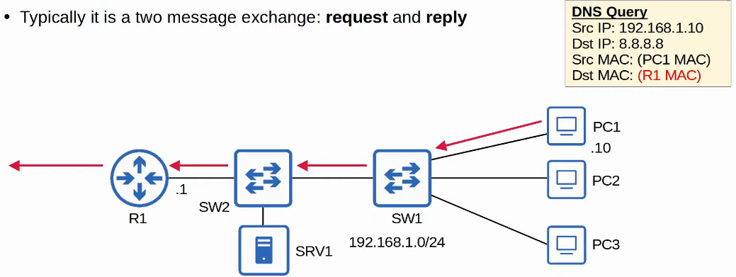

Gratuitous ARP

* It is an ARP reply that is sent w/o receiving an ARP Request
* It is sent to the broadcast MAC address
* It allows other devices to learn the MAC address of the sending device w/o having to send ARP requests
* Some devices automatically send GARP messages when an interface is enabled, IP address is change, MAC address is changed, etc

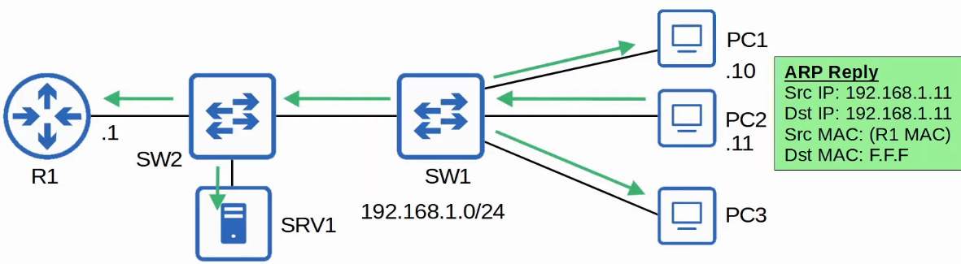

Dynamic ARP Inspection

* DAI is a security feature of switches that is used to filter ARP messages received on untrusted ports
* DAI only filters ARP messages
  + Non-ARP messages are not affected
* All ports are untrusted by default
  + Typically, all ports connected to other network devices (switches, routers) should be configured as trusted
  + Interfaces connected to end hosts should remain untrusted

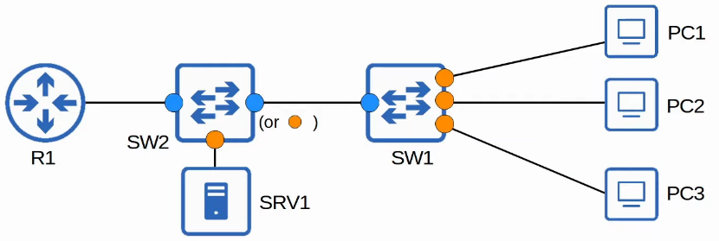

* SW2 interface facing downlink can also be untrusted
  + But Cisco documentation say any ports connected to network devices should be trusted

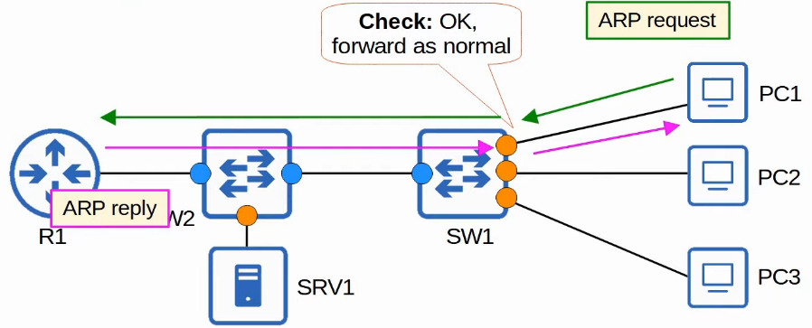

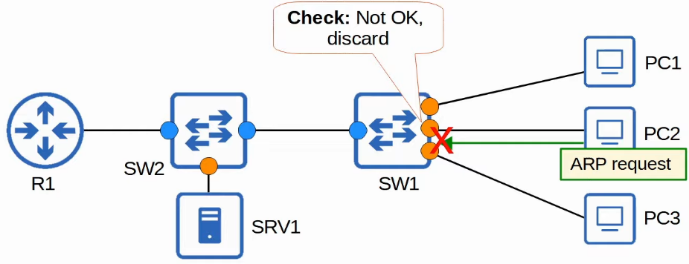

ARP Poisoning (Man-in-the-middle)

* Similar to DHCP poisoning, ARP poisoning involves an attacker manipulating targets' ARP tables so traffic is sent to the attacker
* To do this, the attacker can send gratuitous ARP messages using another device's IP address
* Other devices in the network will receive the GARP and update their ARP table, causing them to send traffic to the attacker instead of the legitimate destination

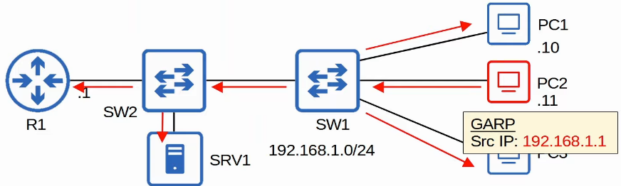

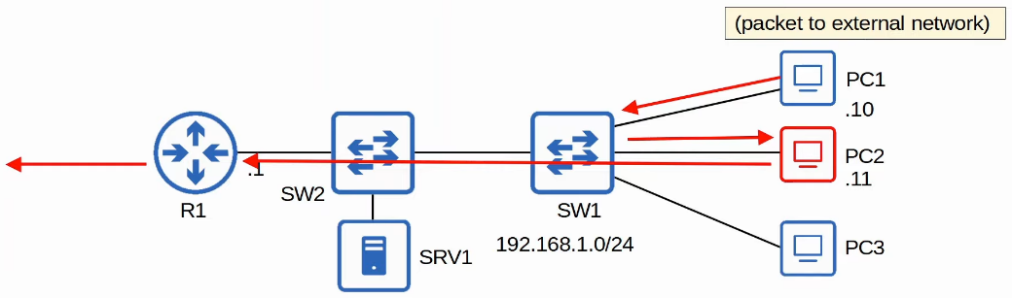

DAI Operations

* DAI inspects the sender MAC and sender IP fields of ARP messages received on untrusted ports and checks that there is a matching entry in the DHCP snooping binding table
  + If there is a matching entry, the ARP message is forwarded normally

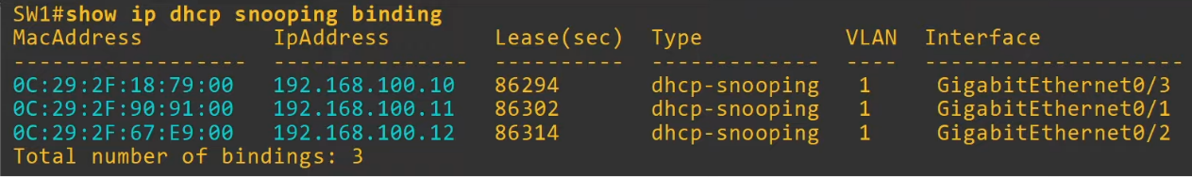

* DAI does not inspect messages received on trusted ports
  + They are forwarded as normal
* ARP ACLs can be manually configured to map IP addresses/MAC addresses for DAI to check
  + Useful for hosts that don't use DHCP
* DAI can be configured to perform more in depth check
* DAI also supports rate-limiting to prevent attackers from overwhelming the switch with ARP messages
  + DHCP snooping and DAI both require work from the switch's CPU
  + Even if the attacker's messages are blocked, they can overload the CPU with ARP messages

Config

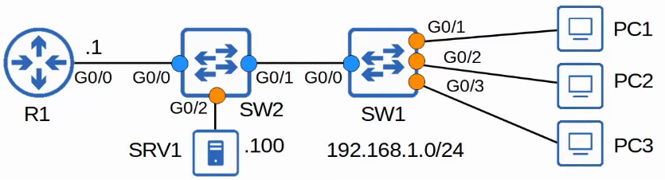

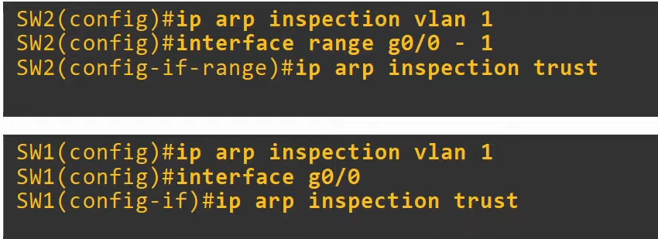

* Don’t need to configure globally like in DHCP snooping, just straight away on VLAN

"show ip arp inspection interfaces"

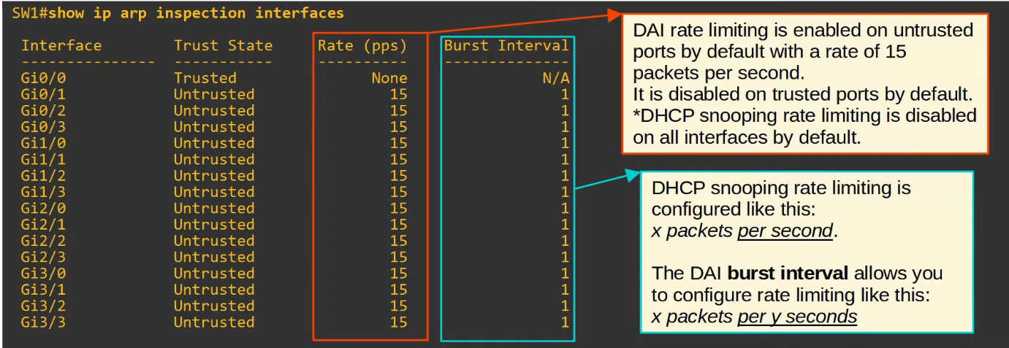

DAI rate-limiting

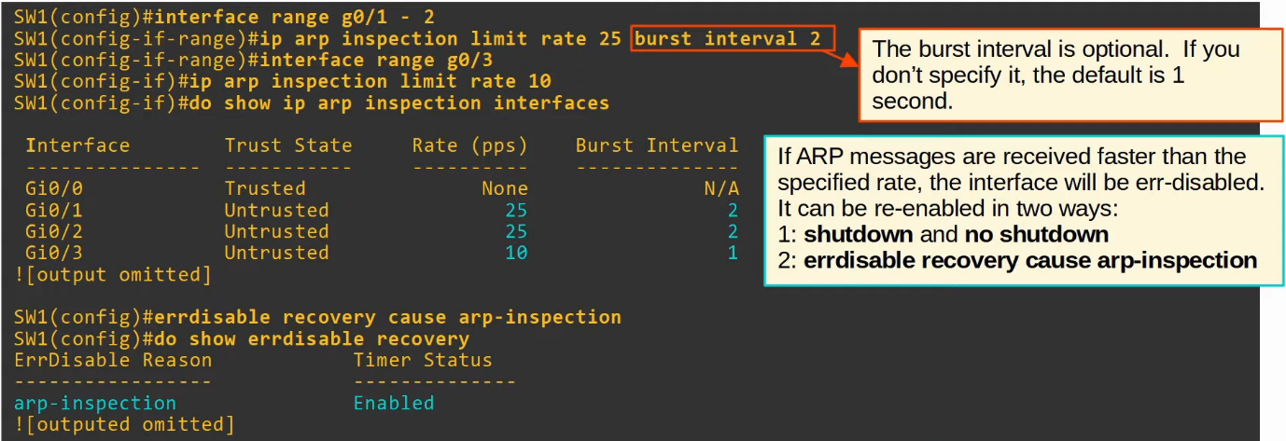

DAI Optional Checks

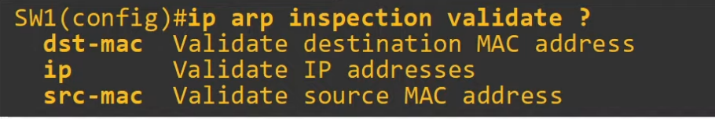

* These checks are done in addition to the standard DAI check (sender MAC/IP)
  + If configured, an ARP message must pass all of the checks to be considered valid
* "dst-mac"
  + Check if destination MAC address in Ethernet header and ARP body are the same
* "ip"
  + Check for invalid and unexpected IP address
  + E.g. 0.0.0.0, 255.255.255.255, all IP multicast address
  + Check the sender IP in all ARP request and response
  + Check the target IP only in ARP response
* "src-mac"
  + Check if source MAC address in Ethernet header and ARP body are the same

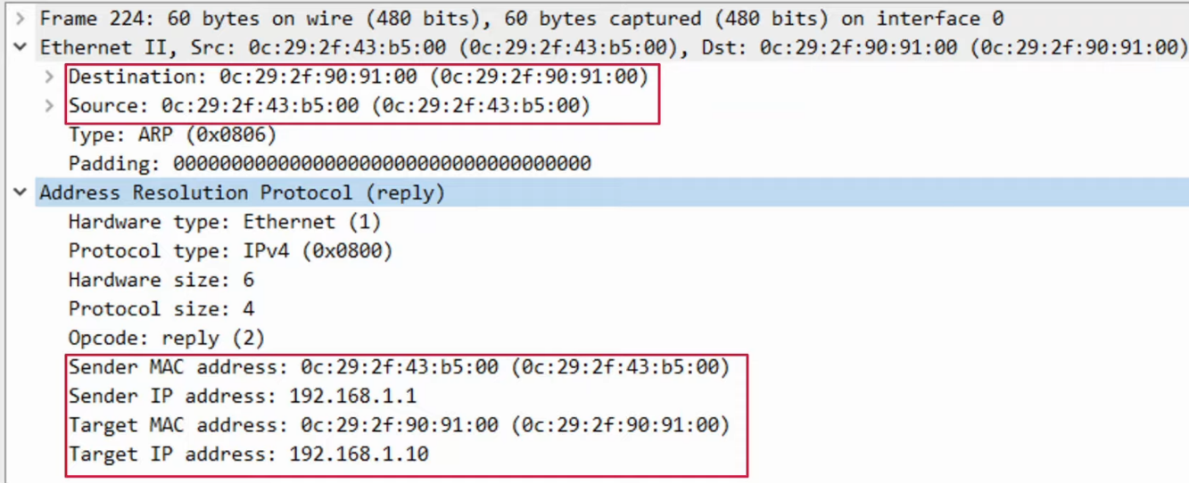

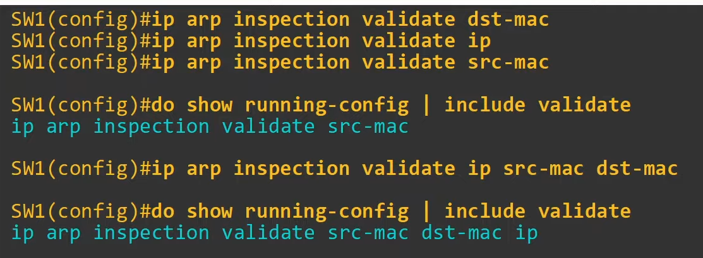

* Must enter all the validation checks in a single command
  + Can specify 1, 2 or 3
  + The order does not matter

ARP ACLs

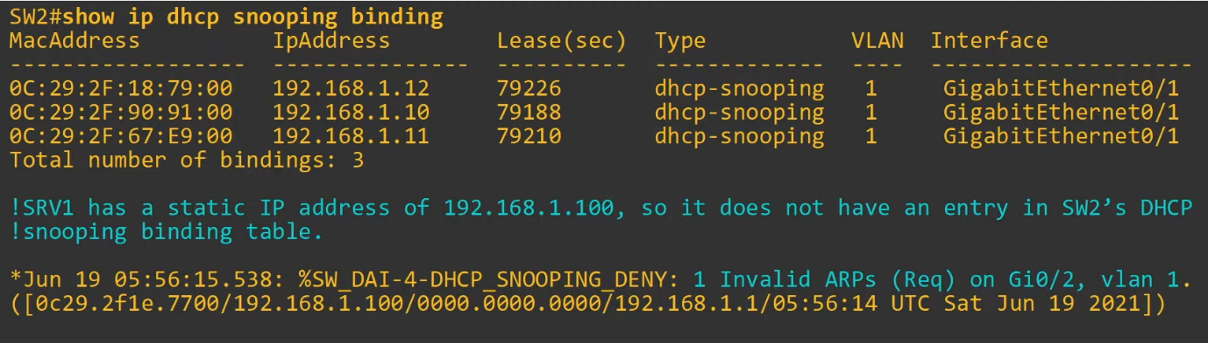

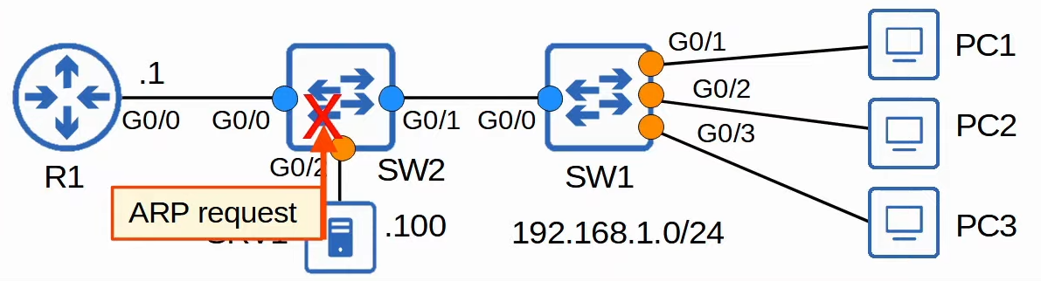

* SRV1 not in SW2 DHCP snooping binding table

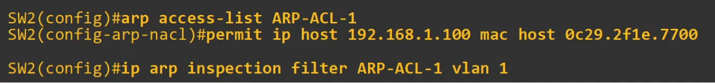

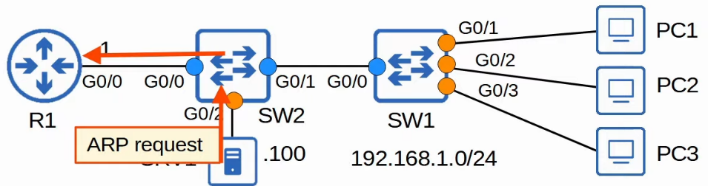

"show ip arp inspection"

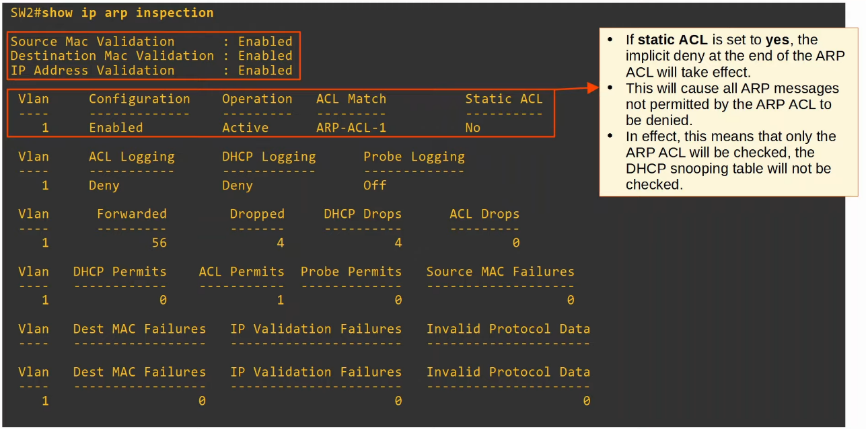

Summary

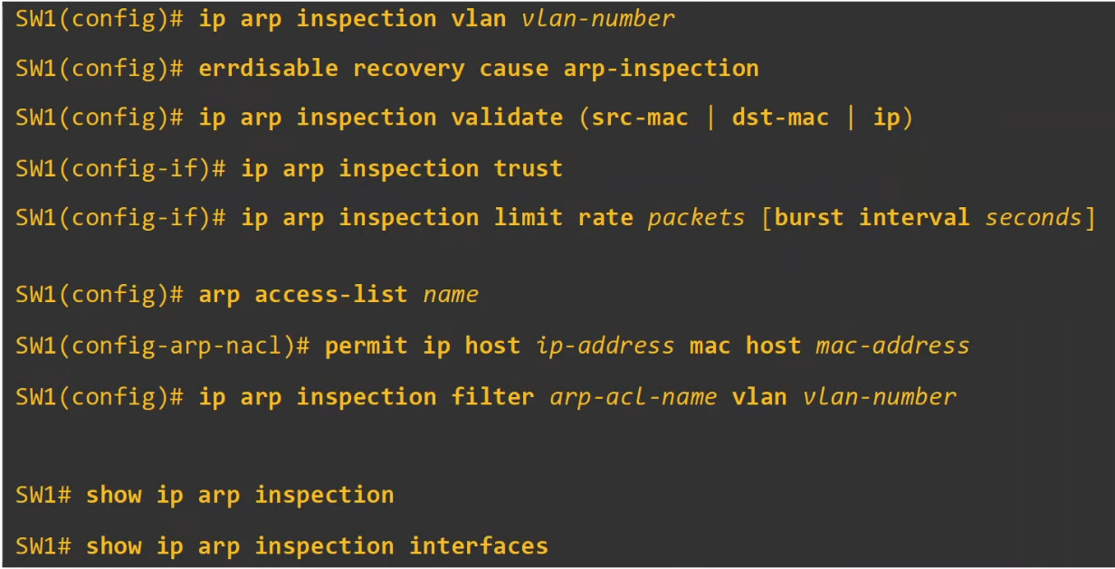

# Network Architectures

## LAN Architectures

Things covered

* 2-tier and 3-tier LAN Architecture
* Spine-leaf architecture
* SOHO (Small Office / Home office)

**Common Terminologies**

* Star
  + When several devices all connect to 1 central device

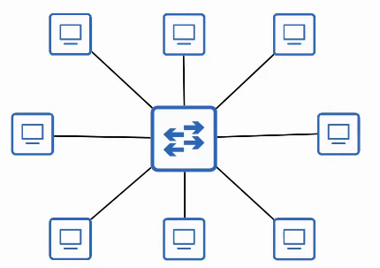

* Full Mesh
  + When each device is connected to all other device

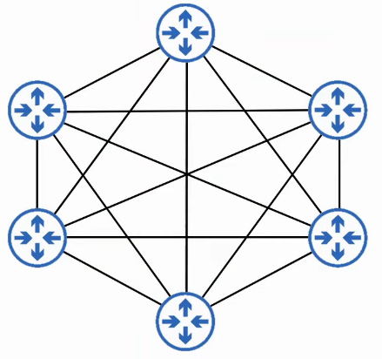

* Partial Mesh
  + When only some devices are connected to all other devices

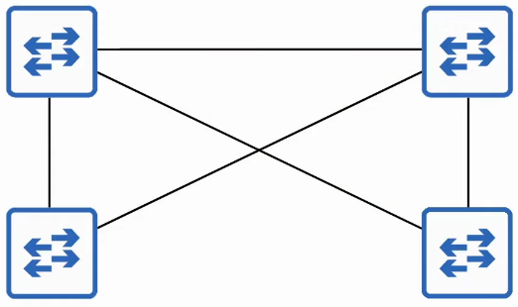

**2-Tier Campus LAN Design**

* The 2-tier LAN design consists of 2 hierarchical layers
  + Access Layer
  + Distribution Layer
* Also called a "Collapsed Core" design because it omits a layer that is found in the 3-tier design, the Core Layer
* **Access Layer**
  + The layer that end hosts connects to (PCs, printers, cameras, etc)
  + Typically Access Layer switches have lots of ports for end hosts to connect to
  + QoS marking is typically done here (good to mark frames ASAP)
  + Security services like port security, DAI, etc are typically performed here
  + Switchports might be PoE-enabled for wireless APs, IP Phones, etc
* **Distribution Layer (Aggregation Layer)**
  + Aggregates connections from the Access Layer Switches
  + Typically is the border btw Layer 2 and Layer 3
    - They run both services, e.g. OSPF etc
  + Connects to services such as Internet, WAN, etc (*for 2 tier design)

**Example**

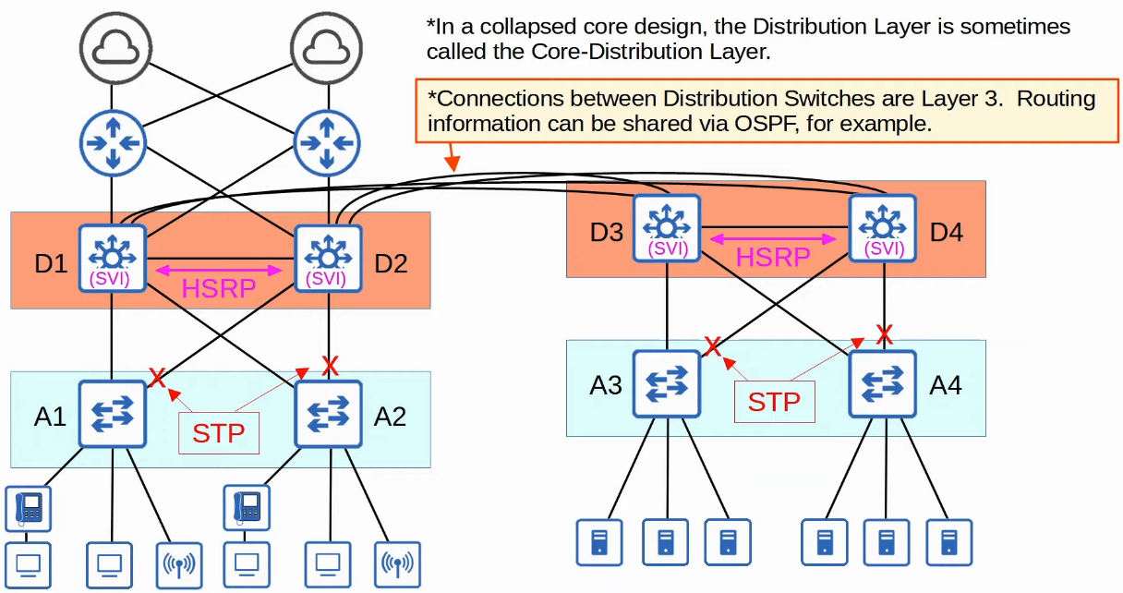

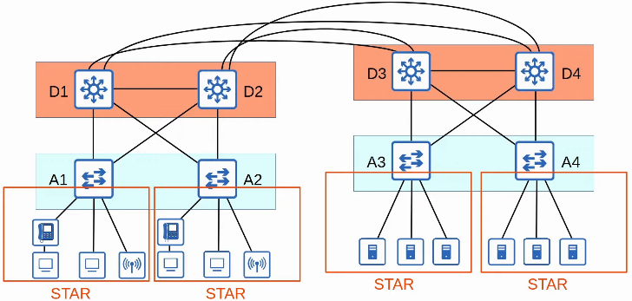

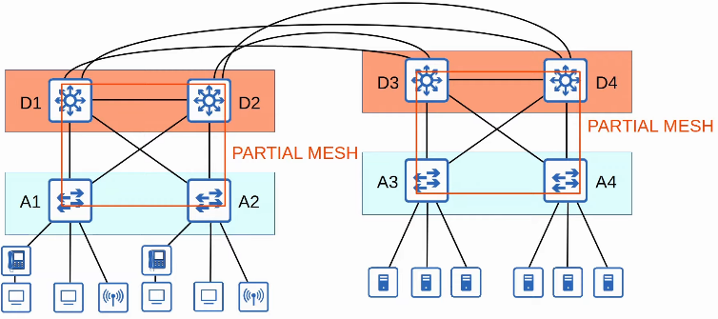

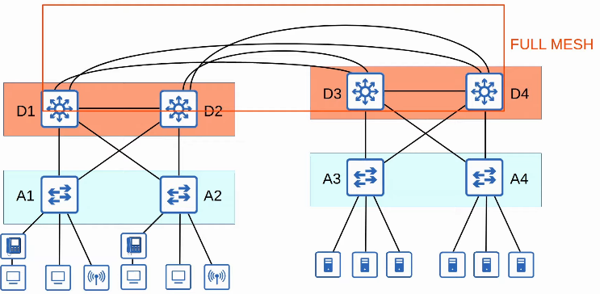

**Problem**

* In large LAN networks with many Distribution Layer switches (e.g. in separate buildings), the number of connections required btw Distribution Layer switches grows rapidly
* To help scale large LAN networks, a Core Layer can be added
  + Cisco recommends adding a Core Layer if there are more than 3 Distribution Layers in a single location

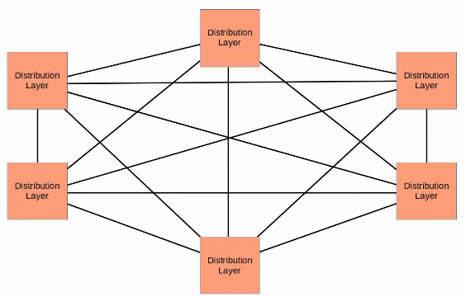

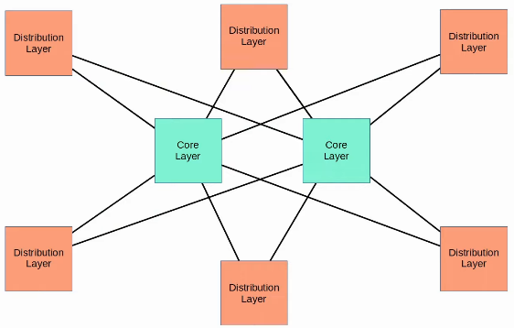

**3-Tier Campus LAN Design**

* Consist of 3 hierarchical layers
  + Access Layer
  + Distribution Layer
  + Core Layer
* **Core Layer**
  + Connects Distribution Layers together in large LAN networks
  + The focus is speed ('fast transport') - only care about forwarding packets from 1 Distribution Layer switch to another
  + CPU-intensive operations such as security, QoS marking/classification, etc should be avoided at this Layer
  + Connections are all Layer 3, no spanning-tree
  + Should maintain connectivity throughout the LAN even if devices fail

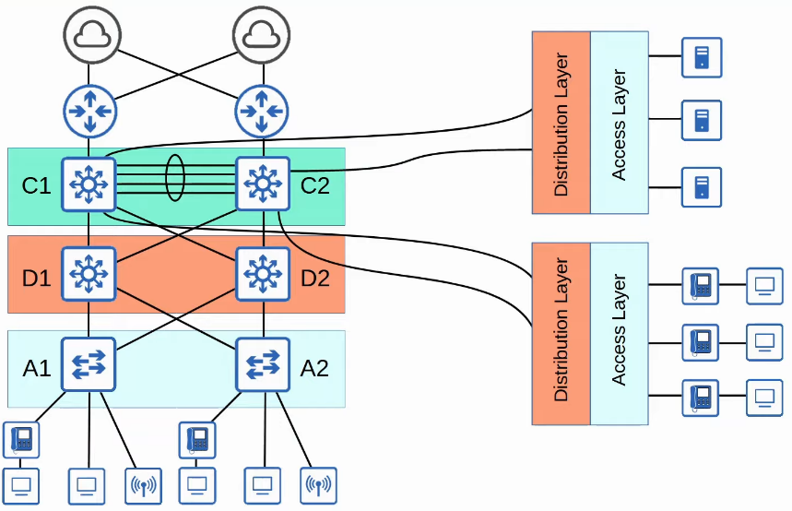

**Spine-Leaf Architecture**

* Data centres are dedicated spaces/buildings used to store computer systems such as servers and network devices
* Traditional data centre design uses a 3-tier architecture (Access-Distribution-Core)
* This worked well when most traffic in the data centre was North-South

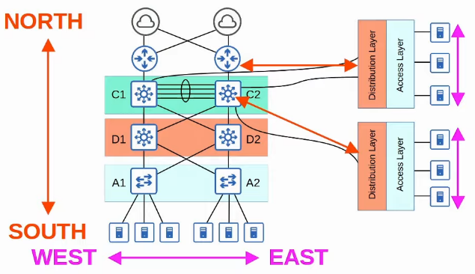

* With the precedence of virtual servers, applications are often deployed in a distributed manner (across multiple physical servers), which increases the amount of East-West traffic in the data centre
* The traditional 3-tier architecture led to bottlenecks in bandwidth as well as variability in the server-to-server latency depending on the path the traffic takes
* To solve this, Spine-Leaf architecture (Clos architecture) has become prominent in data centres

* There are some rules about Spine-Leaf architecture
  + Every leaf switch is connected to every spine switch
  + Every spine switch is connected to every Leaf switch
  + Leaf switches do not connect to other Leaf switches
  + Spine switches do not connect to other Spine switches
  + End hosts (servers, etc) only connect to Leaf switches
* The path taken is randomly chosen to balance the traffic load among Spine switches
* Each server is separated by the same number of 'hops' (except those connected by the same Leaf switch), providing consistent latency for East-West traffic
* Easy to scale

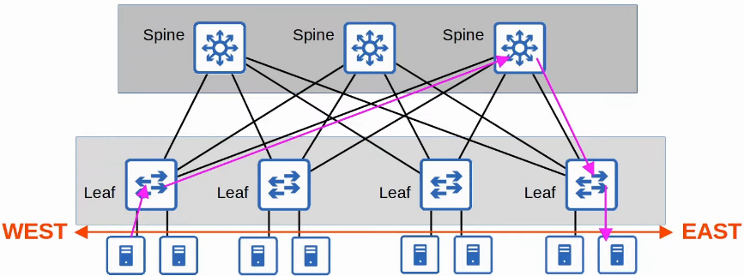

**SOHO Networks**

* Small Office / Home Office (SOHO) refers to the office of a small company, or a small home office with few devices
  + Does not have to be an actual home 'office', if your home has a network connected to the Internet it is considered a SOHO network
* SOHO networks don't have complex needs, so all networking functions are typically provided by a single device, often called a 'home router' or 'wireless router'
* This 1 device can serve as a
  + Router
  + Switch
  + Firewall
  + Wireless Access Point
  + Modem

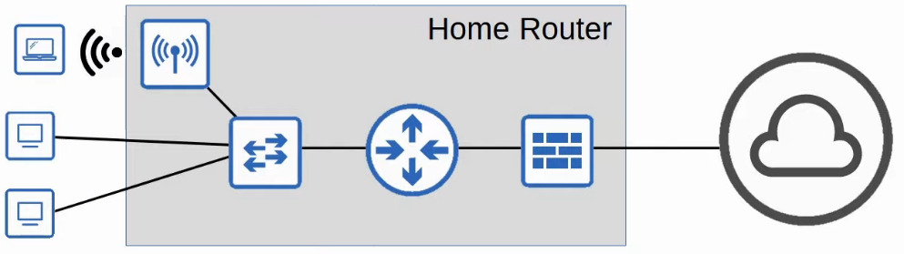

WAN Architectures

Things covered

* Intro to WANs
* Leased Lines
* MPLS VPNs
* Internet connectivity
* Internet VPNs

## WAN Architectures

* Wide Area Network
* Extends over a large geographic area
* WANs are used to connect geographically separate LANs
* Although the Internet itself is considered a WAN, the term WAN is usually used to refer to an enterprise's private connections that connect their offices, data centres, and other sites together
* Over public/shared network like Internet, VPNs (Virtual Private Networks) can be used to create private WAN connections
* There have been many different WAN technologies over the years. Depending on the location, some may be available and some may not
* Technologies which are considered 'legacy' (old) in 1 country may still be used in another

**WAN over dedicated connection (Leased Line)**

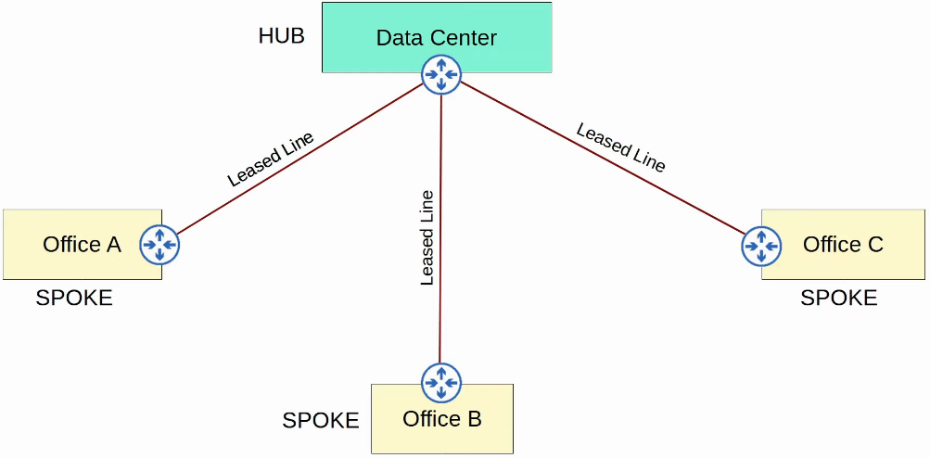

* Hub and Spoke Topology

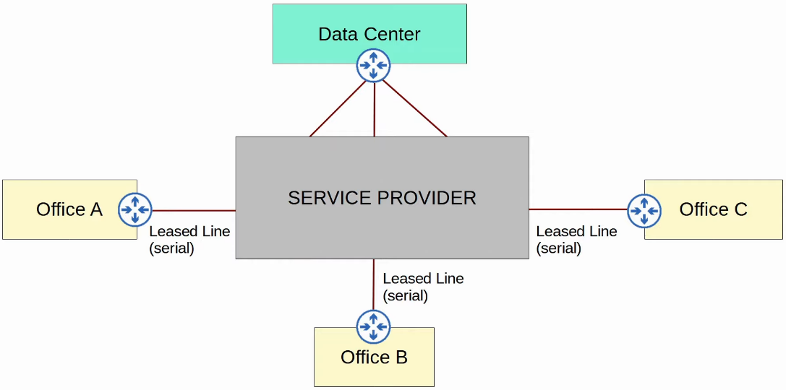

* Better representation of Leased Line

**WAN connection via Ethernet (Fiber)**

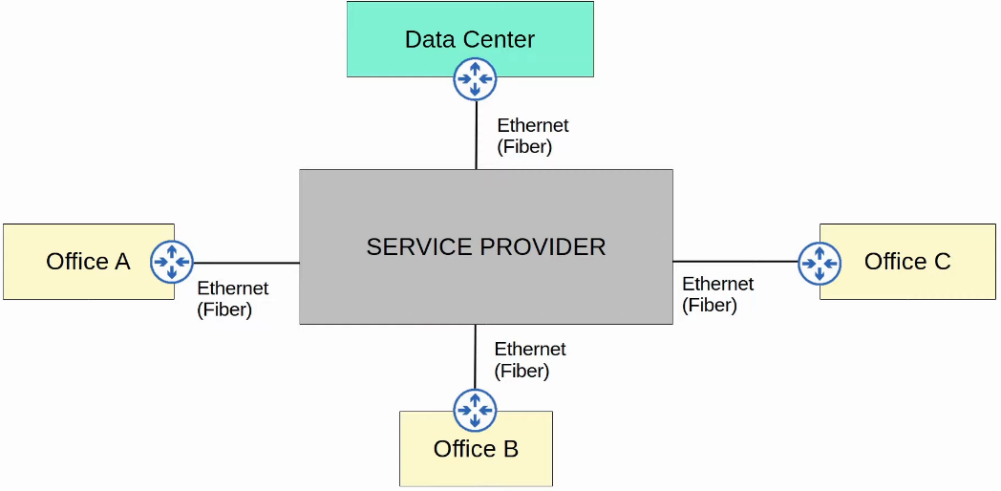

**WAN over shared Infrastructure (Internet VPN)**

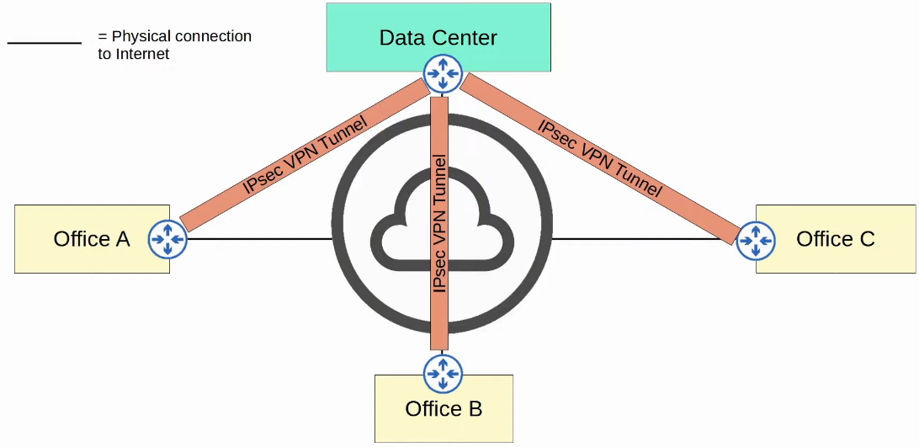

**Leased Line**

* A dedicated physical link, typically connecting 2 sites
* Leased Lines use serial connections (PPP or HLDC encapsulation)
* There are various standards that provide different speeds, and different standards are available in different countries
* Due to the higher cost, higher installation lead time, and slower speeds of leased lines, Ethernet WAN technologies are becoming more popular

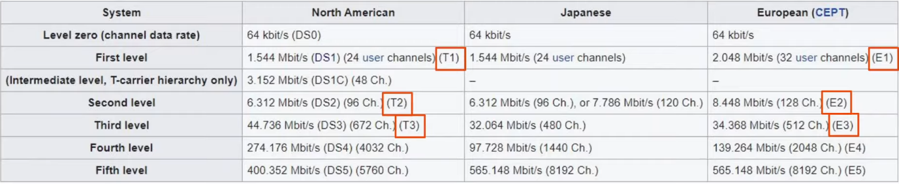

**MPLS**

* Multi-Protocol Label Switching
* Similar to the Internet, service providers' MPLS networks are shared infrastructure because many customer enterprises connect to and share the same infrastructure to make WAN connections
* However, the label switching in the name of MLPS allows VPNs to be created over the MLPS infrastructure through the use of labels
* Some important terms
  + Customer Edge (CE) Router
  + Provider Edge (PE) Router
  + Provider core (P) router
* When the PE routers receive frames from the CE routers, they add a label to the frame
* These labels are used to make forwarding decisions within the service provider network, not the destination IP

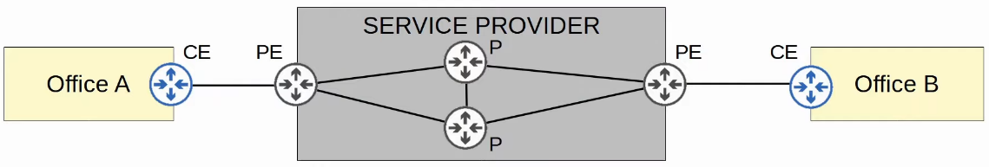

**Layer 3 MPLS**

* The CE routers don't use MPLS, it is only used by PE and P routers
* When using a Layer 3 MPLS VPN, the CE and PE routers peer using OSPF, for example, to share routing information
  + The CE can use the PE as the next hop of their static routes also
* For example, Office A's CE will peer with one PE, and Office B's CE will peer with the other PE
* Office A's CE will learn about Office B's routes via this OSPF peering, and Office B's CE will learn about Office A's routes too

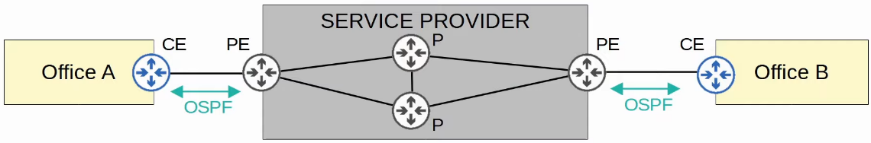

**Layer 2 MPLS**

* When using a Layer 2 MPLS VPN, the CE and PE routers do not form peerings
* The service provider network is entirely transparent to the CE routers
* In effect, it is like the 2 CE routers are directly connected
  + Their WAN interfaces will be in the same subnet
* If a routing protocol is used, the 2 CE routers will peer directly with each other
  + The service provider is still running MPLS, but doing so in a way that it is acting like a switch

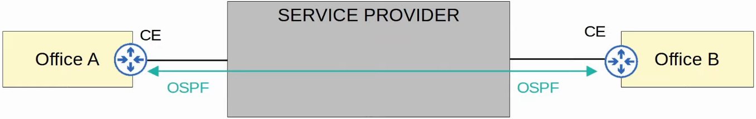

* Many different technologies can be used to connect to a service provider's MPLS network for WAN service

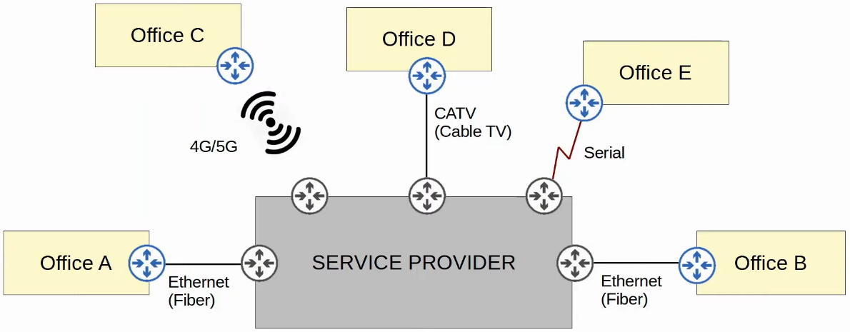

**Internet connections**

* There are countless of ways for an enterprise to connect to the Internet
* E.g. private WAN technologies such as leased lines and MPLS VPNs can be used to connect to a service provider's internet infrastructure
* In addition, technologies such as CATV and DSL commonly used by consumers (home Internet access) can also be used by an enterprise
* These days, for both enterprise and consumer internet access , fiber optic Ethernet connections are getting more popular due to high speeds they provide over long distances

**Digital Subscriber Line (DSL)**

* Provides Internet connectivity to customers over phone lines, and can share the same phone line that is already installed in most homes
* A DSL modem (modulator-demodulator) is required to convert data into a format suitable to be sent over the phone lines
  + The modem might be a separate device or might be incorporated in to the 'home router'

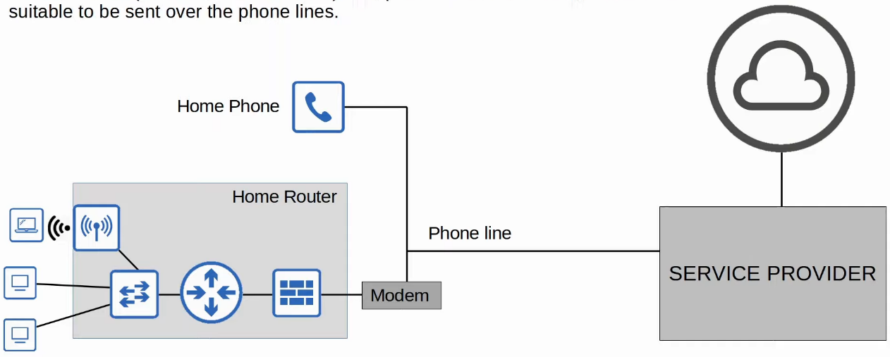

**Cable Internet**

* Provides Internet access via the same CATV (Cable Television) lines used for TV service
* Like DSL, a cable modem is required to convert data into a format suitable to be sent over the CATV cables
  + Like a DSL modem, it can be separate device or built into the home router

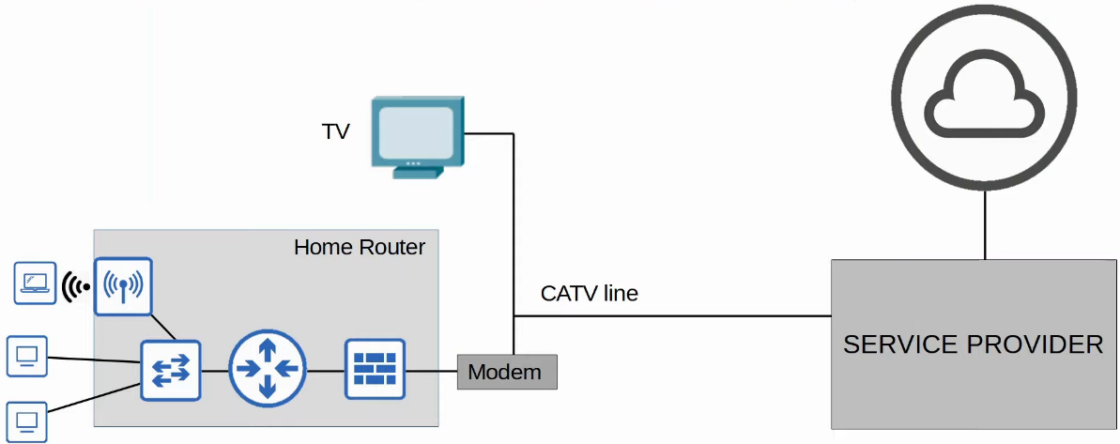

**Redundant Internet Connections**

* Single homed
  + 1 connection to 1 ISP

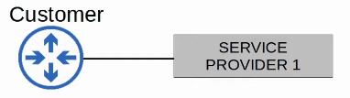

* Dual homed
  + 2 connections to 2 ISP

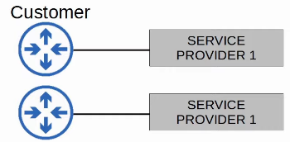

* Multihomed
  + 1 connection to each of 2 ISPs

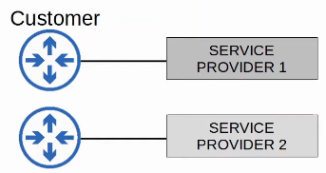

* Dual Multihomed
  + 2 connections to each of 2 Ips

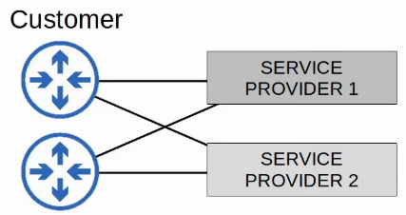

**Internet VPNs**

* Private WAN services such as leased lines and MPLS provide security because each customer's traffic is separated by using dedicated physical connections (leased lines) or by MPLS tags
* When using the Internet as a WAN to connect sites together, there is no built-in security by default
* To provide secure communications over the Internet, VPNs are used
* We will cover 2 kinds of Internet VPNs
  + Site-to-Site VPNs using IPSec
  + Remote-accessing VPNs using TLS

**Site-to-Site VPNs (IPSec)**

* A VPN btw 2 devices and is used to connect 2 sites together over the Internet
* A VPN 'tunnel' is created btw the 2 devices by encapsulating the original IP packet with a VPN header and new IP header
  + When using IPSec, the original packet is encrypted before being encapsulated with the new header

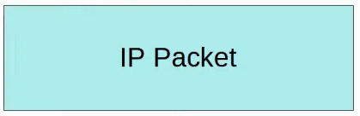

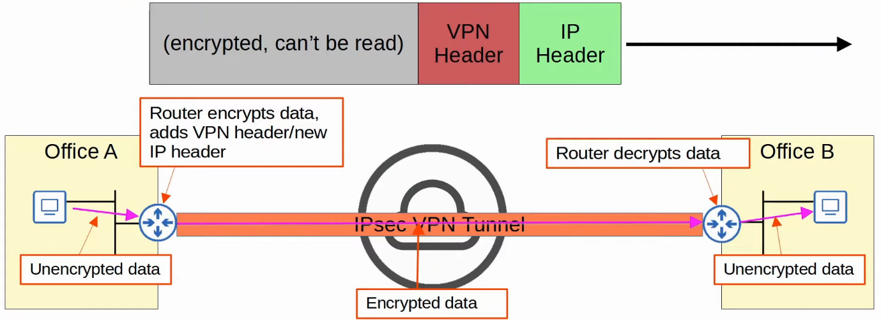

* **Summary**
  1. The sending device combines the original packet and session key (encryption key) and runs them through an encryption formula
  2. The sending device encapsulates the encrypted packet with a VPN header and a new IP header
  3. The sending device sends the new packet to the device on the other side of the tunnel
  4. The receiving device decrypts the data to get the original packet, and then forwards the original packet to its destination
* In a site-to-site VPN, a tunnel is formed only btw 2 tunnel endpoints (e.g. the 2 routers connected to the internet)
* All other devices in each site don't need to create a VPN for themselves. They can send unencrypted data to their site's router, which will encrypt it and forward it in the tunnel as described above
* **Limitations**
  1. IPSec don't support broadcast and multicast traffic, only unicast
     + Routing protocols such as OSPF can't be used over the tunnels because they rely on multicast traffic
     + Can be solved with "GRE over IPSec"
  2. Configuring a full mesh of tunnels btw many sites is labour-intensive
     + Can be solved using Cisco's DMVPN

**GRE over IPSec**

* GRE (Generic Routing Encapsulation) creates tunnels like IPSec, however, it does not encrypt the original packet, so it is not secure
* However, it has the advantage of being able to encapsulate a wide variety of Layer 3 protocols as well as broadcast and multicast messages
* To get the flexibility of GRE with the security of IPSec, GRE over IPSec can be used
* The original packet will be encapsulated by a GRE header and a new IP header, and then the GRE packet will be encrypted and encapsulated within an IPSec VPN header and new IP header

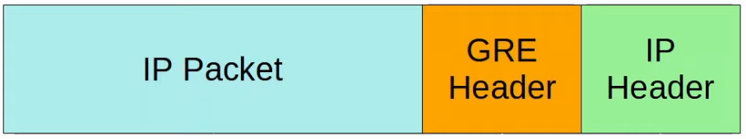

* The above GRE packet is then encrypted as shown below

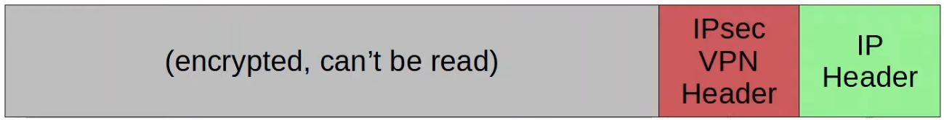

**DMVPN**

* DMVPN (Dynamic Multipoint VPN) is a Cisco-developed solution that allows routers to dynamically create a full mesh of IPSec tunnels without having to manually configure every single tunnel
* DMVPN provides the configuration simplicity of hub-and-spoke (each spoke router only needs one tunnel configured) and the efficiency of direct spoke-to-spoke communication (spoke routers can communicate directly without traffic passing through the hub)

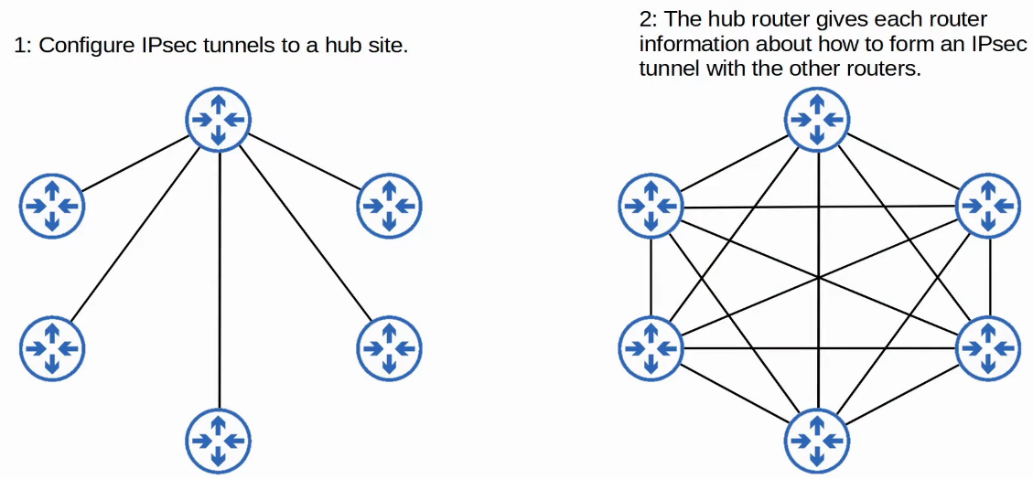

**Remote-Access VPNs**

* Whereas site-to-site VPNs are used to make point-to-point connection btw 2 sites over the Internet, remote-access VPNs are used to allow end devices (PCs, mobile phones) to access the company's internal resources securely over the Internet
* Remote-access VPNs typically use TLS (Transport Layer Security)
  + TLS is also what provides security for HTTPS (HTTP Secure)
  + TLS was formerly known as SSL (Secure Sockets Layer) and developed by Netscape, but it was renamed to TLS when it was standardized by the IETF
* VPN client software (e.g. Cisco AnyConnect) is installed on end devices (e.g. company-provided laptops used by employees to work from home)
* These end devices form secure tunnels to one of the company's routers/firewalls acting as a TLS server
* This allows the end users to securely access resources on the company’s internal network without being directly connected to the company network

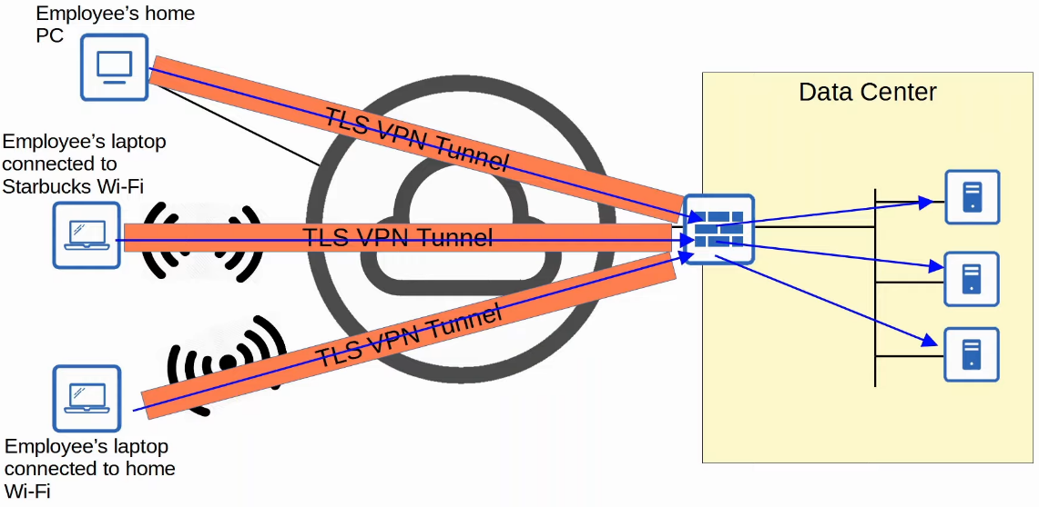

* TLS also encrypt and add additional headers to packets

**Site-to-Site VS Remote-Access VPN**

* SS VPNs typically use IPSec
* RA VPNs typically use TLS

* SS VPNs provide service to many devices within the sites they are connecting
* RA VPNs provide service to the one end device the VPN client software is installed on

* SS VPNs are typically used to permanently connect 2 sites over the Internet
* RA VPNs are typically used to provide on-demand access for end devices that want to securely access company resources while connected to a network which is not secure